FIG. S1. The principal components analysis of three developmental stages in S. litura. The expression of transcripts was transformed using rlog function.

FIG. S2. The Venn diagram of DETs between pairwise comparison groups of three developmental stages in S. litura.

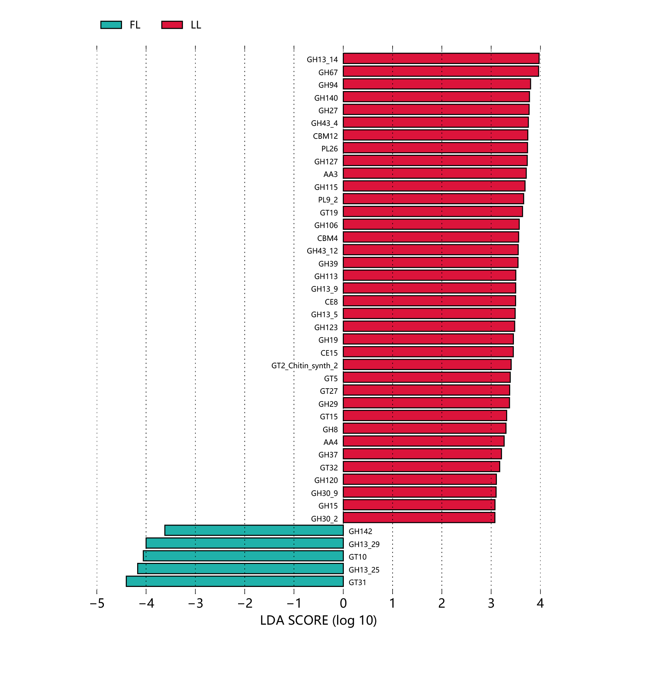
FIG. S3. LDA effect size (LEfSe) analysis of the function of Carbohydrate-Active enzymes (CAZy) between the two groups.

