Supplemental Figures
Supplemental Figure 1. GWAS analysis associated with sex of A. japonicus on chromosome 9, 17, 18. The x-axis depicts the physical location of SNPs, and the y-axis depicts the −log10 (P). The red threshold line represents P-value =1-e6. Red dots represent outlier values of P-value (P<1-e6).
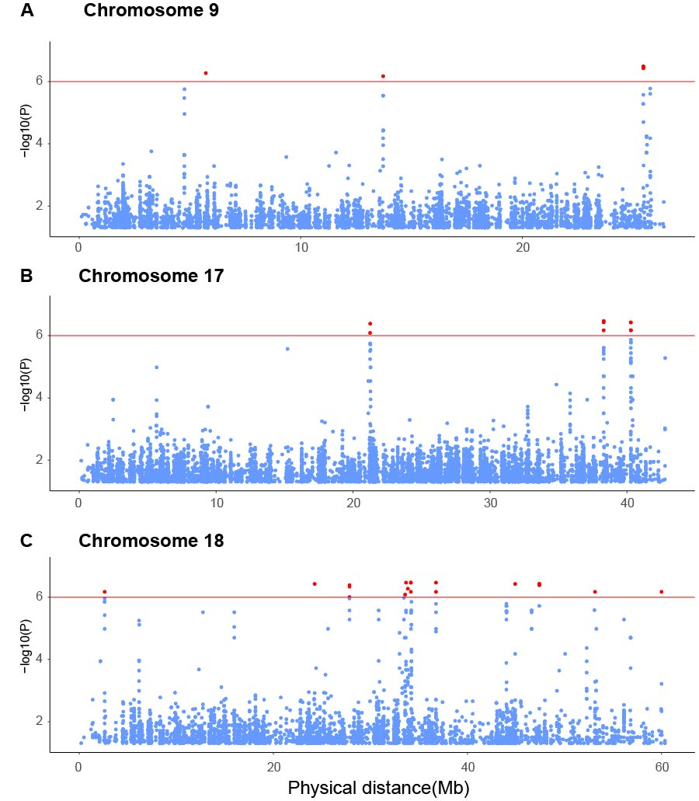
Supplemental Figure 2. Venn diagram showed intersection of annotated genes from GWAS studies, sex-specific SNPs analysis, transcriptome analysis and genes within SDR.
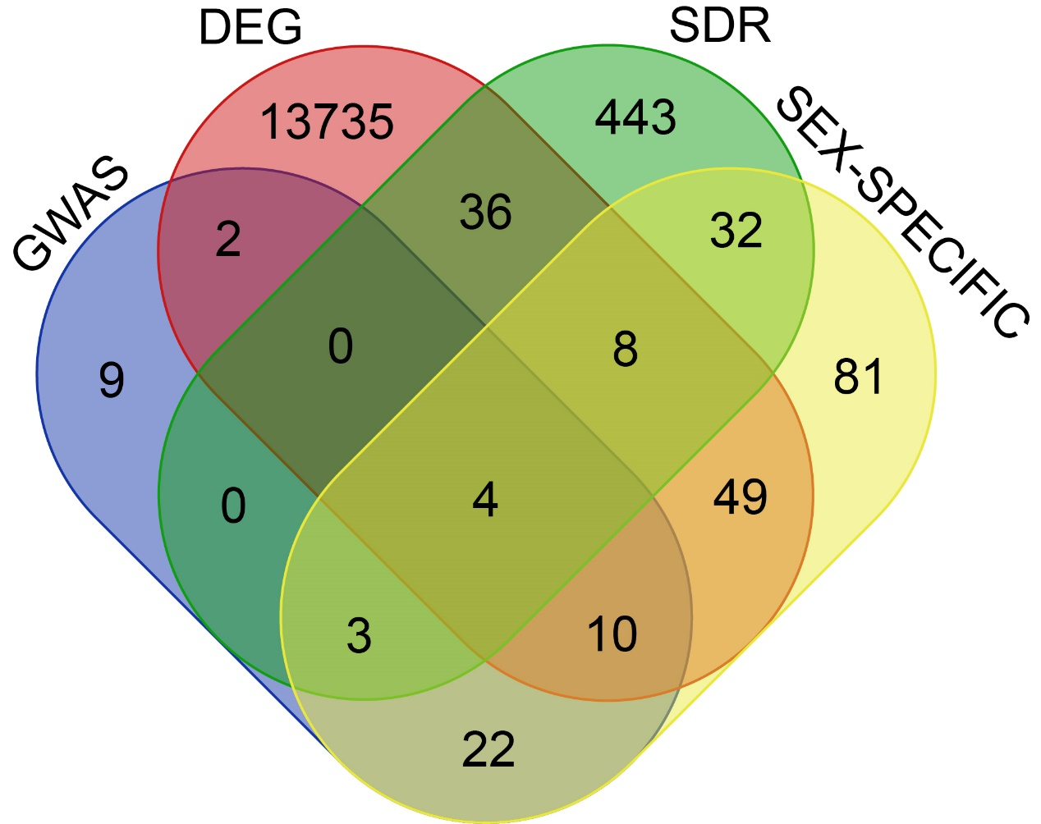

Supplemental Figure 3. Circos plot of the global landscape of SNP and INDEL frequency, and sex determination locus in A. japonicus. The orange shading indicates important chromosomes contributing to sex determination of A. japonicus.
The tracks from outside to inside represent:
(1) 23 chromosomes of AJH1.0 genome assembly (Mb).
(2) Distribution of INDEL density with a sliding window of 500kb.
(3) Distribution of SNP density with a sliding window of 500kb.
(4) Distribution of sex determination locus identified by GWAS.
