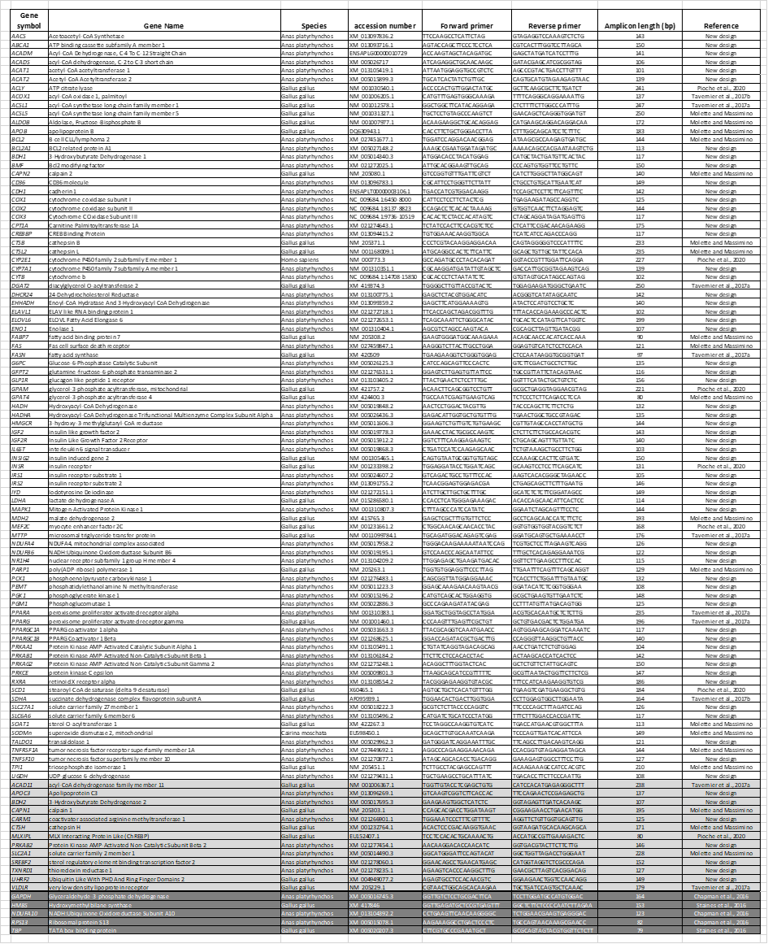
The genes targeted in the study are related to energy metabolism as well as to amino acid transport, oxidative stress, apoptotic activity and susceptibility to liver damage. Sequences were obtained either from Anas platyrhynchos when available, or from Gallus gallus on NCBI (https://www.ncbi.nlm.nih.gov/gene/) and/or Ensembl (http://www.ensembl.org/index.htm) databases. Genes showing more that 25% of missing data were removed from the study and are highlighted in light grey. The 5 potential reference genes are highlighted in dark grey. Molette and Massimino: unpublished data from Caroline Molette and William Massimino.

