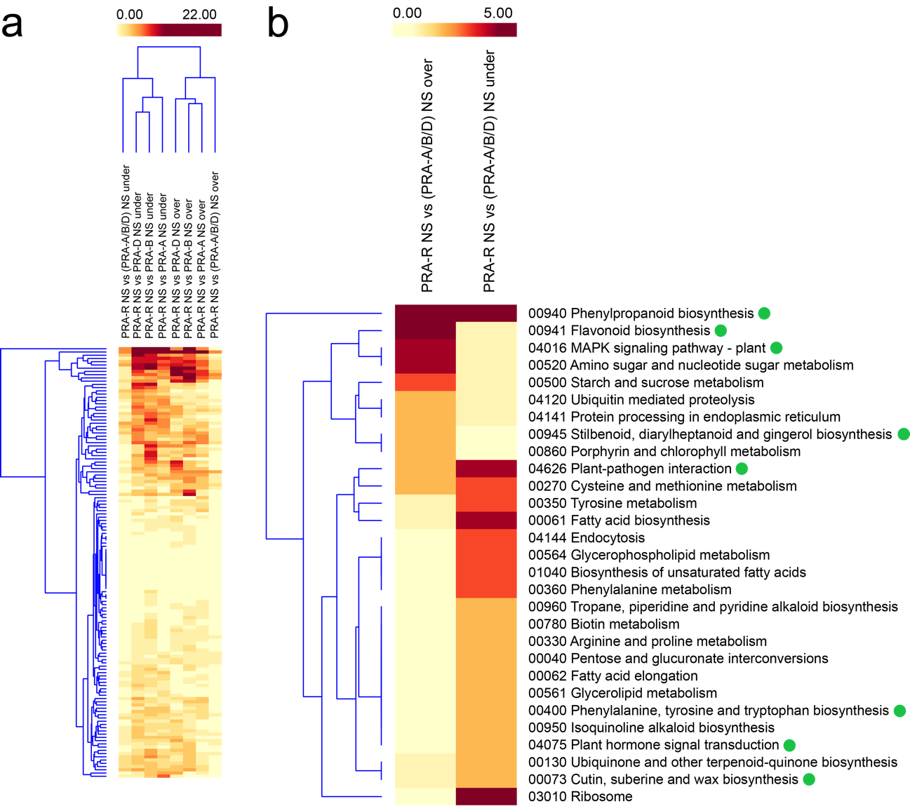

Additional file 15: Figure S7. Constitutive differences between the resistant and susceptible genotypes viewed through heat maps of DEGs distribution across pathways (pathway fingerprint).
(a) DEGs distribution across pathways for all independent contrasts between PRA-R NS needles and susceptible genotypes NS needles (PRA-R NS vs. PRA-A NS, PRA-R NS vs. PRA-B NS and PRA-R NS vs. PRA-D NS), grouped together with the subset of 706 shared transcripts (PRA-R NS vs. PRA-A/B/C NS) for both under and over-expressed DEGs. (b) Among the shared DEGs, we found a set of DEGs coding for enzymes previously proposed to be involved in plant defence pathways (Trujillo-Moya et al. 2020), marked with a green dot. The number of enzymes-encoding genes found within each pathway is indicated using a colour scale from light yellow (0) to dark red colour (22 for “a” and 5 for “b”).

