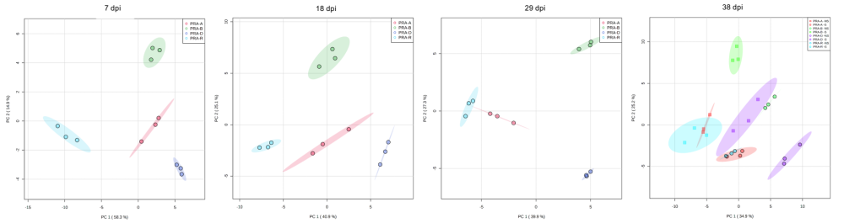

Additional file 22: Figure S9. Principal component analysis (PCA) of terpene contents over time.
Note how the first component (PC1) separates the resistant genotype PRA-R from the susceptible genotypes PRA-A, PRA-B and PRA-D at 7 dpi, and how PRA-A becomes more similar to PRA-R with time.

