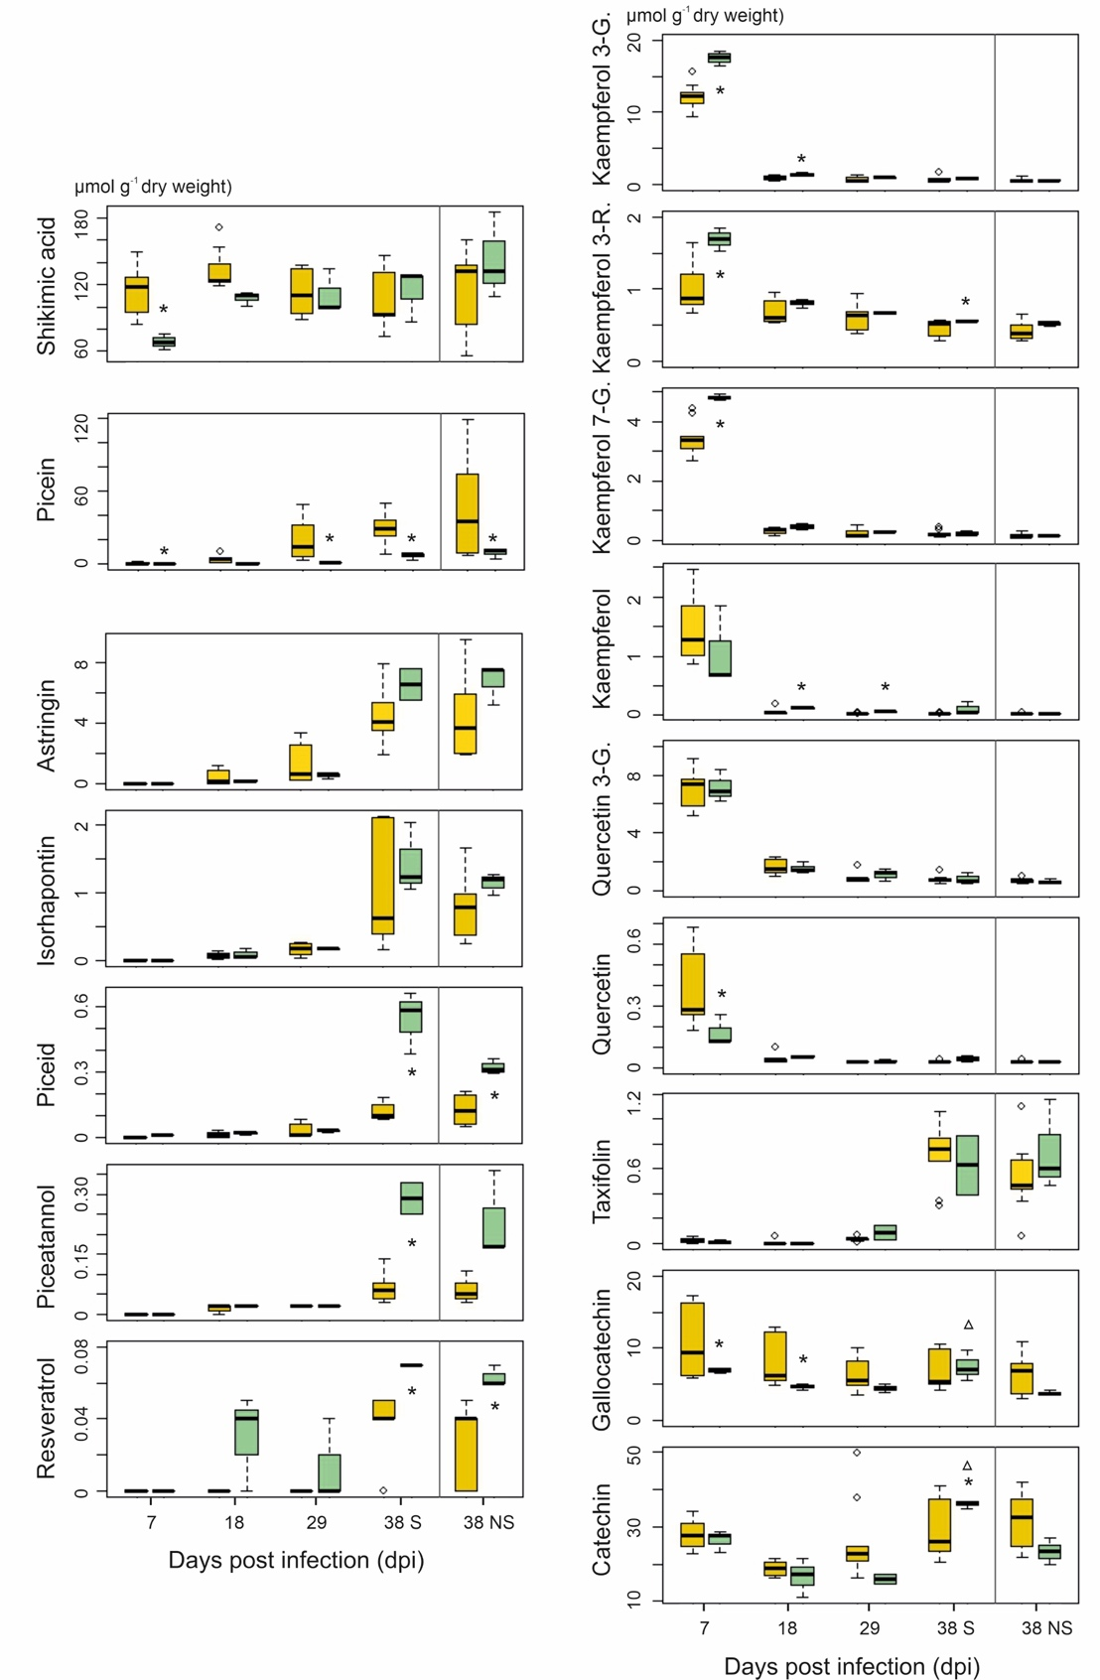

Additional file 24: Figure S11. Content levels of all individual phenolic compounds.
Phenolic compound contents between 7 and 38 dpi in needles of susceptible genotypes (pooled data of PRA-A/B/D; yellow boxes) and the resistant genotype PRA-R (green boxes). For 38 dpi, results for both symptomatic (S) and non-symptomatic (NS) needles are shown. Three branches per tree were analysed; significantly different contents in PRA-R compared to susceptible genotypes are marked with asterisks and in 38 dpi S compared to NS needles with a triangle.

