Comparative Analysis of the Daily Liver Transcriptomes in Wild Nocturnal Bats

Yujia Chu¹, Jingjing Li¹, Lei Feng², Guoting Zhang¹, Hui Wu¹, Tinglei Jiang², Hui Wang¹* and Jiang Feng^{1, 2}*
¹ College of Life Science, Jilin Agricultural University, Changchun 130118, China
² Jilin Provincial Key Laboratory of Animal Resource Conservation and Utilization, Northeast Normal University, Changchun 130117, China

* Correspondence:
Jiang Feng
fengj@nenu.edu.cn
Hui Wang
wangh681@nenu.edu.cn

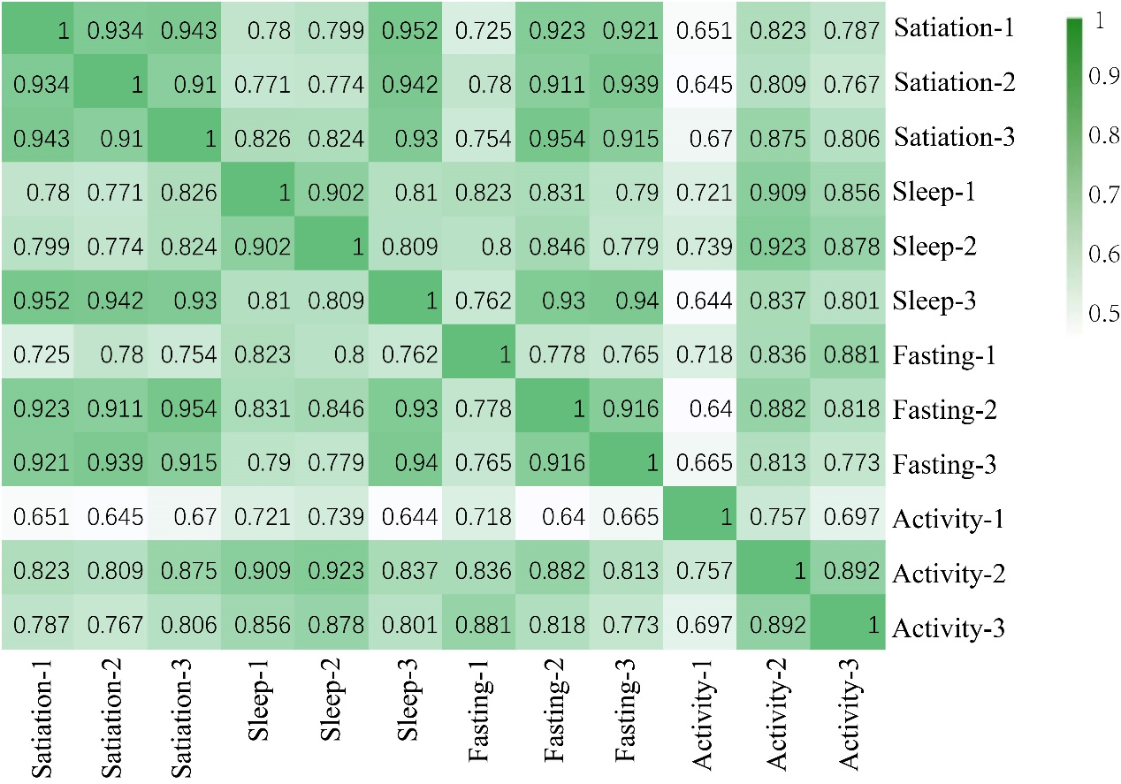
Figure S1. Correlation analysis between each pair of replicates for four states.

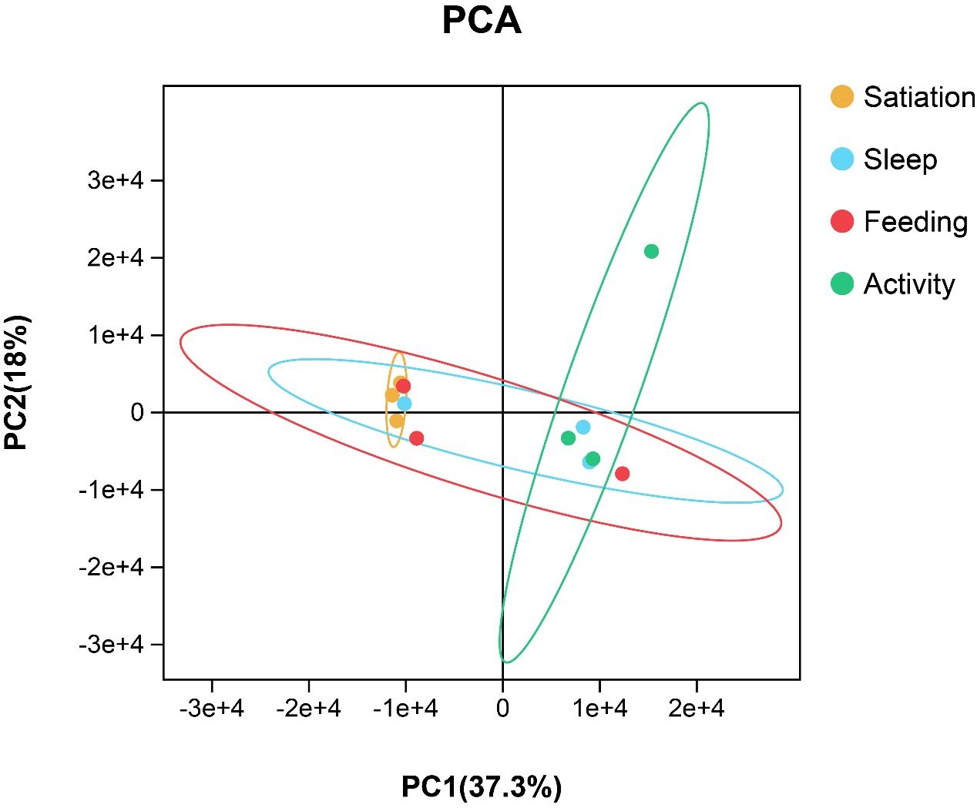
Figure S2. Principal component analysis (PCA) of the transcriptome of four states.

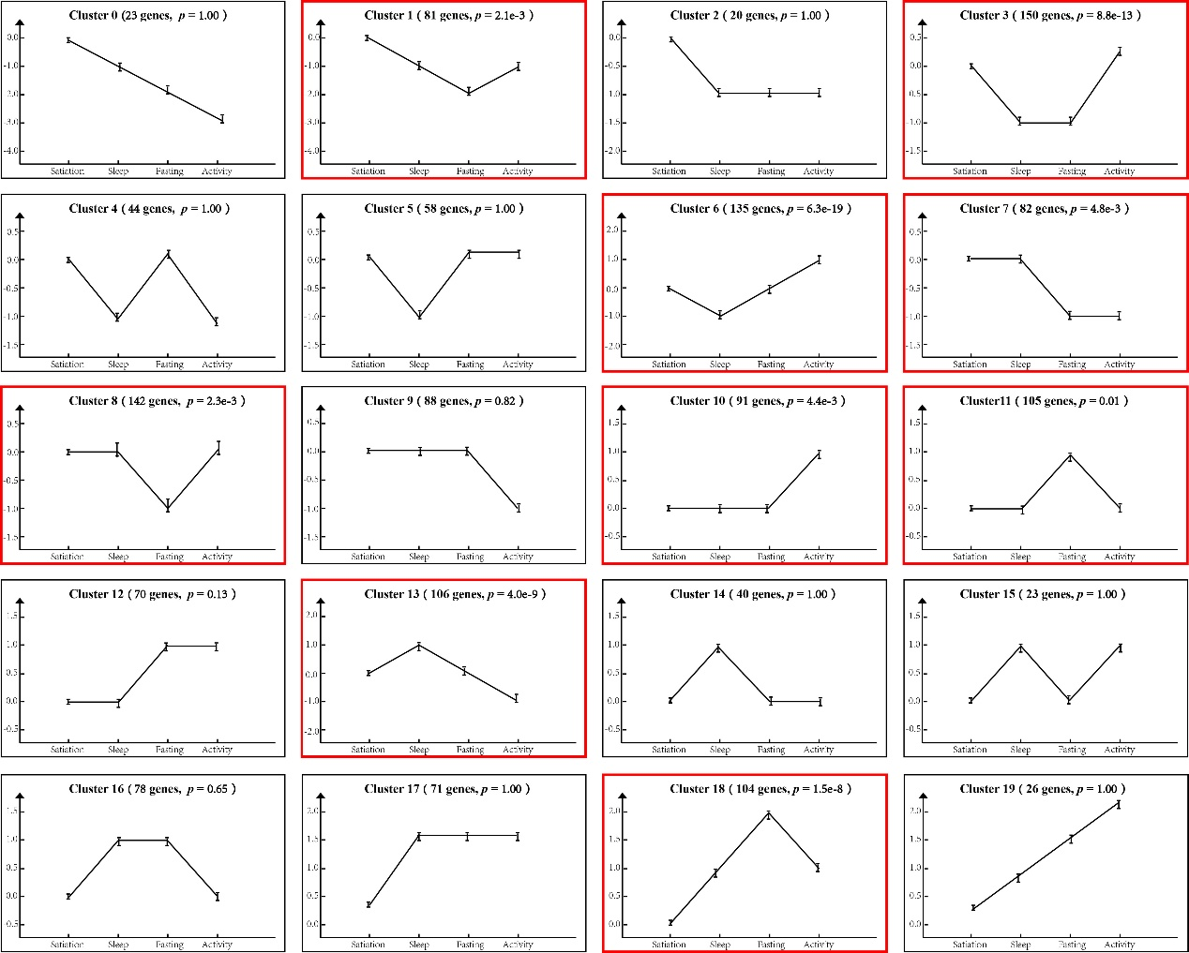
Figure S3. Differential gene cluster expression trend line chart.

