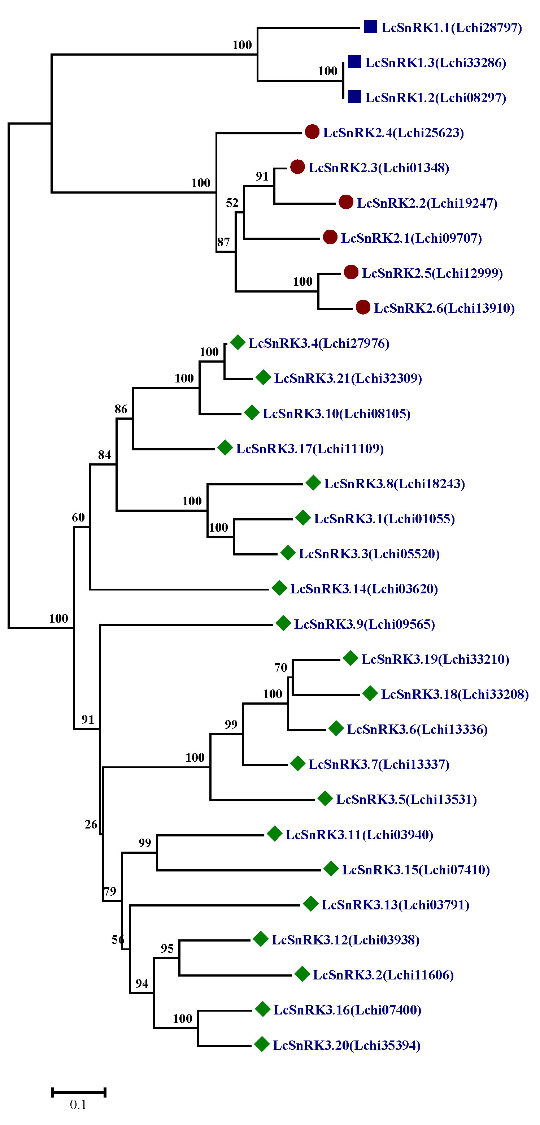
Figure S1. LcSnRK phylogenetic tree. The scale of the length of each branch is labeled at the bottom of the graph, and the bootstrap value of each branch is labeled at the node position.

