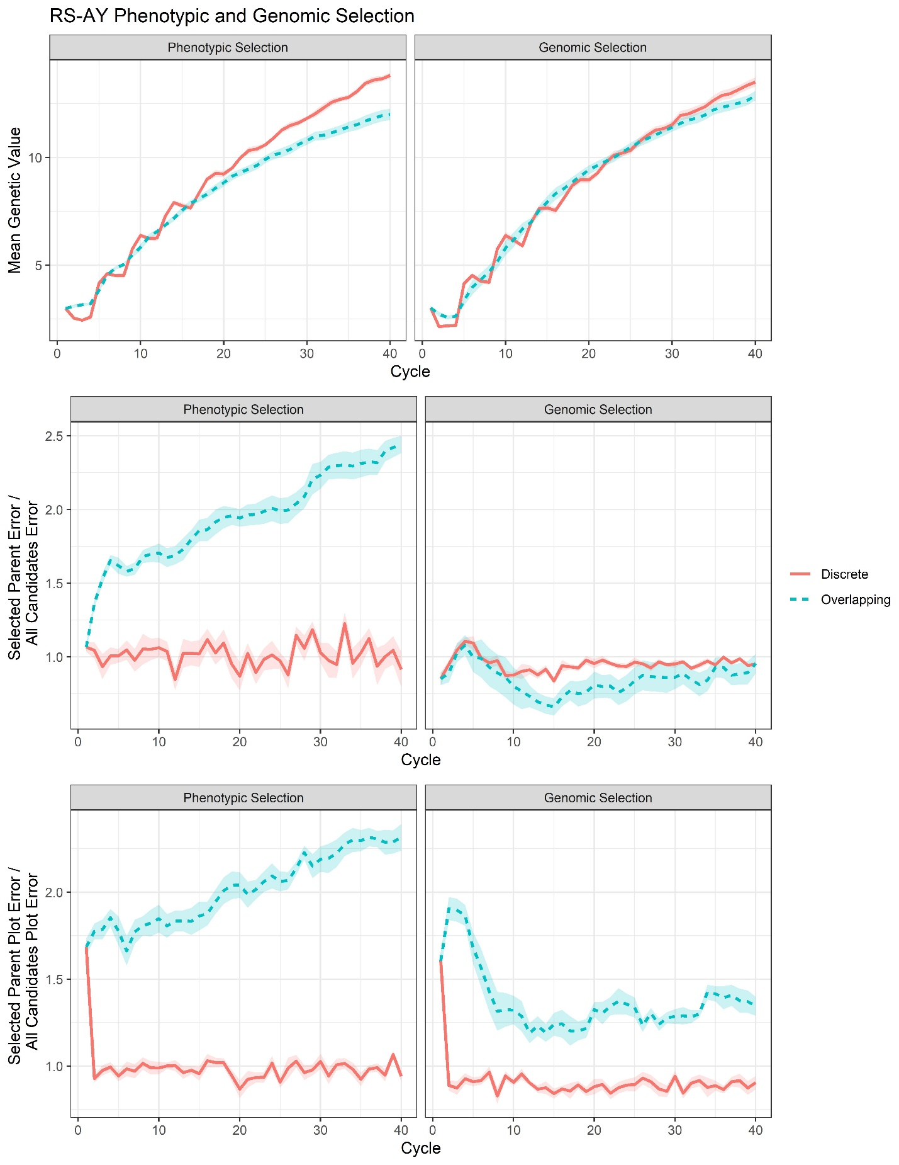

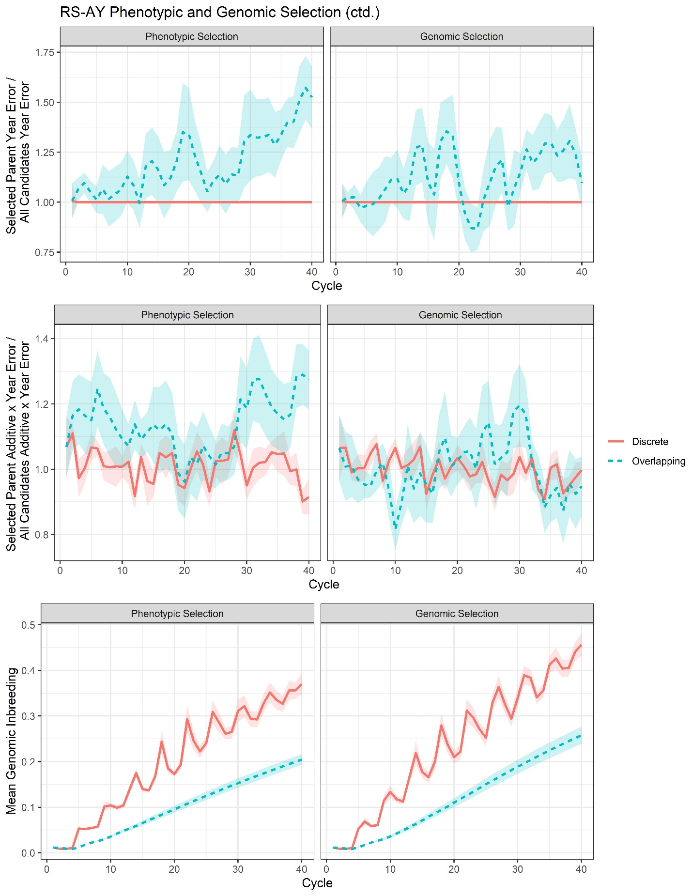

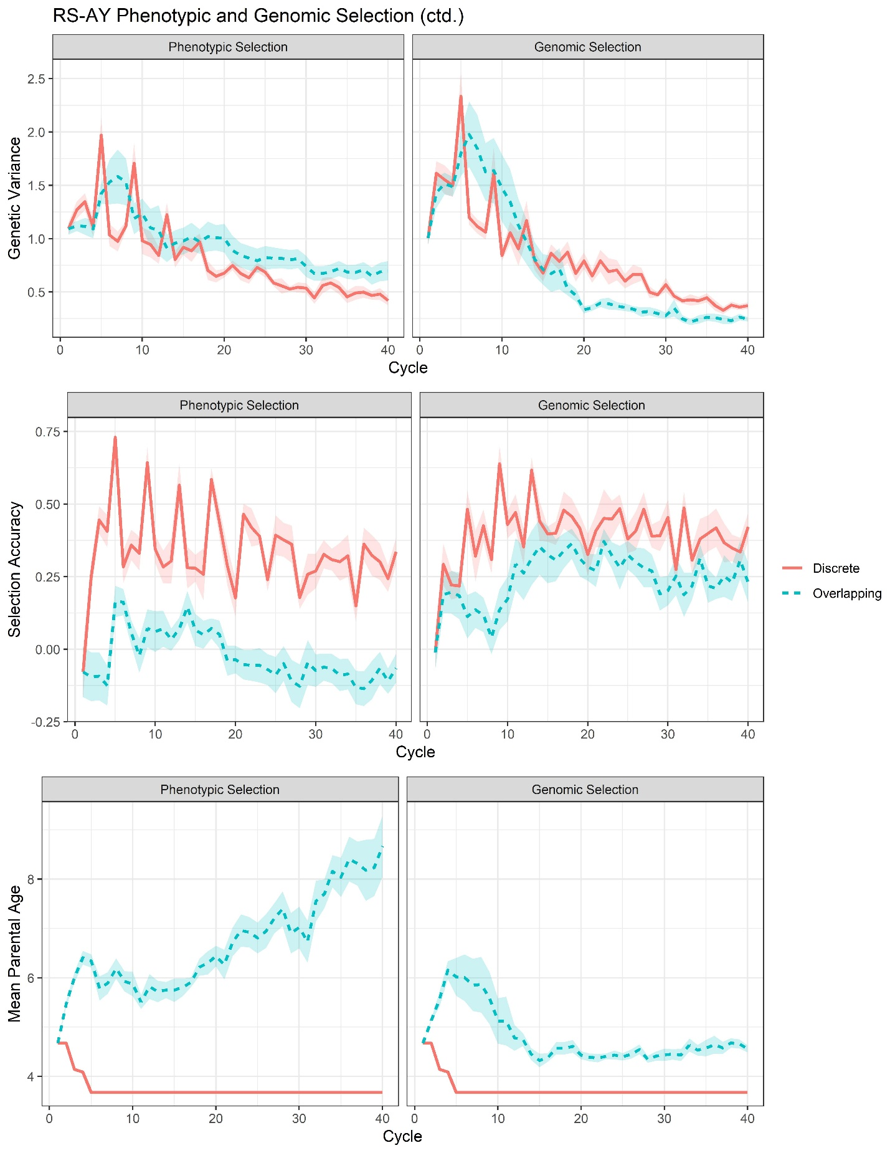
Supplemental File 26, Figure S14. Plots of all responses recorded for the RS-AY scenarios, including both phenotypic and genomic selection.

