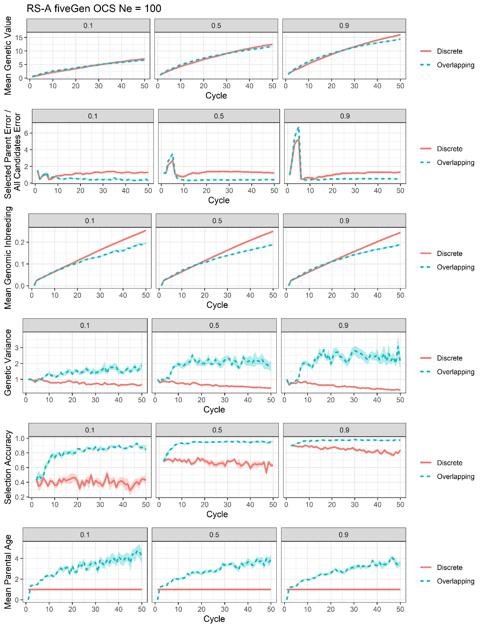
Supplemental File 25, Figure S13. Plots of all responses recorded for the RS-A genomic optimum contribution selection with training on the previous five generations scenario at Ne = 100 (fiveGen OCS Ne = 100).

