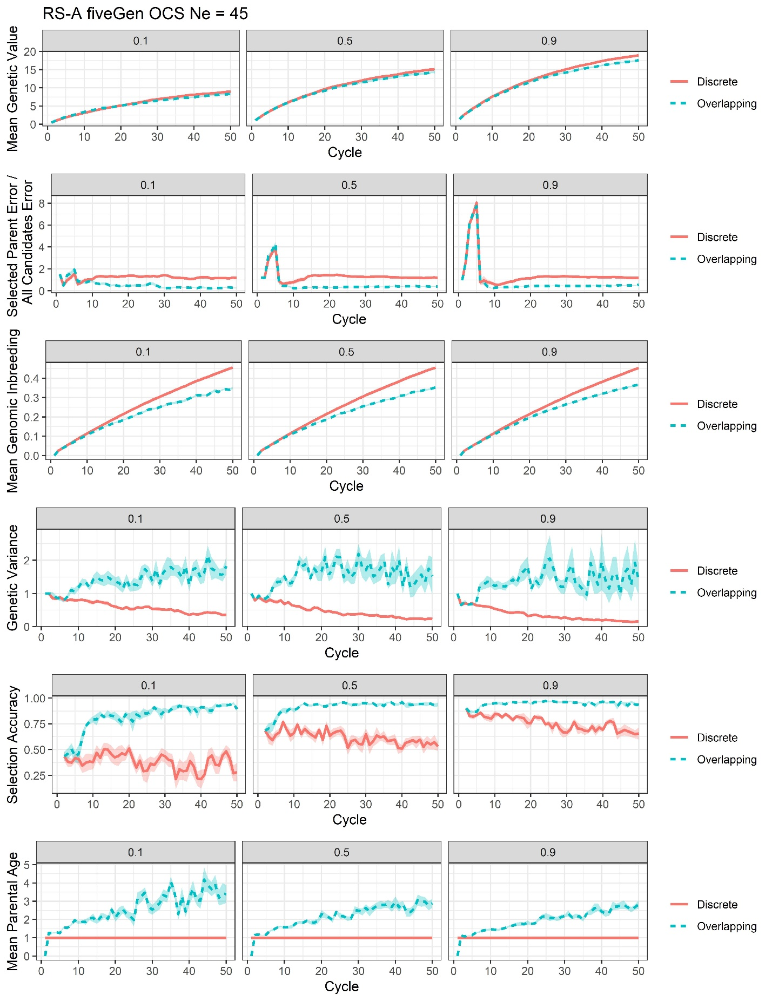
Supplementary File 24, Figure S12. Plots of all responses recorded for the RS-A genomic optimum contribution selection with training on the previous five generations scenario at Ne = 45 (fiveGen OCS Ne = 45).

