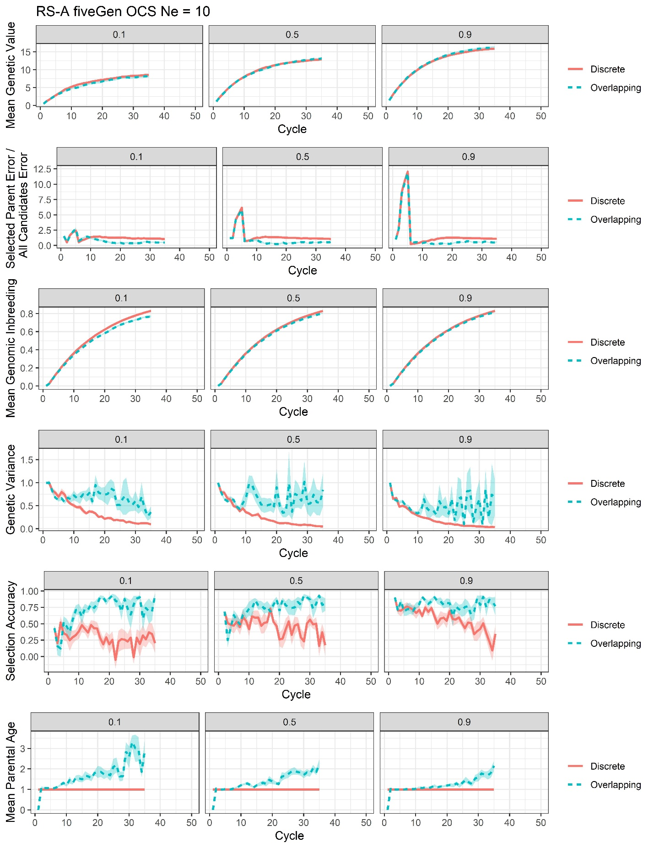
Supplementary File 23, Figure S11. Plots of all responses recorded for the RS-A genomic optimum contribution selection with training on the previous five generations scenario at Ne = 10 (fiveGen OCS Ne = 10).

