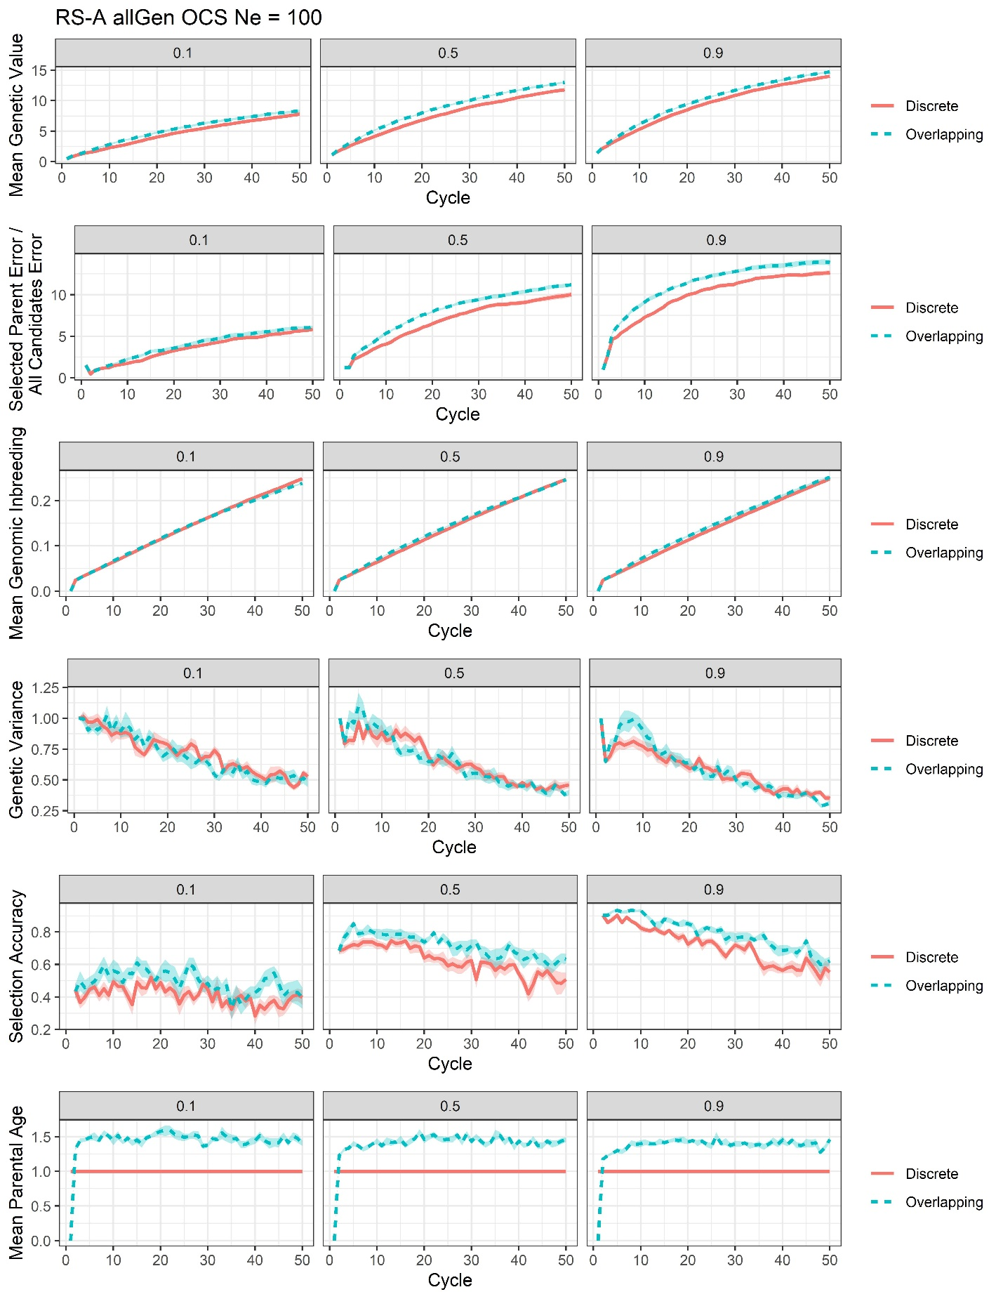
Supplementary File 22, Figure S10. Plots of all responses recorded for the RS-A genomic optimum contribution selection with training on all previous generations scenario at Ne = 100 (allGen OCS Ne = 100).

