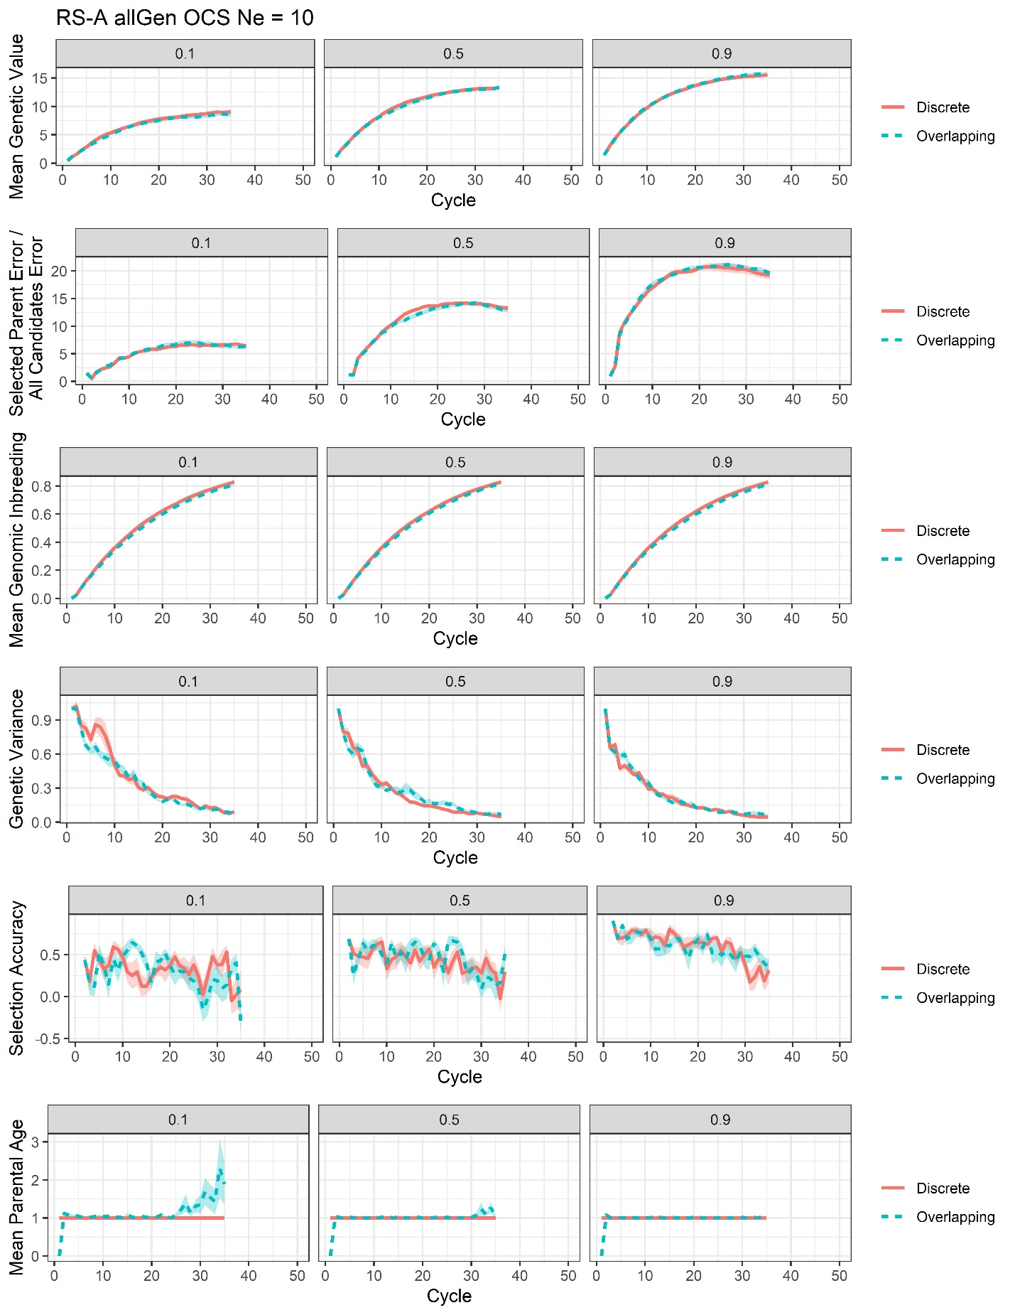
Supplementary File 20, Figure S8. Plots of all responses recorded for the RS-A genomic optimum contribution selection with training on all previous generations scenario at Ne = 10 (allGen OCS Ne = 10)

