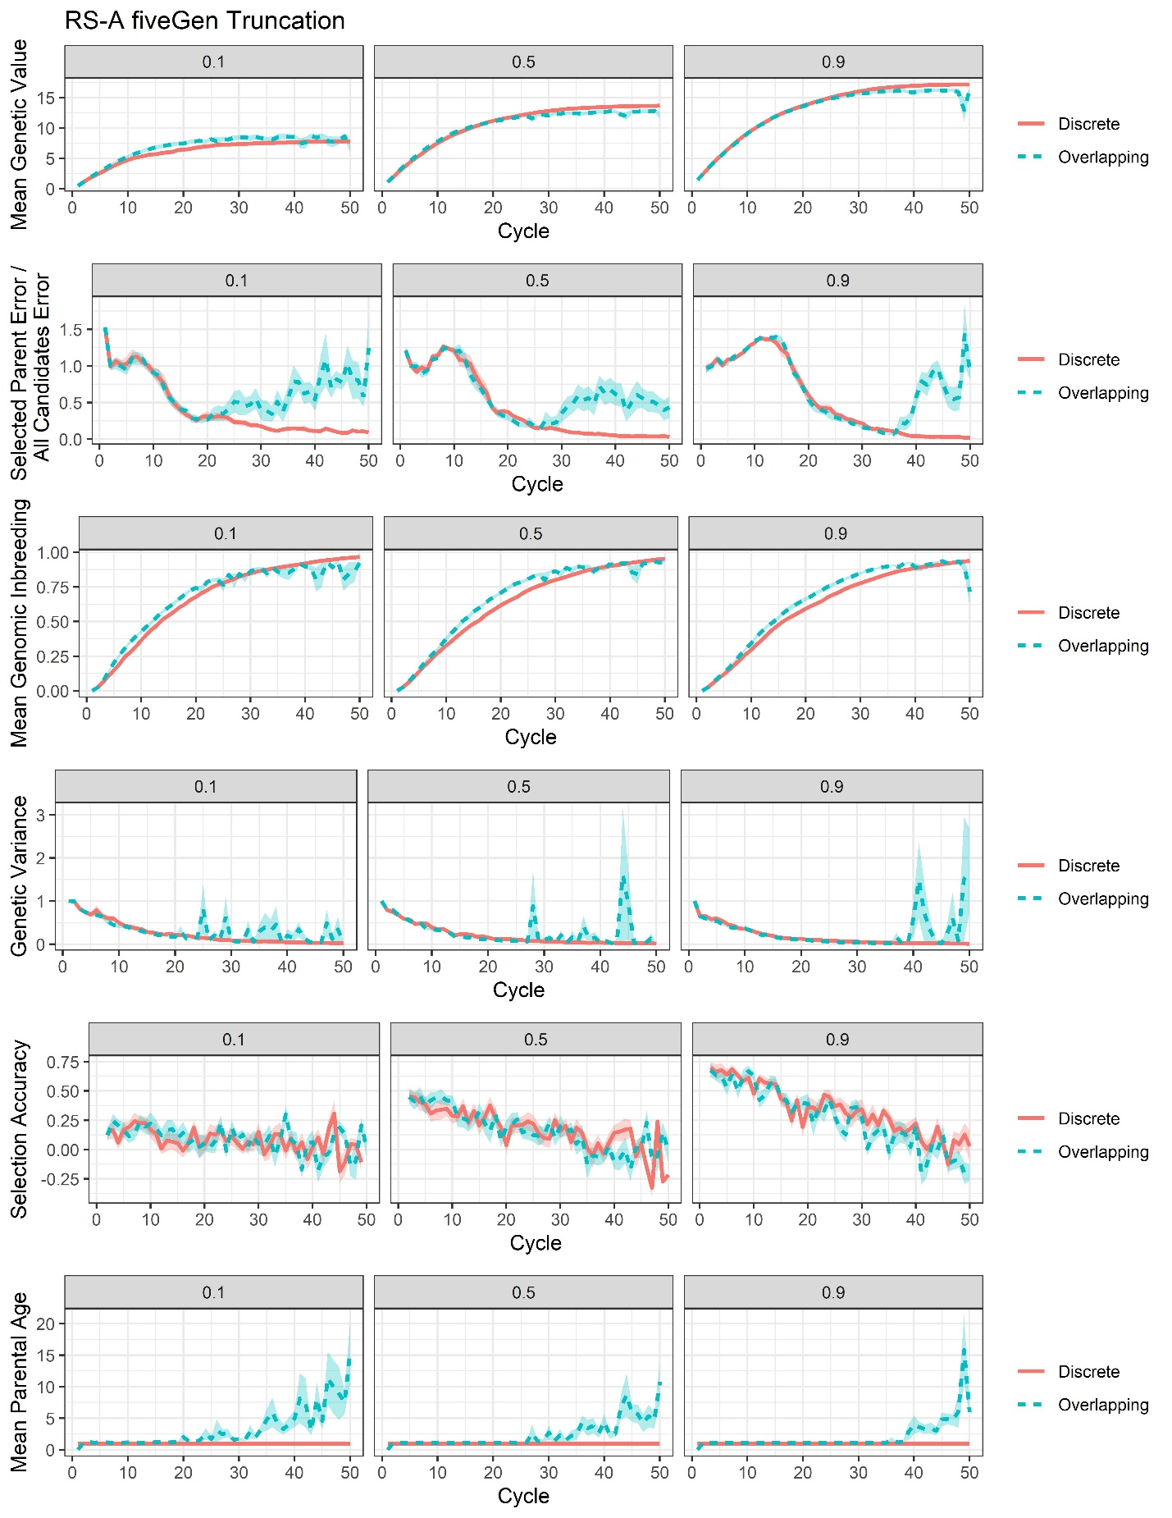
Supplemental File 19, Figure S7. Plots of all responses recorded for the RS-A genomic truncation selection with training on the previous five generations scenario (fiveGen Trunc).

