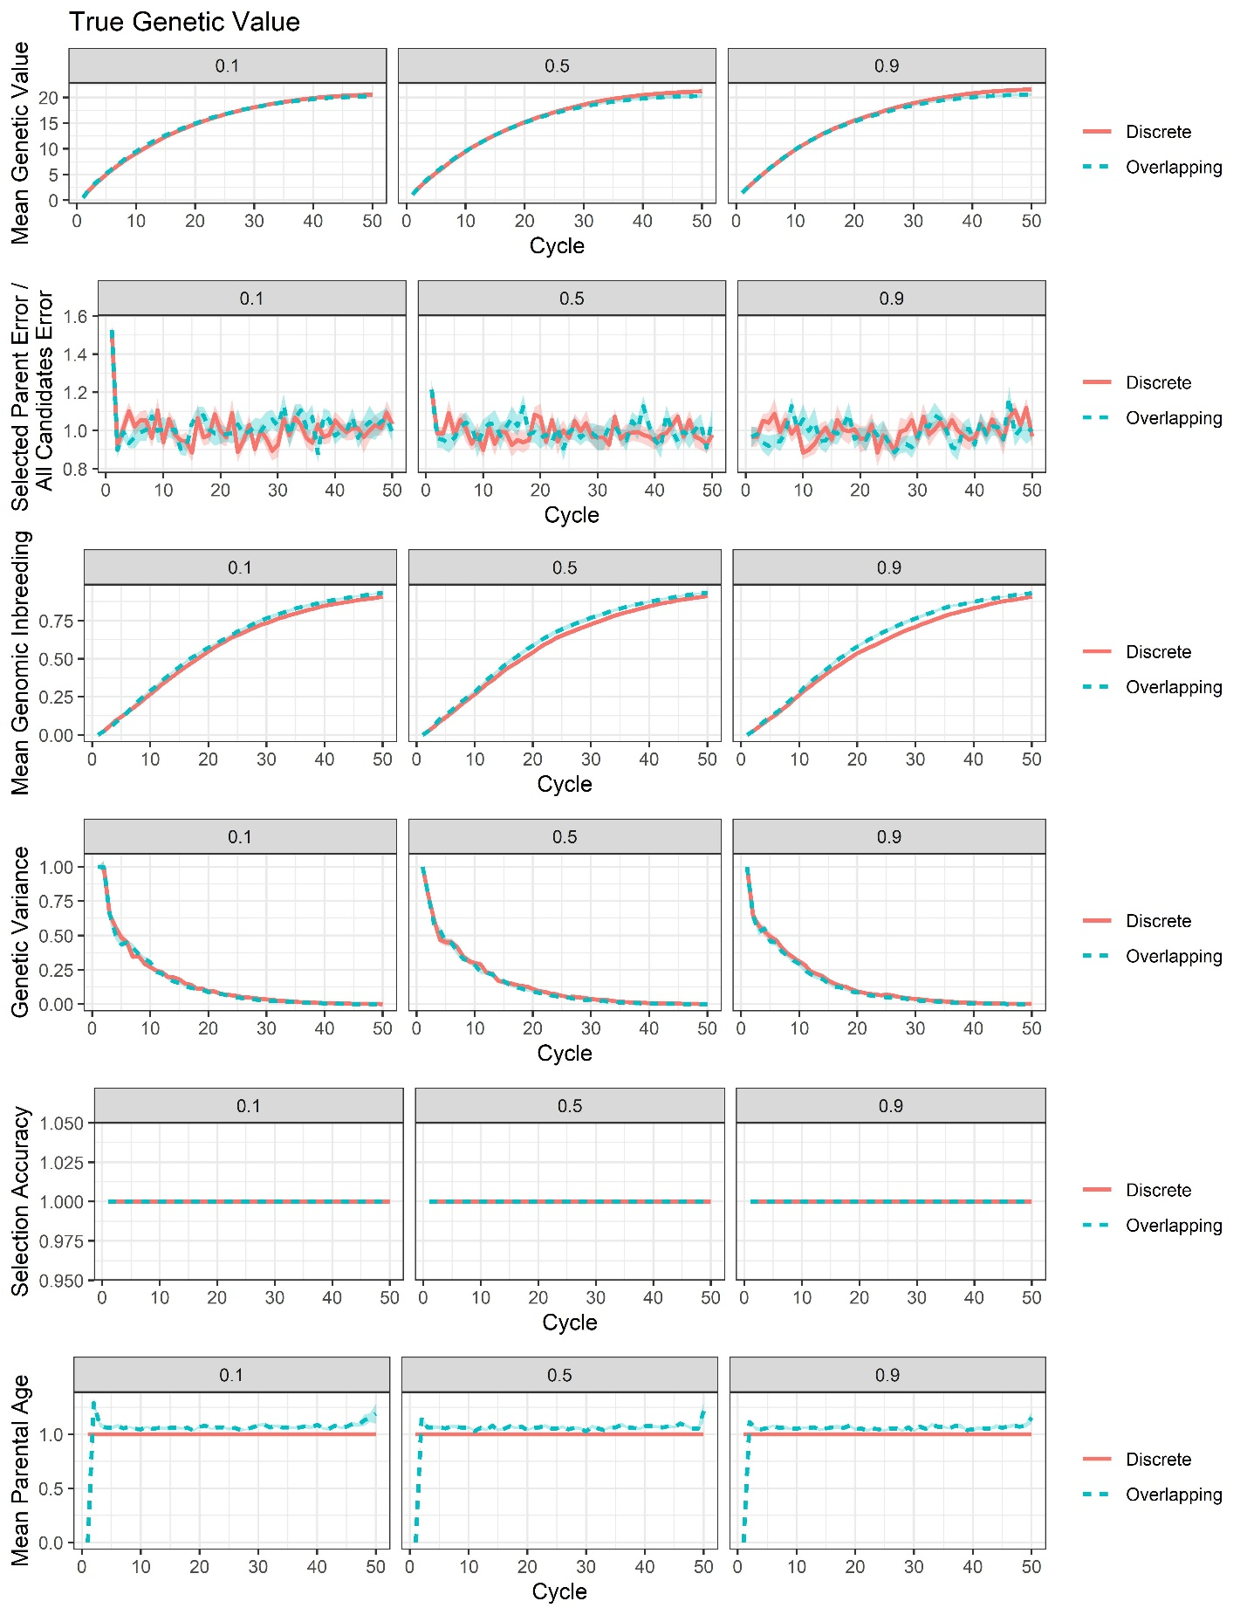
Supplemental File 17, Figure S5. Plots of all responses recorded for the RS-A true breeding value selection scenario.

