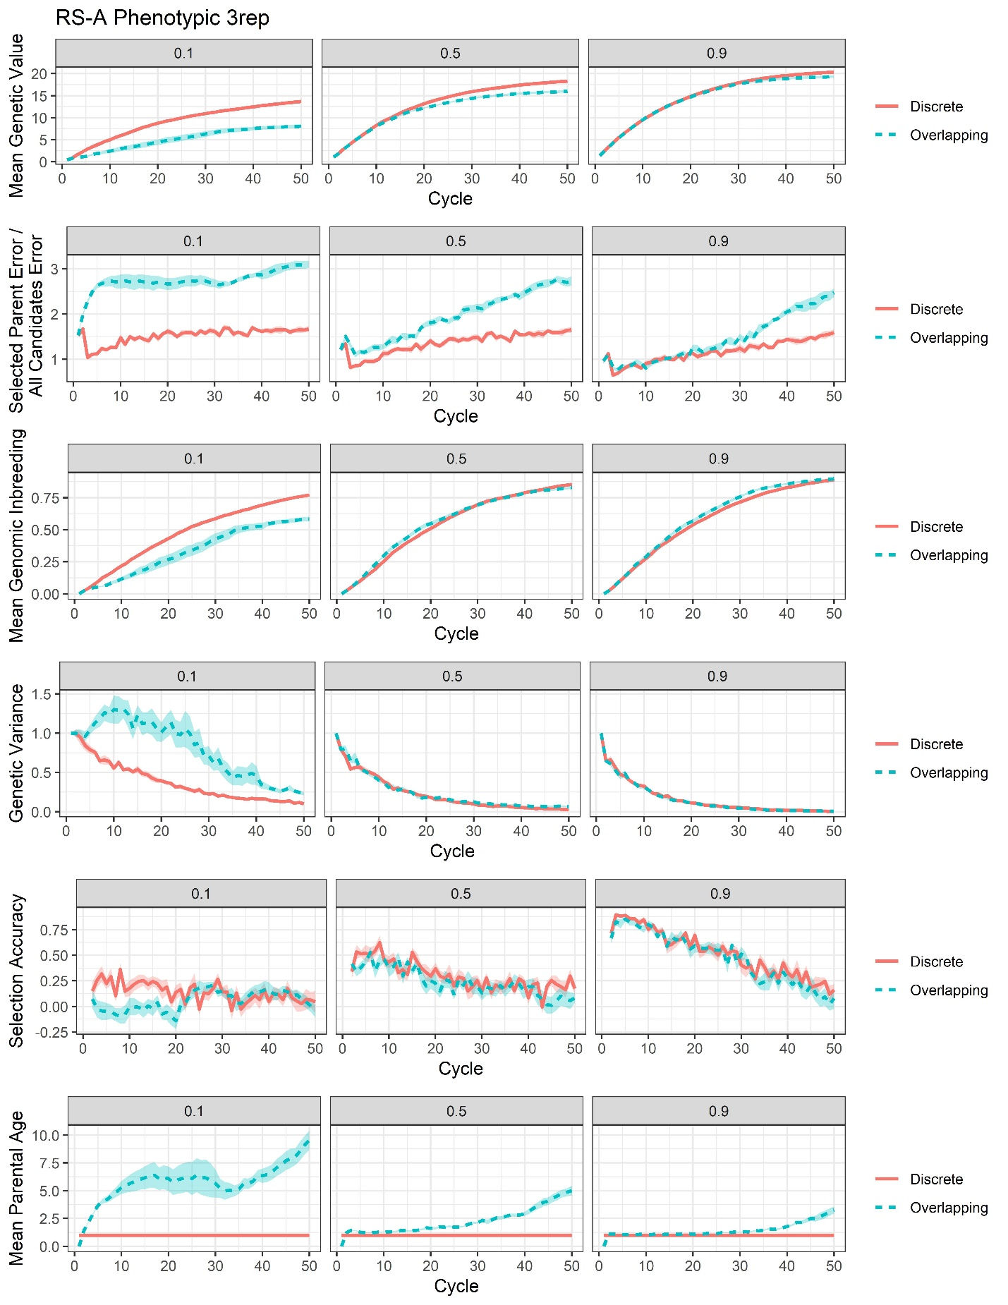
Supplementary File 16, Figure S4. Plots of all responses recorded for the RS-A phenotypic 3rep selection scenario.

