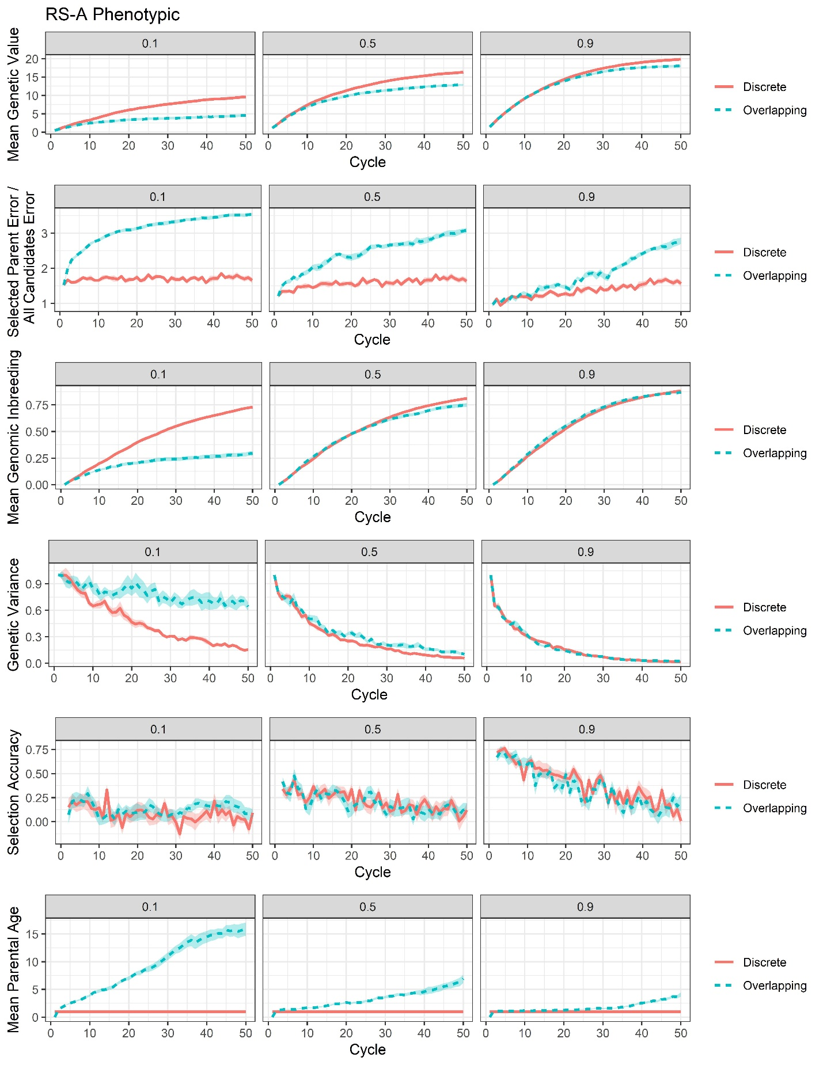
Supplementary File 15, Figure S3. Plots of all responses recorded for the RS-A phenotypic selection scenario.

