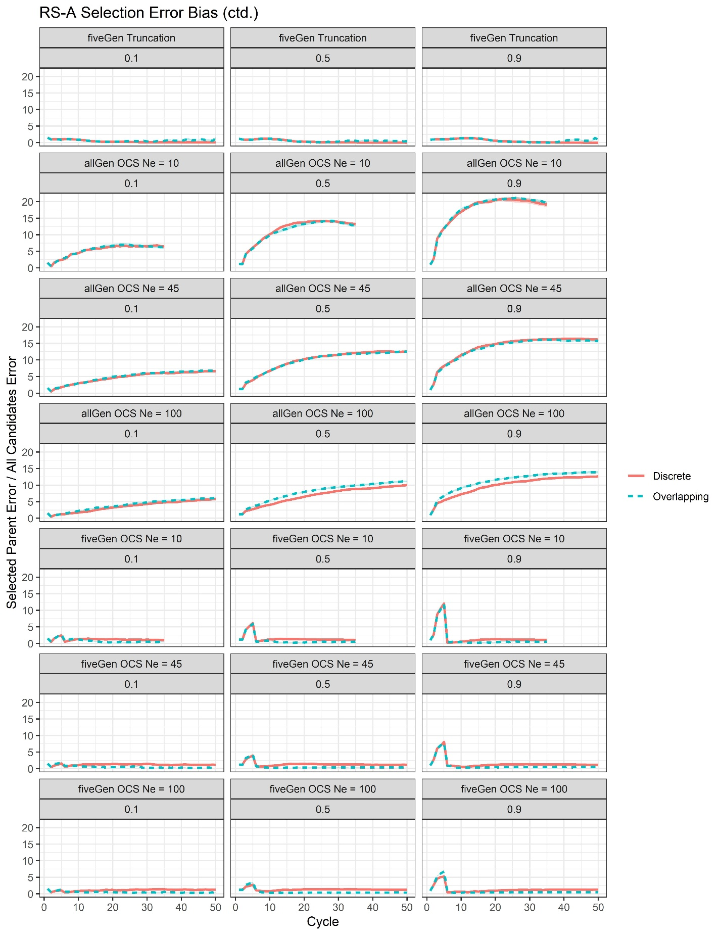
Supplementary File 14, Figure S2. Plots of selection error bias by cycle surrounded by 95% confidence intervals for the RS-A scenarios with genomic truncation selection and training on the previous five generations (fiveGen Trunc) as well as all RS-A OCS scenarios.

