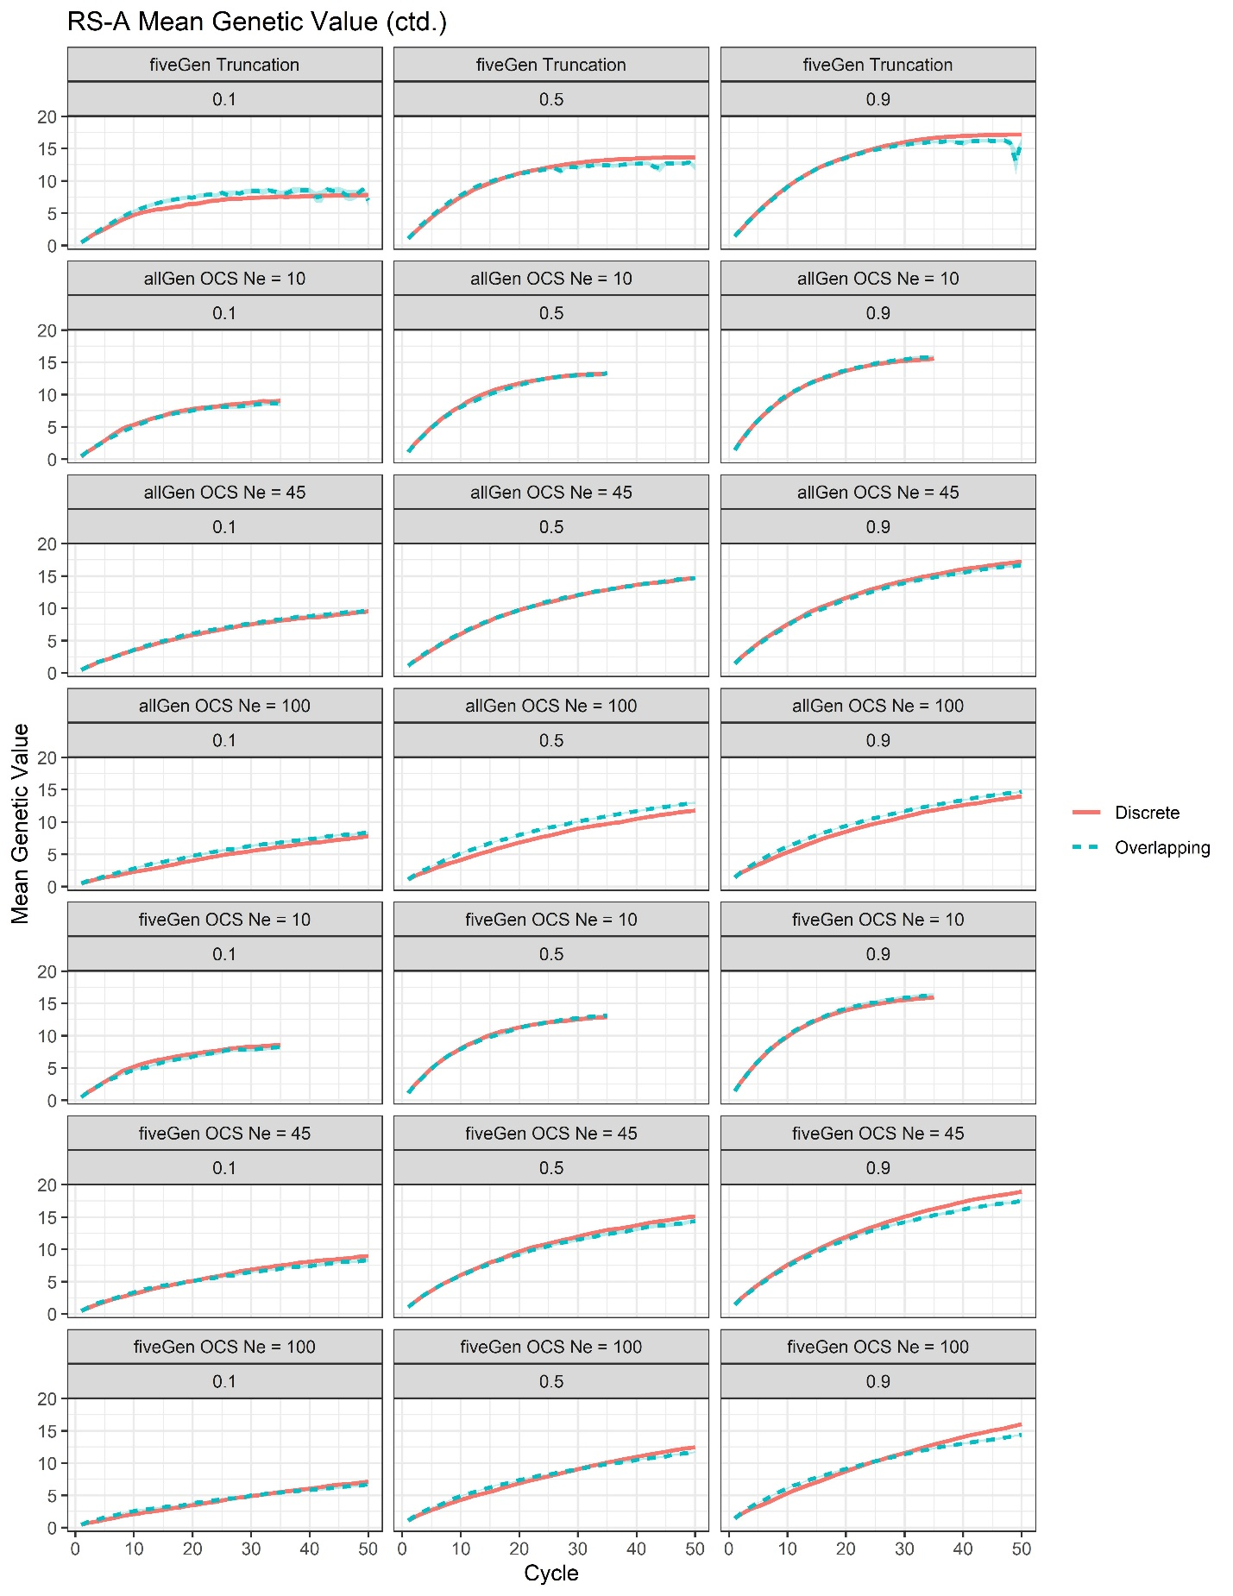
Supplemental File 13, Figure S1. Plots of mean genetic value by cycle surrounded by 95% confidence intervals for the RS-A scenarios with genomic truncation selection and training on the previous five generations (fiveGen Trunc) as well as all RS-A OCS scenarios.

