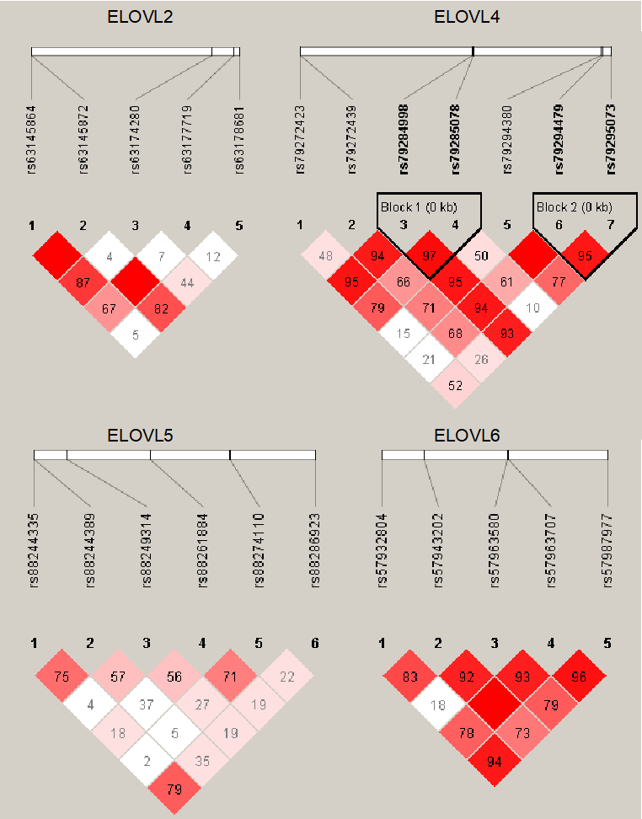
Figure S1. Linkage disequilibrium analysis (LD) of SNPs in ELOVL genes in Gushi × Anka F2 population. LD was carried out by Haploview. The pairwise LD coefficient were evaluated by the D’ value.

