Supplementary Figure S1 Analysis of the 31-nucleotide k-mer distribution among short paired-end reads from 0.5 kb Diabrotica virgifera virgifera genomic insert libraries (SRA accessions: SRR6985753 to SRR6985756). Distributions shown for A) linear and B) log plots. These provided minimum (min) and maximum (max) estimates for genome haploid (1N) length and proportions comprising unique and repeated sequences. Estimated mean heterozygosity and duplication level was 0.448% and 0.331%, respectively. Low coverage area <10 under the red curve indicative of sequence error.
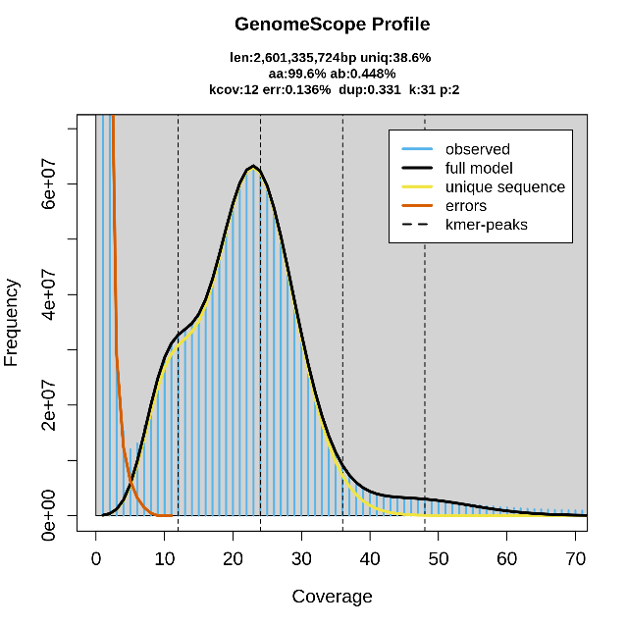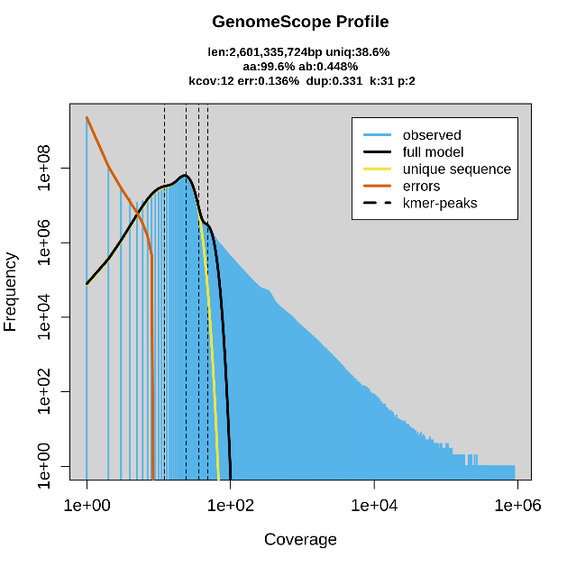
property | min | max
Homozygous (aa) | 99.5357% | 99.5686%
Heterozygous (ab) | 0.431413% | 0.46431%
Genome Haploid Length | 2,589,652,882 bp | 2,601,335,724 bp
Genome Repeat Length | 1,590,100,175 bp | 1,597,273,681 bp
Genome Unique Length | 999,552,707 bp | 1,004,062,043 bp
Model Fit | 43.1855% | 99.035%
Read Error Rate | 0.135869% | 0.135869%

