Figure Legends

Figure S1: Chart showing match probability and gene diversity for the 17 loci of the Sorani Kurds.
Figure S2: Variant alleles, duplications and deletions, at different loci in four different individuals.
Figure S3: Chart showing Y-haplogroup distribution in the Sorani Kurdish population.
Figure S4: Multidimensional scaling plots of fifteen different populations based on Rst values.
Supplementary figures

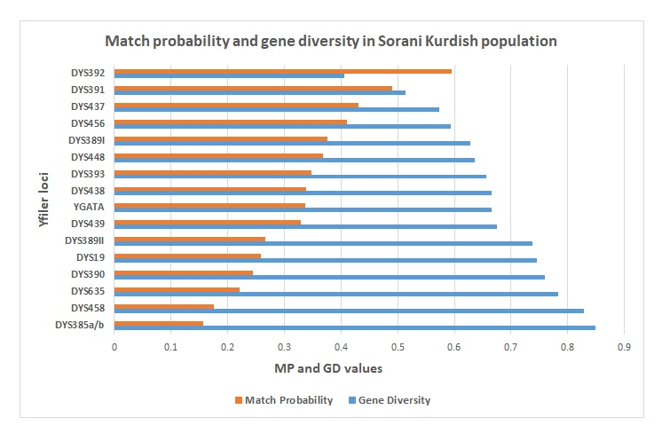
Figure 1
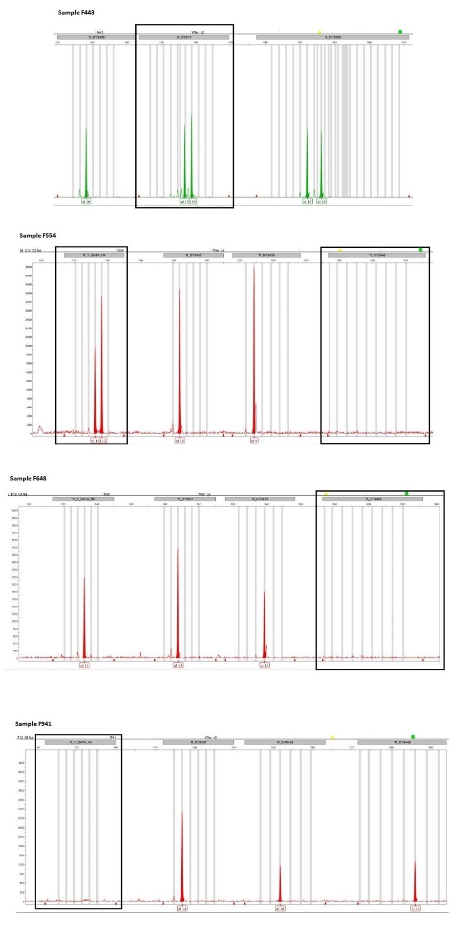
Figure 2
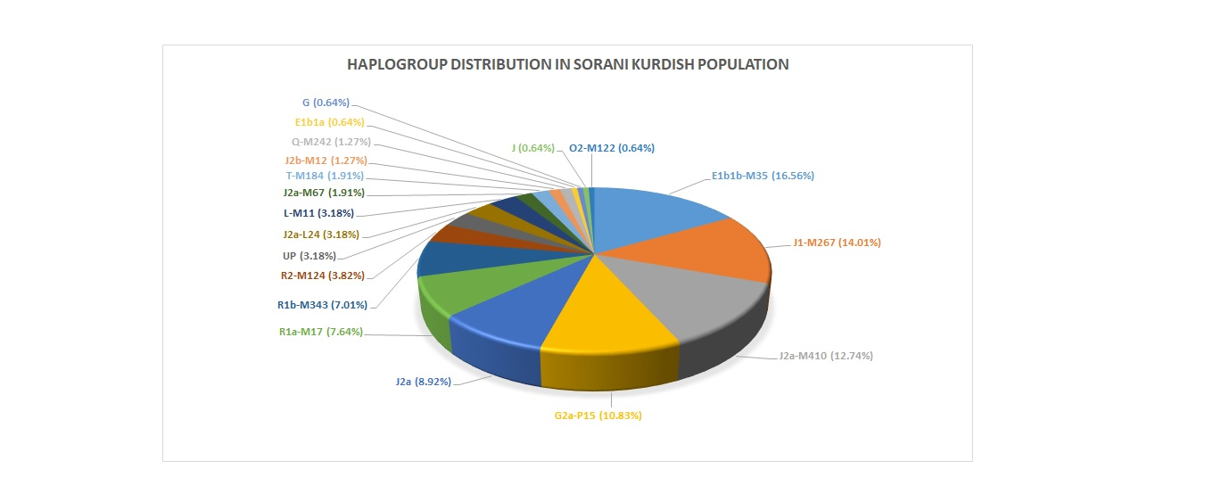
Figure 3
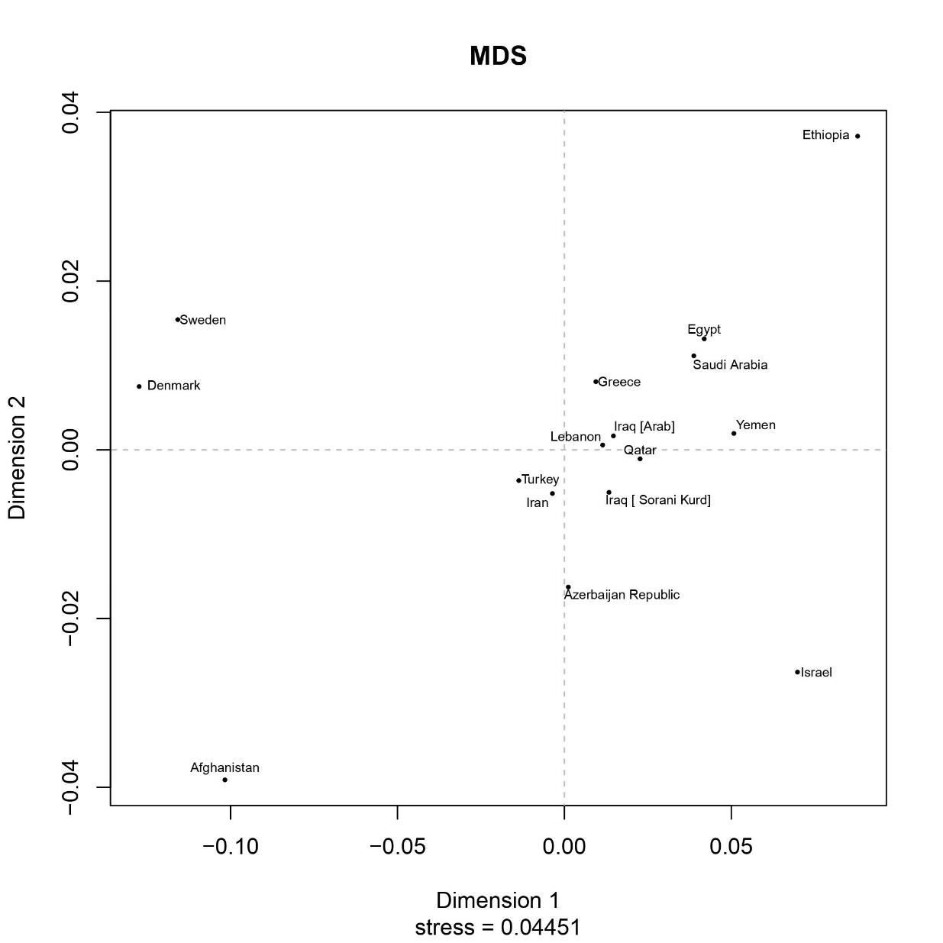
Figure 4

