Gut microbiota profiling variated during colorectal cancer development in mouse
Jingjing Liu, ^{1, 2, +} Wei Dong, ^{1, +} Jian Zhao ¹, Jing Wu ³, Jinqiang Xia², Shaofei Xie², Xiaofeng Song^{1, *}
¹ Department of Biomedical Engineering, Nanjing University of Aeronautics and Astronautics, Nanjing 210016, China
² The State Key Laboratory of Translational Medicine and Innovative Drug Development, Jiangsu Simcere pharmaceutical Co., Ltd., Nanjing 210016, China
³ School of Biomedical Engineering and Informatics, Nanjing Medical University, Nanjing, Jiangsu, 211166, China
Correspondence: xfsong@nuaa.edu.cn
⁺ The first 2 authors should be regarded as joint First Authors.

Table S1. Statistics of sequencing and α-diversity indexes of 16S rRNA. C: Group C, BC: Group BC.
Sample ID | Number of Reads | Observed OTUs | Chao1 Index | Shannon Index | Simpson Index
C1 | 18026 | 616.2 | 870.717 | 5.67 | 0.932
C2 | 24602 | 792.1 | 1148.002 | 6.225 | 0.958
C3 | 23776 | 762.3 | 1149.162 | 5.448 | 0.874
C4 | 18864 | 354.4 | 477.166 | 4.042 | 0.767
BC1 | 16254 | 699.0 | 911.379 | 5.86 | 0.914
BC2 | 28522 | 682.1 | 997.608 | 5.50 | 0.918
BC3 | 21147 | 815.9 | 1254.262 | 6.27 | 0.952
BC4 | 21531 | 478.8 | 681.862 | 5.08 | 0.886

Table S2. General information of mice.
Mouse ID | Gender | Age (week) | Strain | Body weight (g)
M1 | Male | 4 | C57BL/6 | 19.2
M2 | Male | 4 | C57BL/6 | 20.5
M3 | Male | 4 | C57BL/6 | 20.9
M4 | Male | 4 | C57BL/6 | 19.8
M5 | Male | 4 | C57BL/6 | 20.3
M6 | Male | 4 | C57BL/6 | 20.9
M7 | Male | 4 | C57BL/6 | 20.7
M8 | Male | 4 | C57BL/6 | 21.2
M9 | Male | 4 | C57BL/6 | 19.7
M10 | Male | 4 | C57BL/6 | 19.5
M11 | Male | 4 | C57BL/6 | 19.3
M12 | Male | 4 | C57BL/6 | 19.4

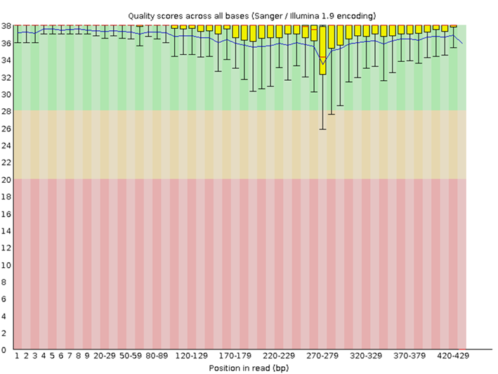
Figure S1. Distribution of quality scores at each position in the read across all reads.
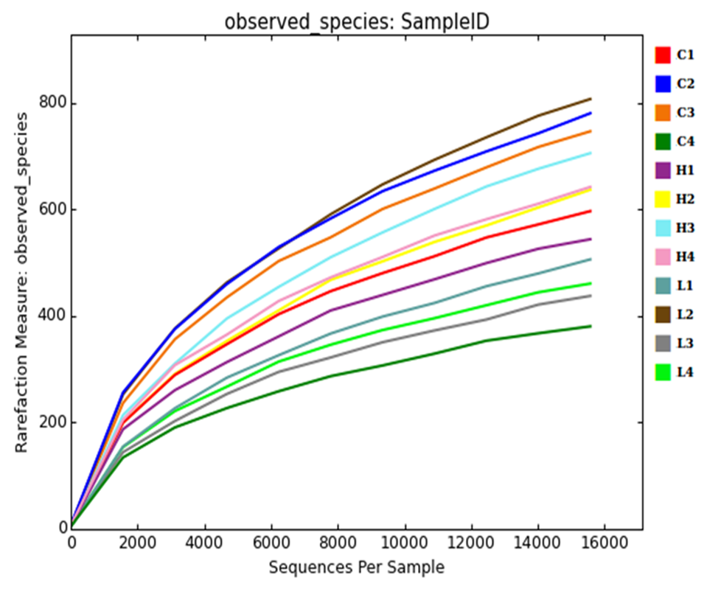
Figure S2. Rarefaction curve for each sample from group C, L and H based on the sequences of 16S rRNA genes.

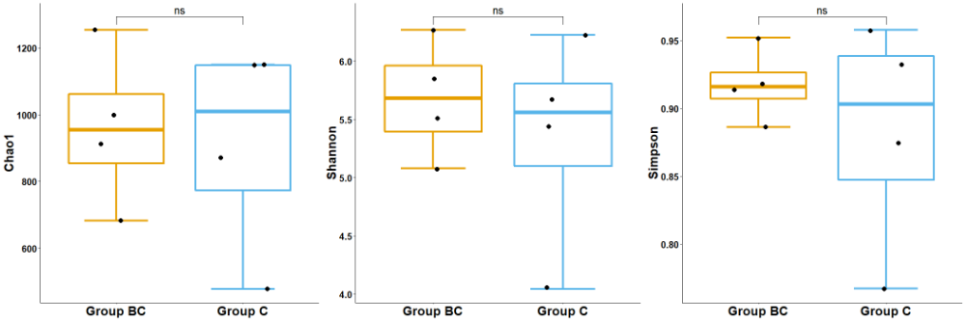
Figure S3. Microbial α diversity in feces samples of Group C and Group BC. (A) Boxplots of Chao1 Richness Index. (B) Boxplots of Shannon Diversity Index. (C) Boxplots of Simpson Diversity Index. ns: p > 0.05,no significant difference.

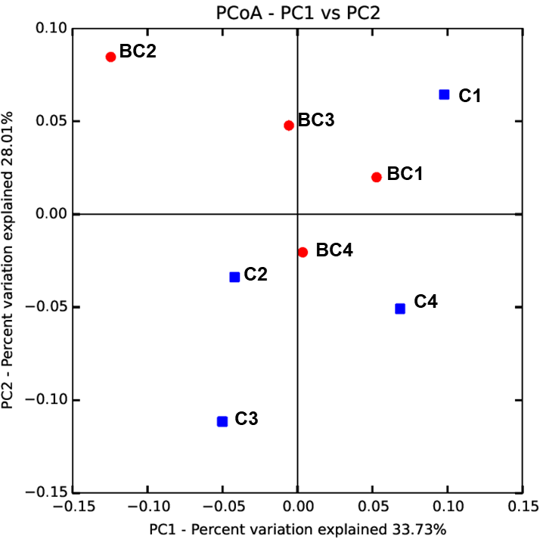
Figure S4. Microbial β diversity in feces samples of Group C and Group BC. PCoA plot of Group C and Group BC, there was no significant change in gut microbiota during mice growth.

