PCR amplification of S. frugiperda partial gene segments
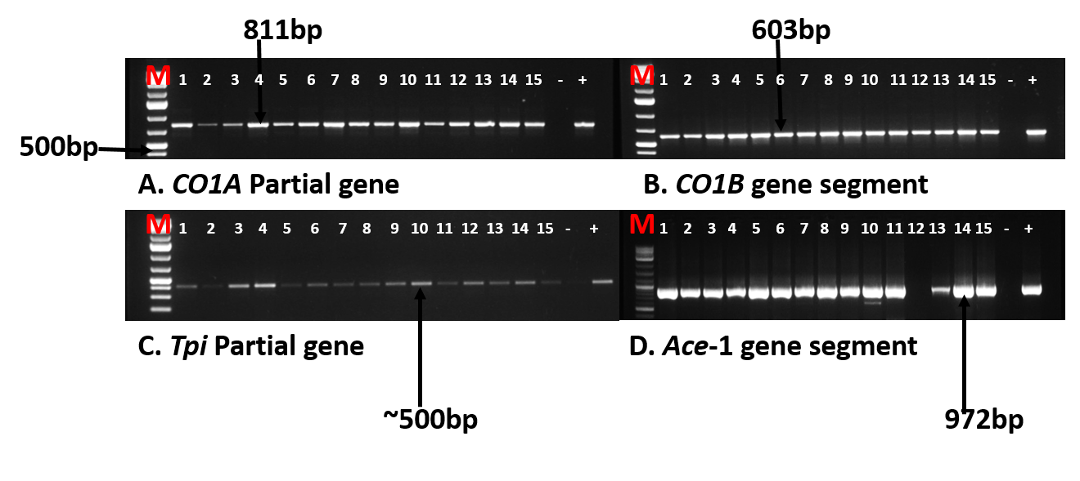
Supplementary figure 1. Amplification of Spodoptera frugiperda cytochrome oxidase 1 subunits, Triosephosphate isomerease and acetylcholinesterase partial gene segments. (A and B)-mitochondrial Cytochrome oxidase 1A and B respectively. (C)- Triosephosphate isomerase sex-linked nuclear gene, and (D) - the Ace-1 gene segment. M = 1kb+ DNA ladder, (-) = Negative control, (+) = Positive control and 1-15 are representative samples of Spodoptera frugiperda. A, B, C, and D partial gene segments were amplified using COI_101F/COI_911R; COI_891F/COI 1472R; Tpi_282F/Tpi 850R and ace_1F/ace_1R primer pairs, respectively. Cropped gel images were extracted from the full length original gels (1, 2, 3, and 4 for A, B, C and D respectively).

Uncropped full length original gels
- Mitochondrial Cytochrome oxidase 1A amplified with COI_101F/COI_911R primer pair
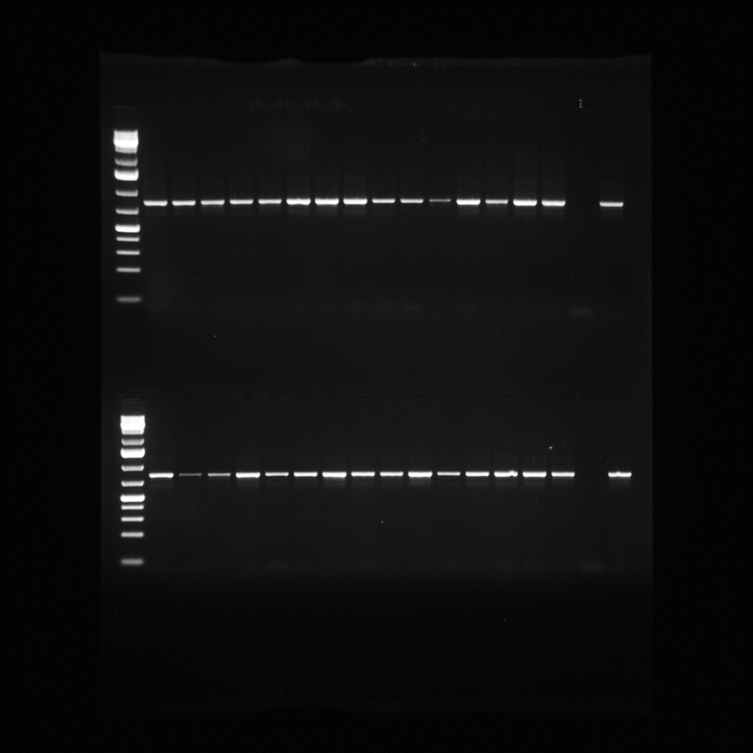
Uncropped Supplementary figure 1A: mitochondrial Cytochrome oxidase 1A of Spodoptera frugiperda. Expected band size=811bp

- Mitochondrial Cytochrome oxidase 1B amplified with COI_891F/COI 1472R primer pair
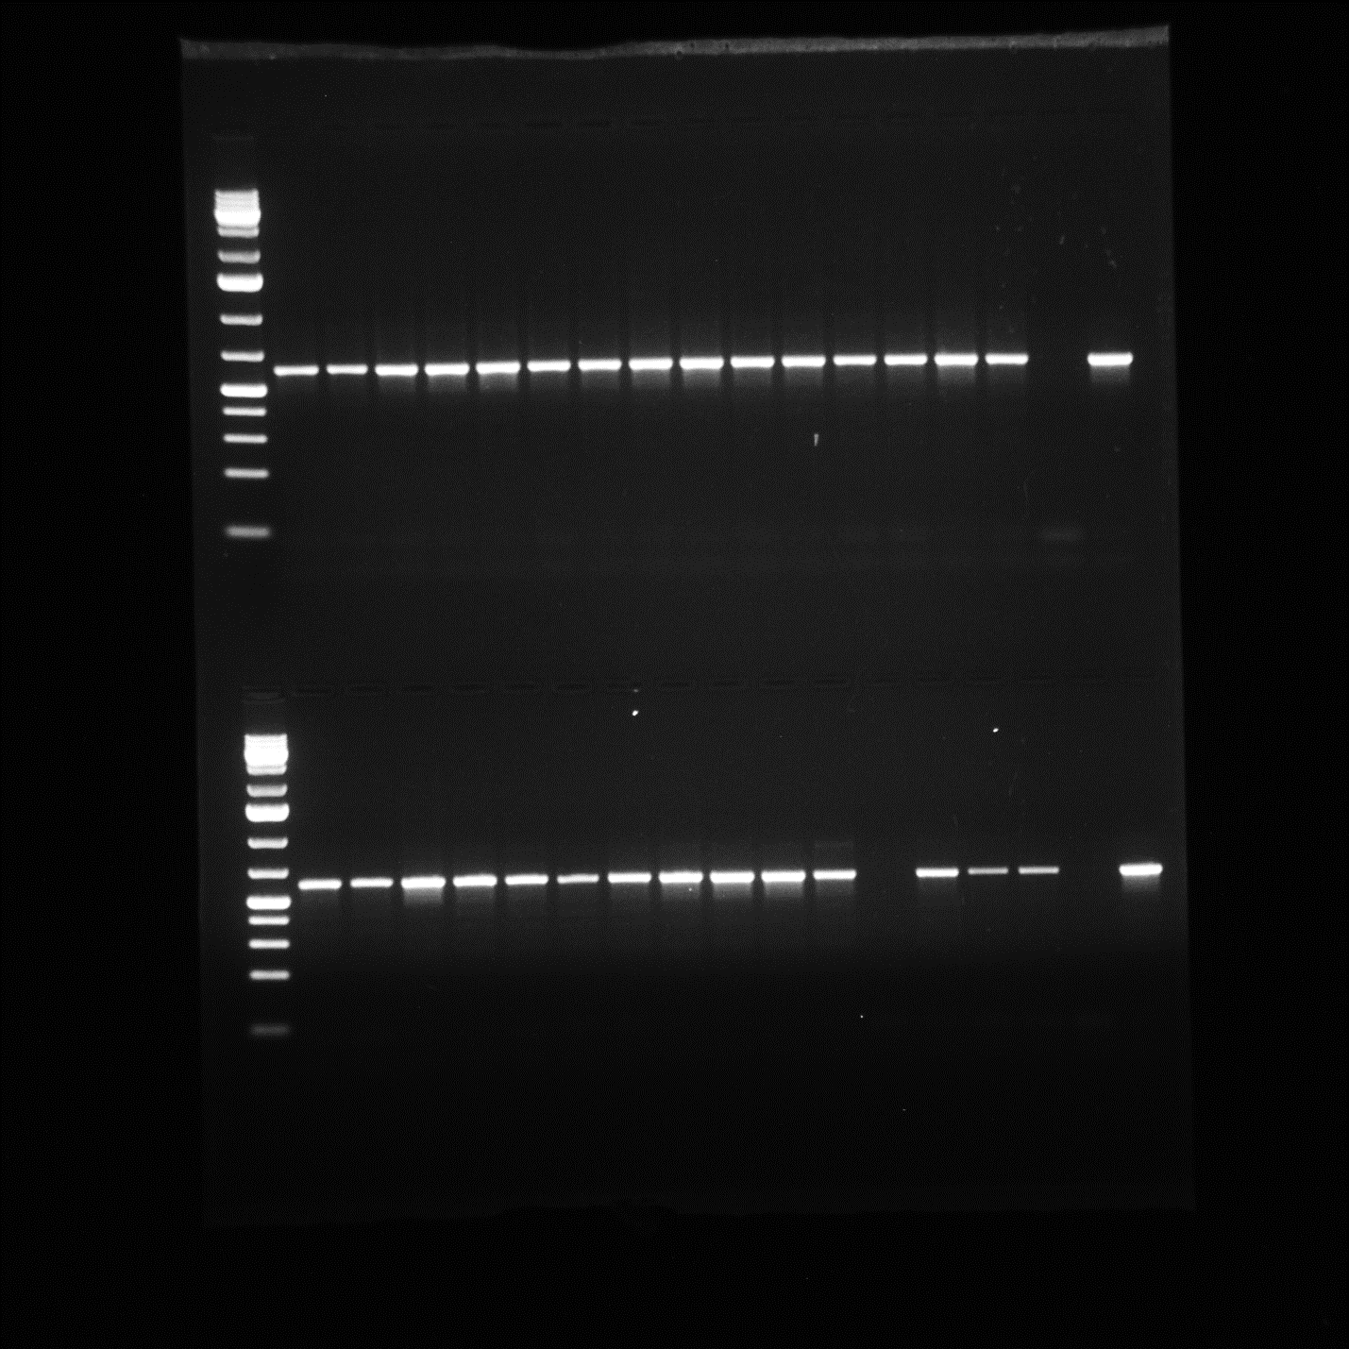
Uncropped Supplementary figure 1B: mitochondrial Cytochrome oxidase 1B of Spodoptera frugiperda. Expected band size=603bp

- Triosephosphate isomerase (Tpi) amplified with Tpi_282F/Tpi 850R primer pair
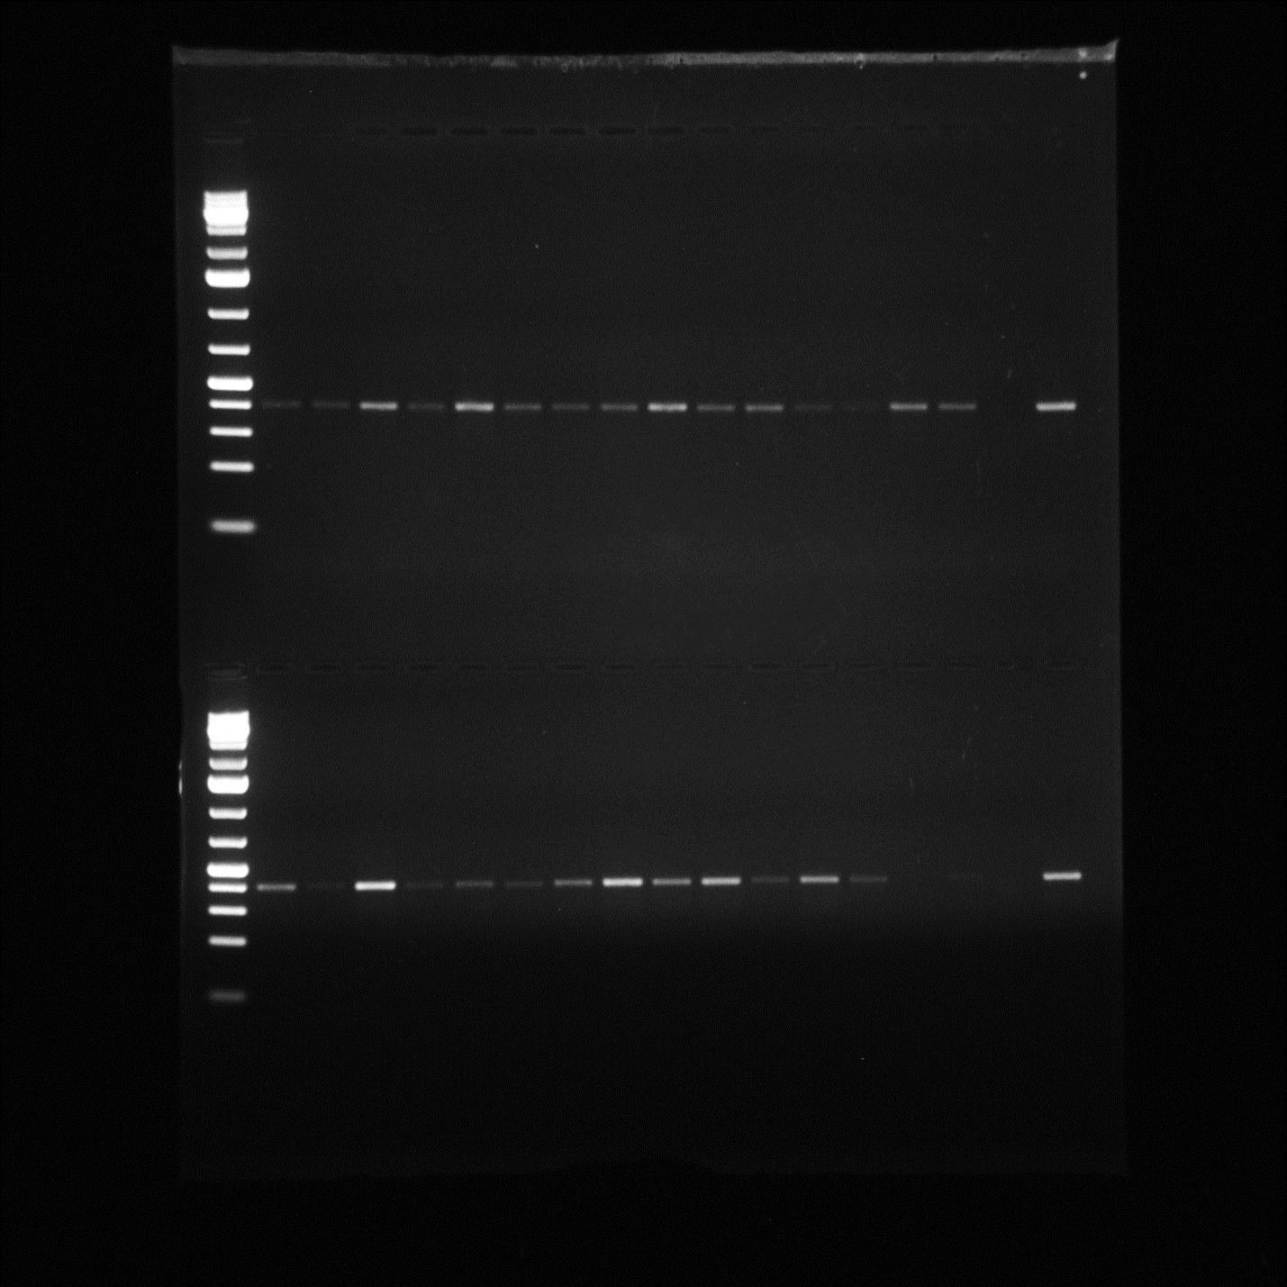
Uncropped Supplementary figure 1C: Triosephosphate isomerase (Tpi) sex-linked nuclear gene of Spodoptera frugiperda. Expected band size=~500bp.

- Acetylcholinesterase-1(Ace-1) partial gene amplified with ace_1F/ace_1R primer pair
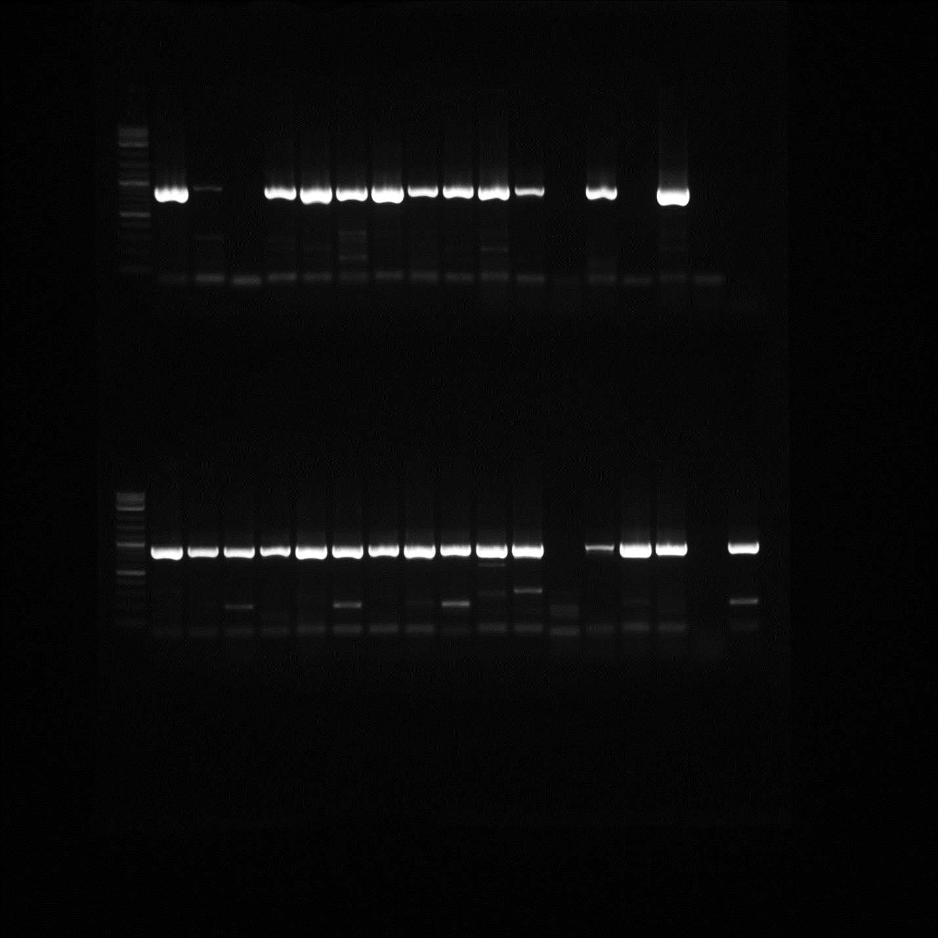
Uncropped Supplementary figure 1D: Acetylcholinesterase-1(Ace-1) partial gene segment of Spodoptera frugiperda. Expected band size=972bp

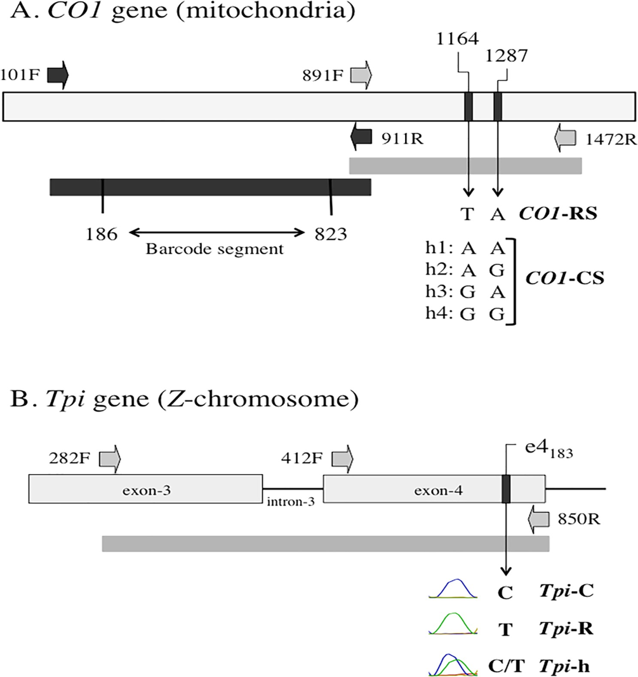Picture source: “(Rodney et al., 2017)(18)”
Supplementary figure 2. COI and Tpi gene segments used in this study. A: COI gene segment. PCR primers 110F/911R (Dark block arrows) were used to amplify the barcode region (dark bar). Primers 891F/1472R (Grey block arrows) amplified COI₁₁₆₄ and COI₁₂₈₇ polymorphic sites fragment (light bar). The Presence of nucleotide base “T” at COI₁₁₆₄ together with a nucleotide base “A” at COI₁₂₈₇ defines COI-RS. Four corn-strain (COI-CS) haplotypes (h1-h4) exist. They are defined by nucleotide base “A” or “G” at both COI₁₁₆₄ and COI₁₂₈₇. B: Portion of the fall armyworm Tpi gene. Block arrows indicate PCR primers (282F/850R).

