Fig S1 Distribution of SNPs on three genomes (A) and on each chromosome (B)

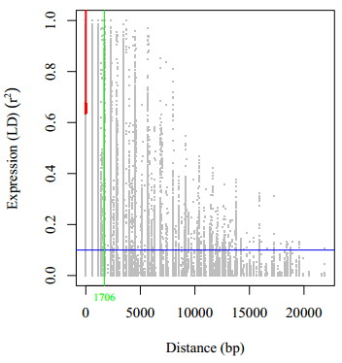
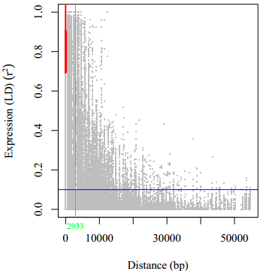
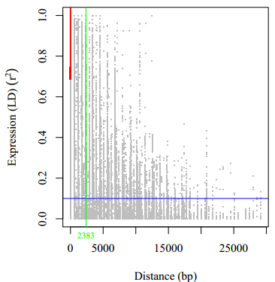
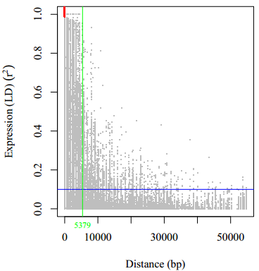

A
B

C
D

Fig. S2 LD decay plot of the (a) A genome, (b) B genome, (c) D genome, and (d) whole genome. Genetic distance in cM is plotted against the LD estimate (r²) for pairs of markers. The blue horizontal line indicates R² threshold (R²=0.1), the green vertical line indicates LD decay distance, and the red line is the moving average of the 10 adjacent markers

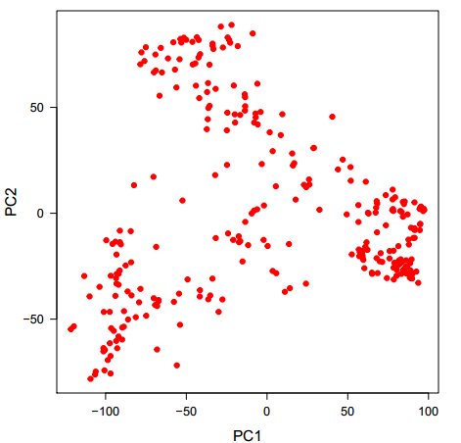
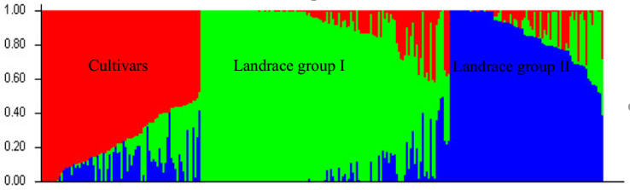
(16.9%)
(6.3%)

A

B

Fig. S3 Structure plot of 320 Iranian bread wheat accessions determined by K=3 (A) and Principal component analysis (B).

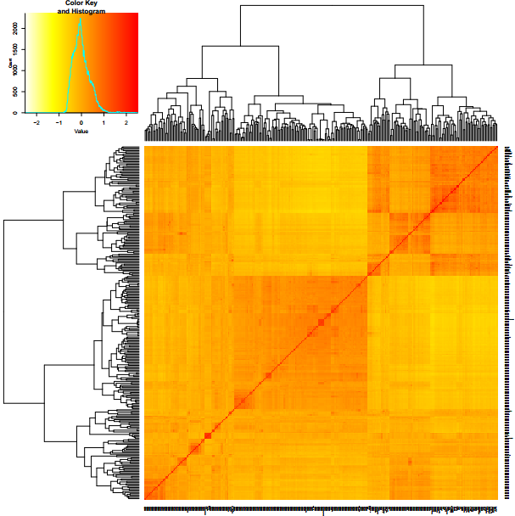
Varieties

Landraces

Landraces

Fig. S4 Cluster analysis using kiniship matrix for Iranian wheat accessions.

