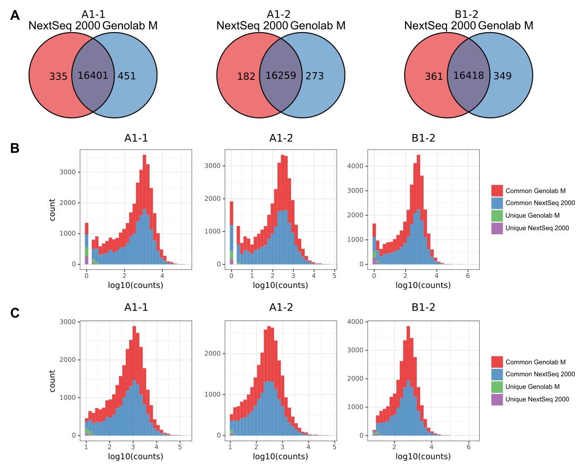
Figure S1. A. Overlap of detected genes. B, C. Raw read count distribution of the common and unique genes. Count is a number of genes.
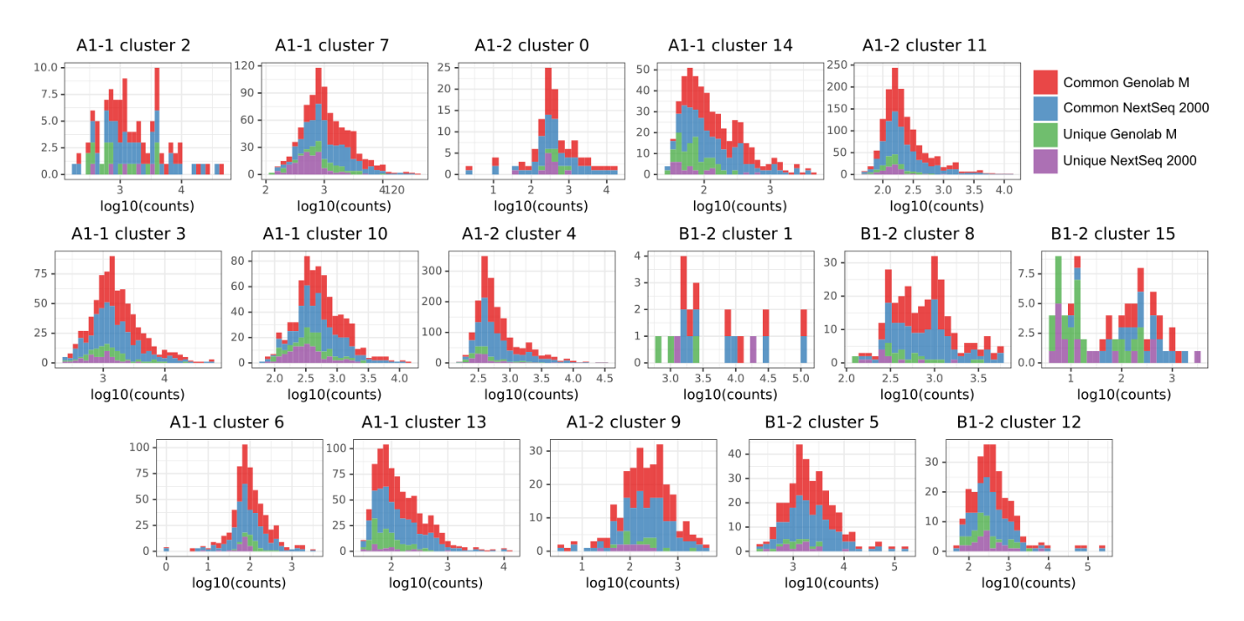
Figure S2. Raw read count distribution of the common and unique DEGs in the clusters. Y-axis is a number of DEGs.
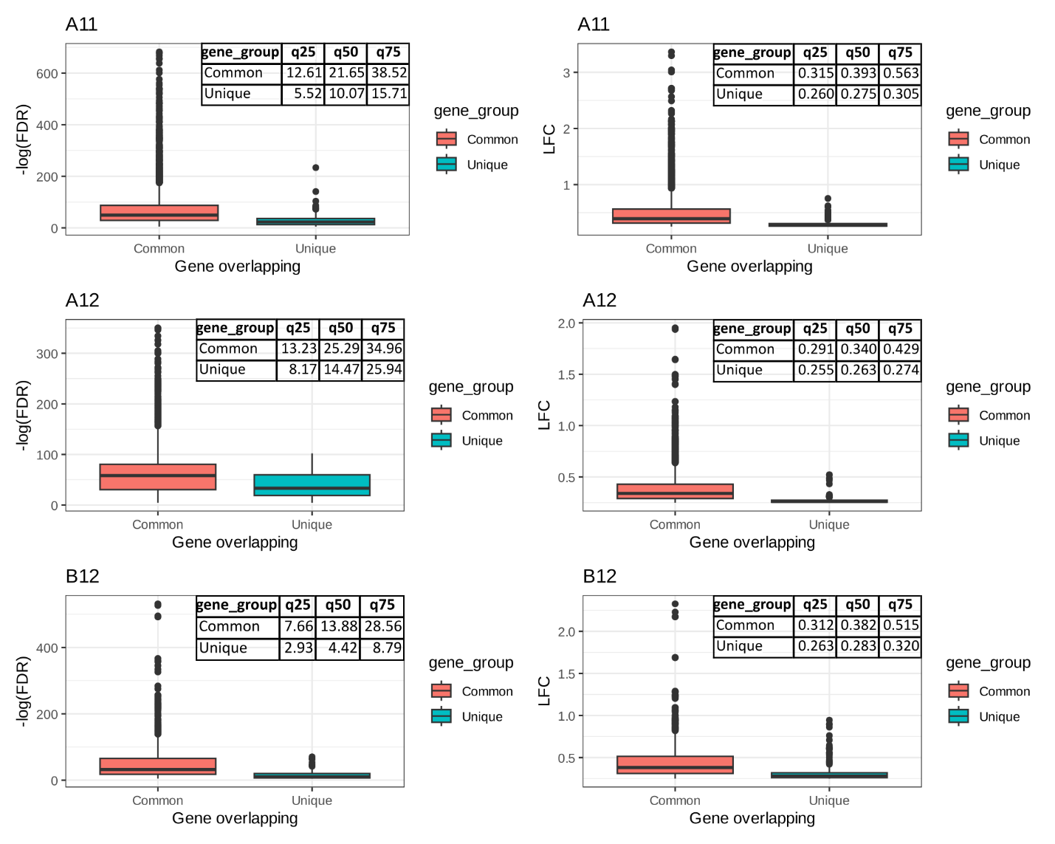
Figure S3. Boxplots describing difference in -log(FDR) and LFC between overlapping (Common) and platform unique (Unique) DEGs.

