Genomic adaptation to extreme climate conditions in beef cattle as a consequence of cross-breeding program

Rugang Tian^{1*†}, Hojjat Asadollahpour Nanaie^{1,2†}, Xiao Wang¹, Baolige Dalai¹, Meng Zhao¹, Fenf Wang¹, Hui Li¹，Ding Yang¹, Hao Zhang¹, Yuan Li¹, Tingyue Wang¹, Tu Luan³, Jianghong Wu^{4*}
¹Inner Mongolia Academy of Agricultural & Animal Husbandry Sciences, Hohhot, 010031, China
² Key Laboratory of Animal Genetics, Breeding and Reproduction of Shaanxi Province, College of Animal Science and Technology, Northwest A&F University, Yangling 712100, China
³Faculty of Biosciences, Norwegian University of Life Sciences
⁴ College of Animal Science and Technology, Inner Mongolia Minzu University
†These authors contributed equally to this work.
*Corresponding author:
Prof. Rugang Tian
E-mail: tiannky@163.com
Phone: +86 15124784023
Dr. Jianghong Wu
E-mail: wujianghonglong@126.com
Phone: +86 18947916076

Fig. S1: Cattle breeds used in this study. The figure was designed by the first author.

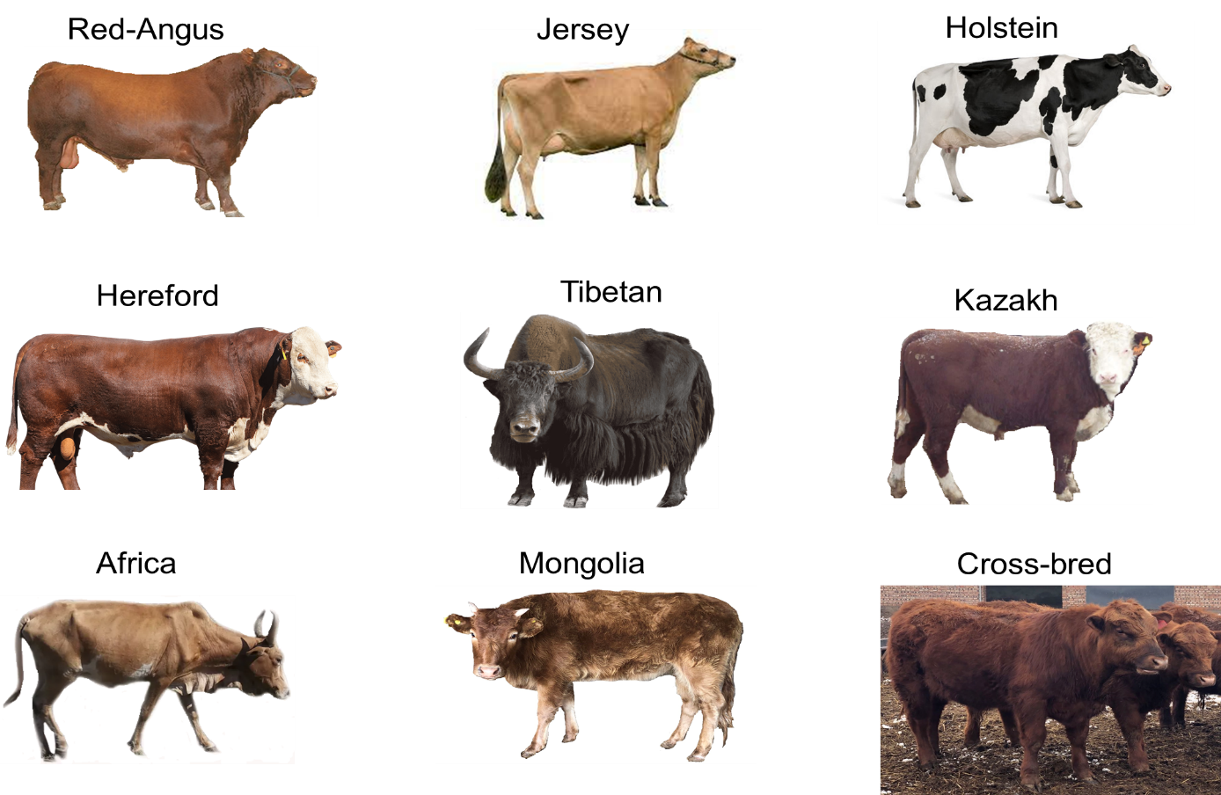

Fig. S2. A phylogenic tree from the genome sequences used in this study. The branches are colored following the same color code used in Fig.1A.
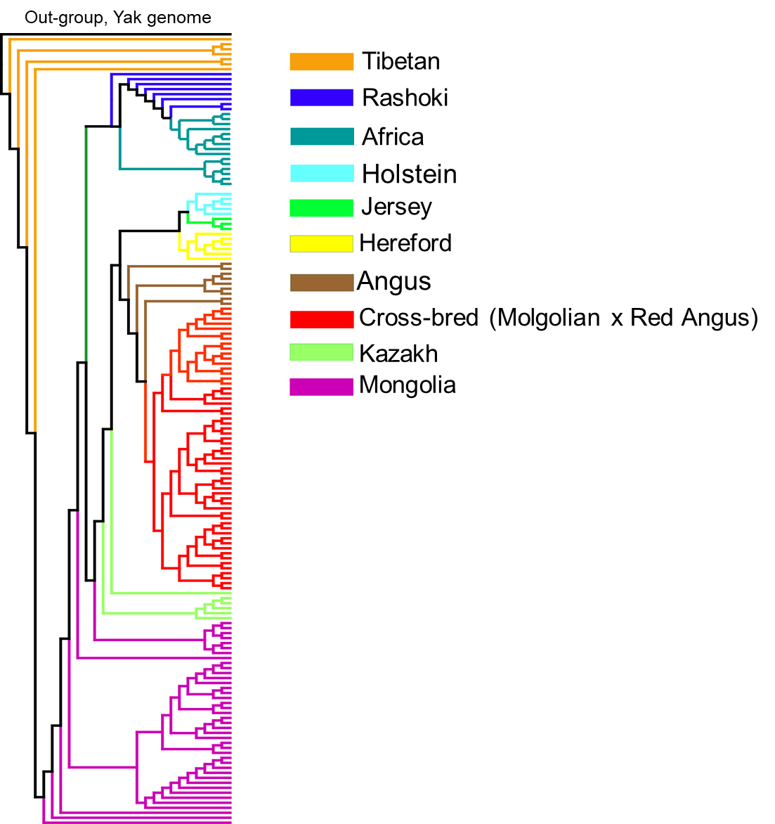

Fig. S3: Cross validation error (CV) plot from ADMIXTURE.
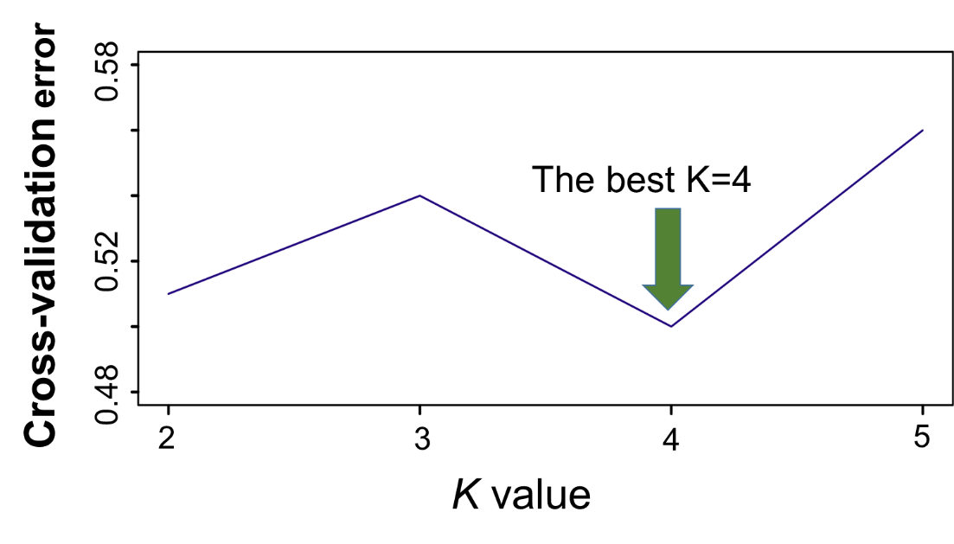

Fig. S4. The heat map of ChromoPainter’s coancestry matrix. The African individuals (red box) show lower haplotype sharing with other world-wide cattle groups.

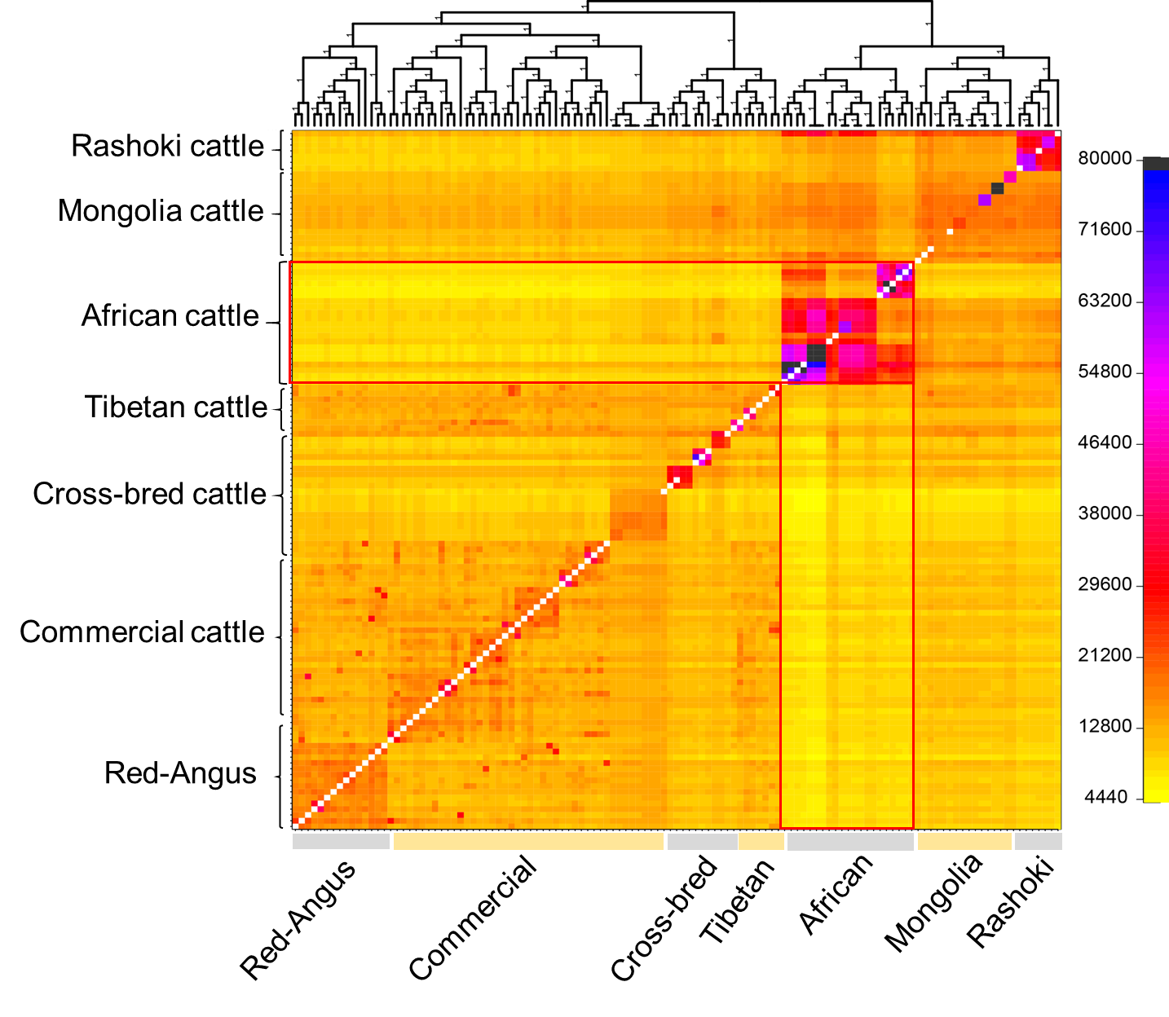

Fig. S5. Inbreeding coefficient (F) for different cattle populations in this study.
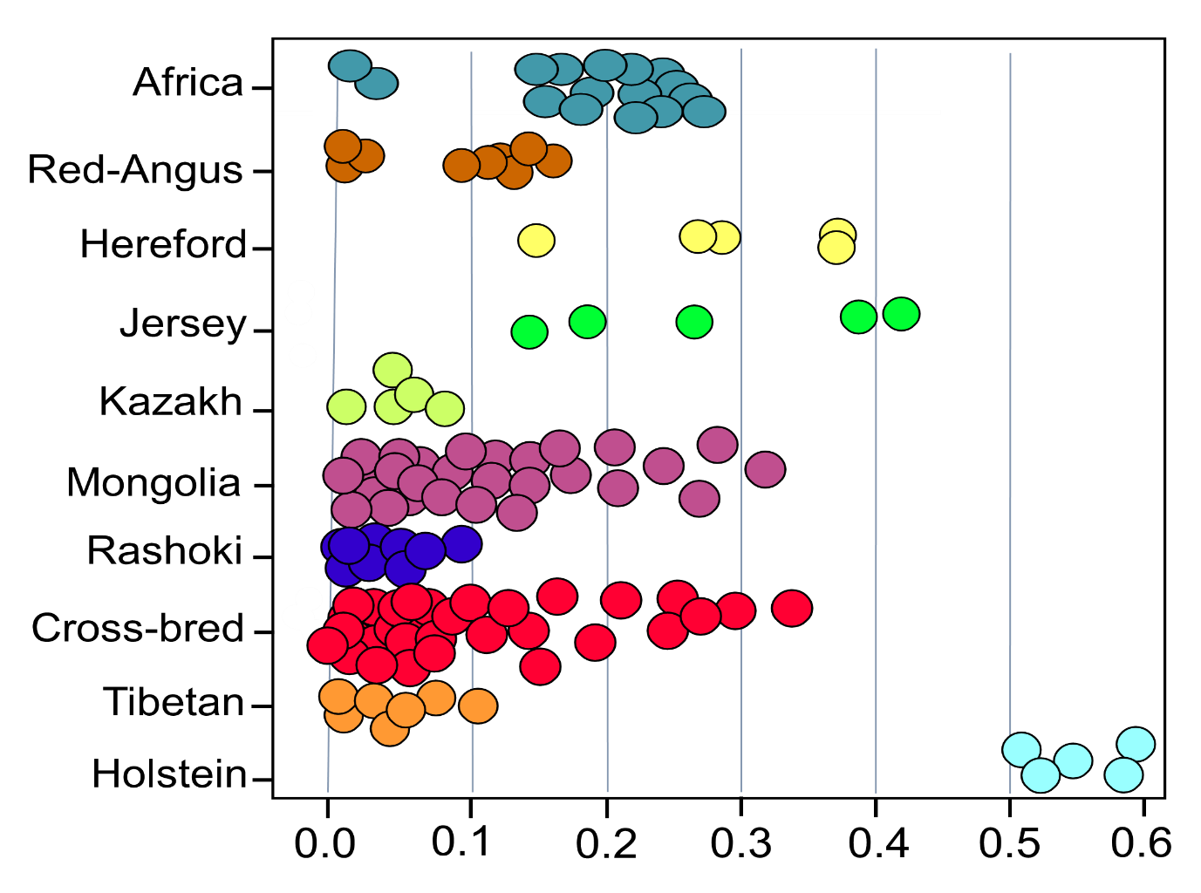

Fig. S6. Genomic landscape of population differentiation by XP-CLR statistic.

