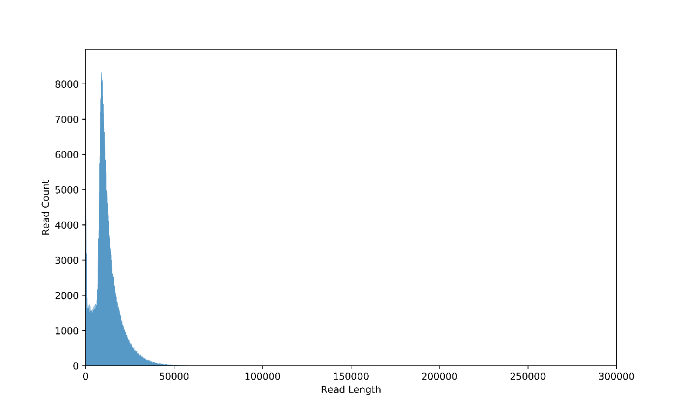
Figure S1 The distribution of read lengths.
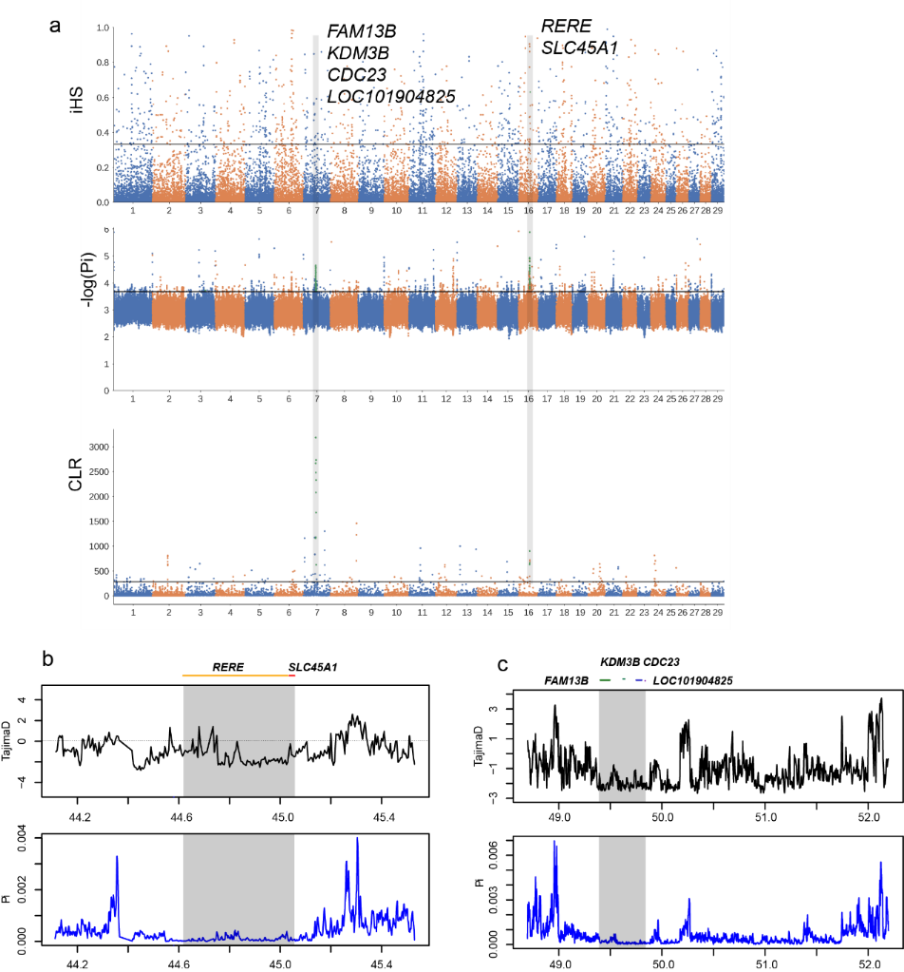
Figure S2 (a) Manhattan plot of selective sweeps in Simental cattle. (b &c ) Selective sweep detected by Tajima’s D and Pi test.

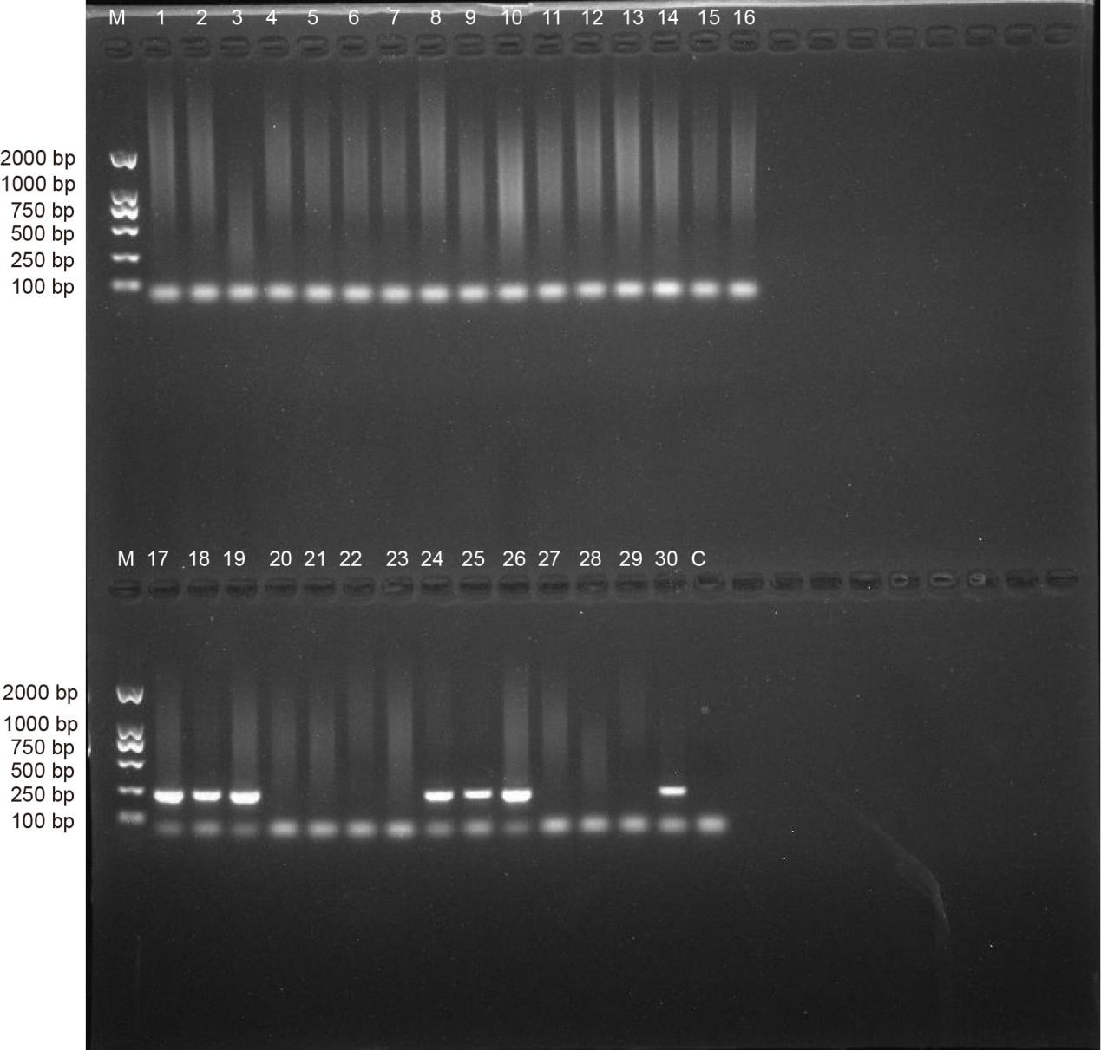
Figure S3 Gel electrophoresis of PCR products of the SPAG16. Marker, D2000 DNA ladder, the “M” represents the marker; the “C” represents the blank control (distilled water); 1-16 represents the individuals from PSM group, 17-30 represent individuals from HSM group.

