Supplemental Figures
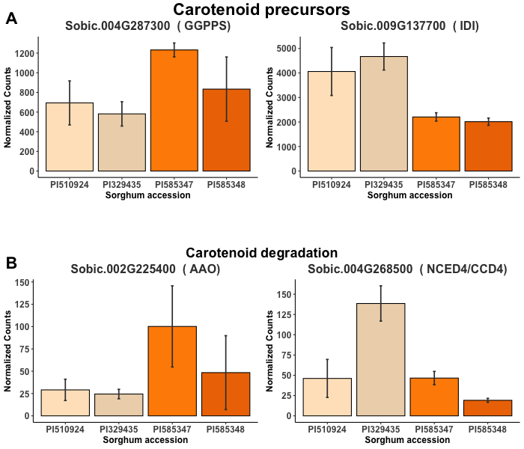
Figure S1. Differentially expressed genes at 14 DAP for high versus low carotenoid sorghum accessions. Genotypes normalized transcript counts for A) carotenoid precursors (MEP pathway); B) carotenoid degradation pathways

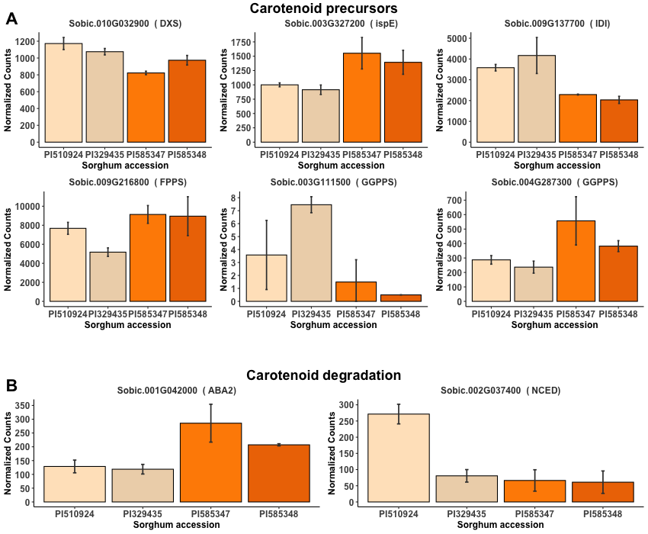

Figure S2. Differentially expressed genes at 28 DAP for high versus low carotenoid sorghum accessions. Genotypes normalized transcript counts for A) carotenoid precursors (MEP pathway); B) carotenoid degradation pathways
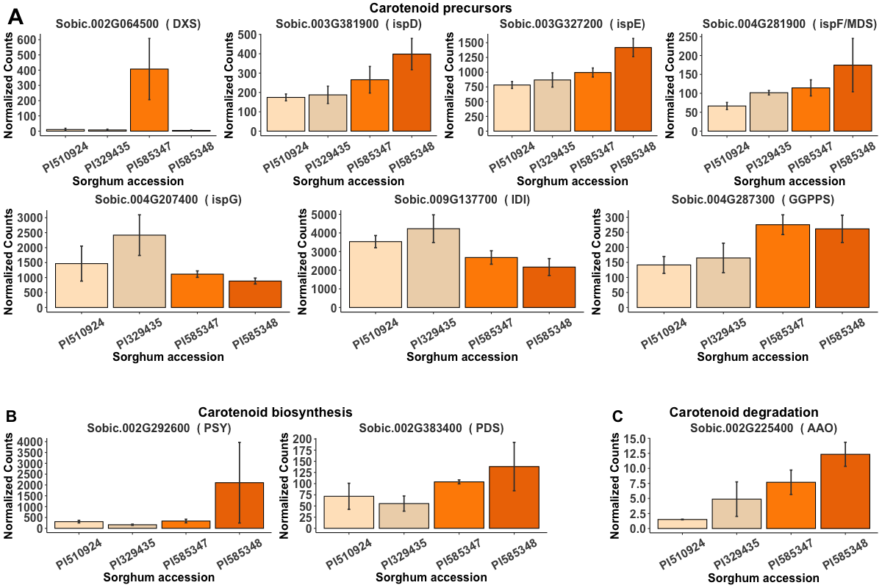
Figure S3. Differentially expressed genes at 42 DAP for high versus low carotenoid sorghum accessions. Genotypes normalized transcript counts for A) carotenoid precursors (MEP pathway); B) carotenoid biosynthesis; C) carotenoid degradation pathways

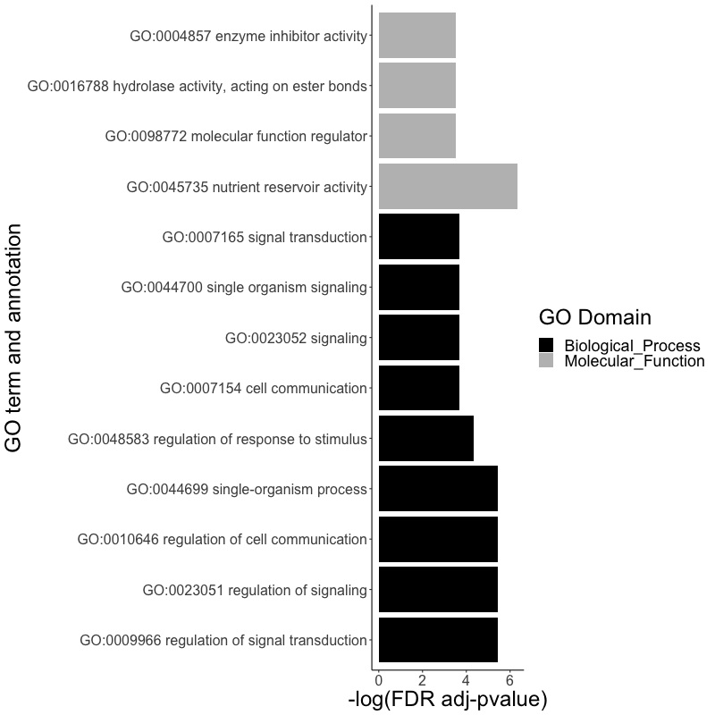
Figure S4. Significant GO terms in the SEA GO enrichment analysis for differentially expressed genes in carotenoid content group (High vs Low) at 14 DAP.

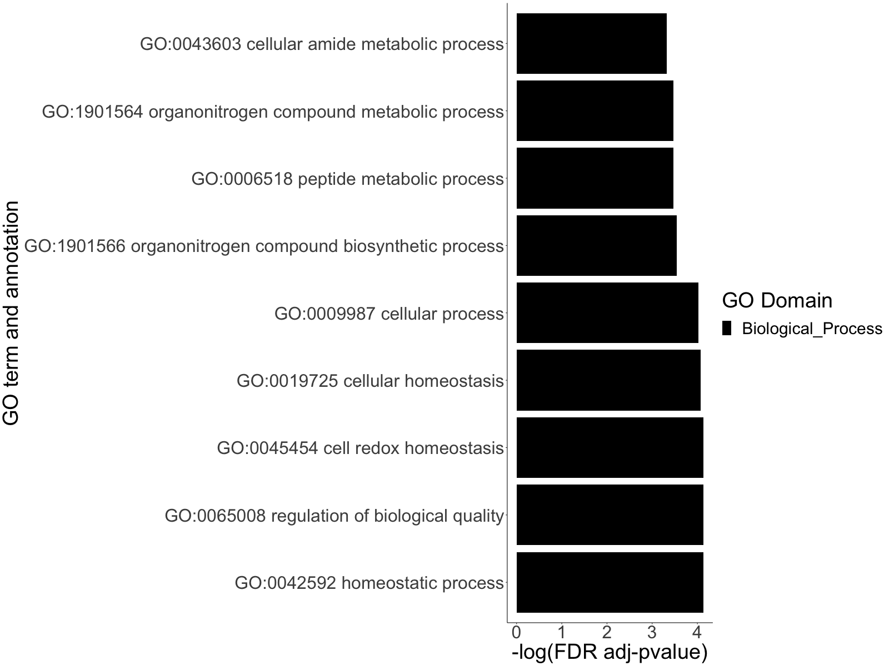
Figure S5. Significant GO terms under the biological process domain in the SEA GO enrichment analysis for differentially expressed genes in carotenoid content group (High vs Low) at 28 DAP.

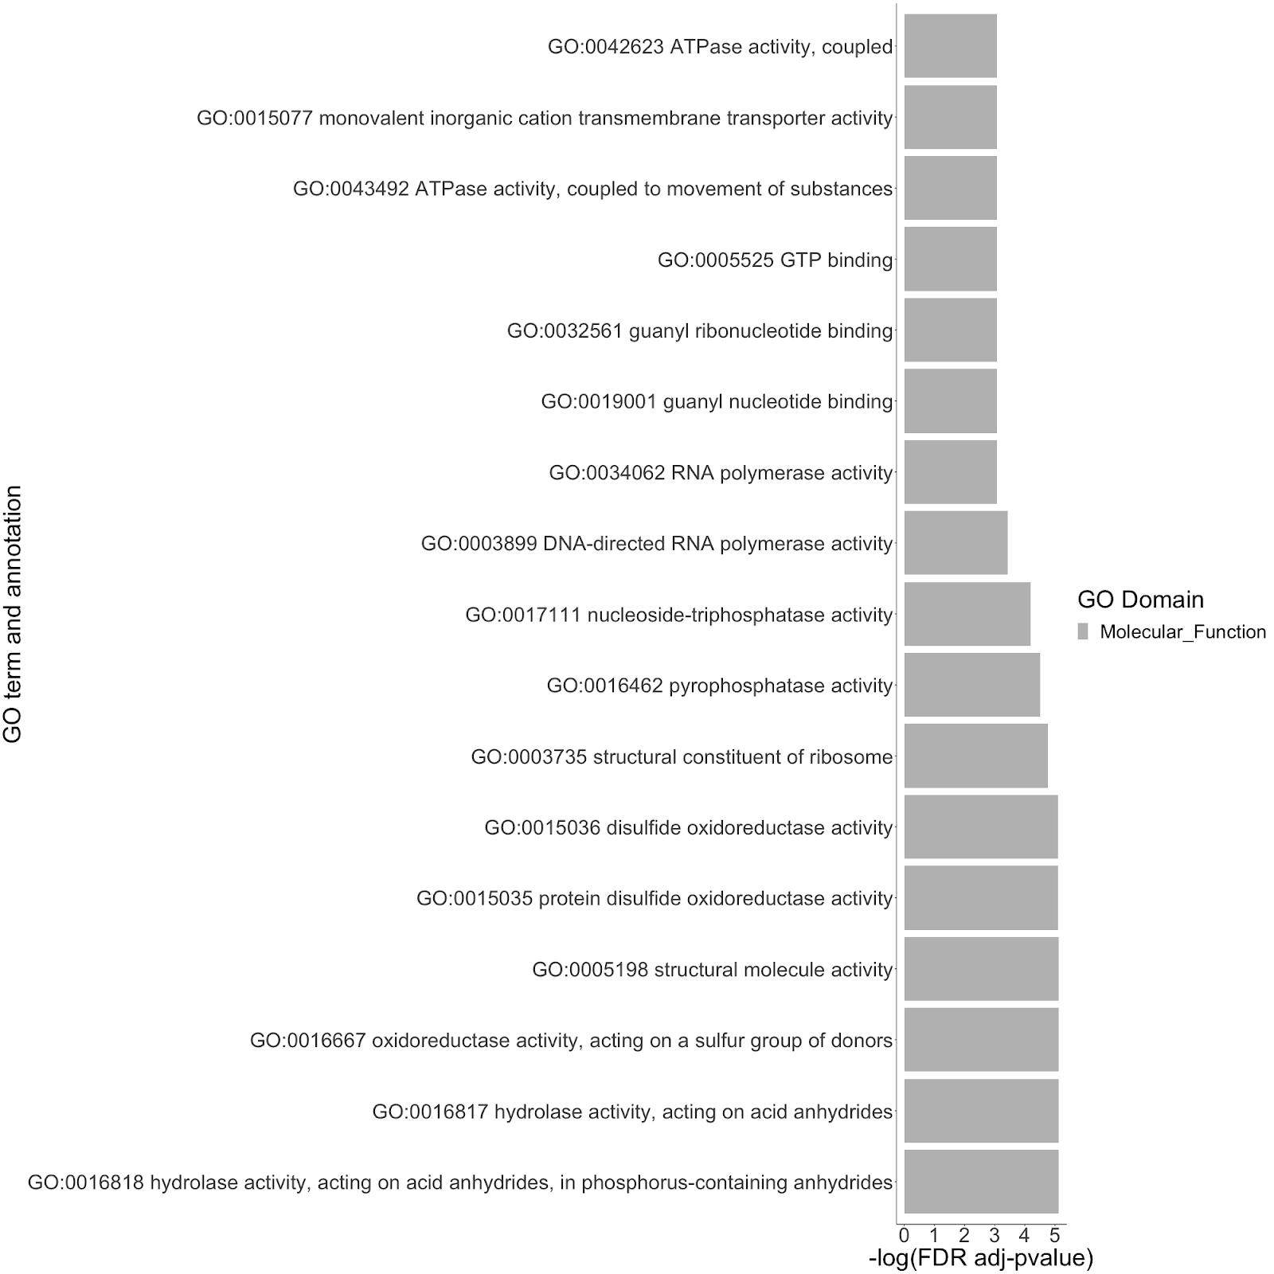
Figure S6. Significant GO terms under the molecular function domain in the SEA GO enrichment analysis for differentially expressed genes in carotenoid content group (High vs Low) at 28 DAP.

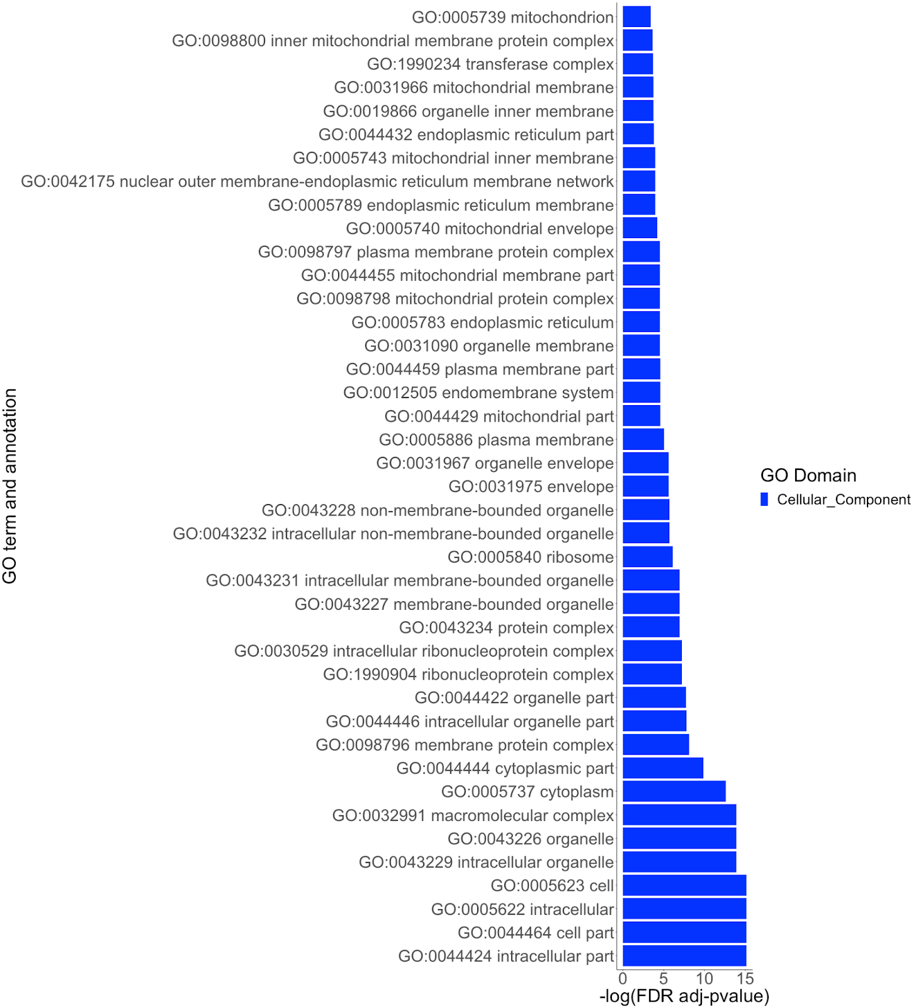
Figure S7. Significant GO terms under the cellular component domain in the SEA GO enrichment analysis for differentially expressed genes in carotenoid content group (High vs Low) at 28 DAP.
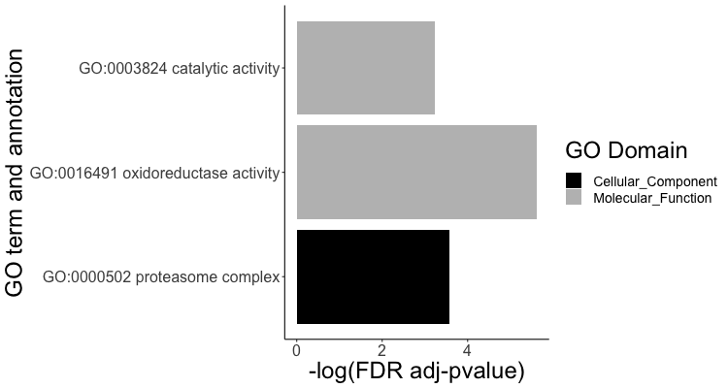
Figure S8. Significant GO terms in the SEA GO enrichment analysis for differentially expressed genes in carotenoid content group (High vs Low) at 42 DAP.

