Supplementary Data
Supplementary Table 1 Cis-element categories based on biological process
Major categories | Description | Motifs
Plant development and growth | Cell cycle regulation | MSA-like
Plant development and growth | Crcadian control | circadian
Plant development and growth | Endosperm expression | AACA_motif
Plant development and growth | Endosperm expression | GCN4_motif
Plant development and growth | Meristem expression | CAT-box
Plant development and growth | Meristem expression | NON-box
Plant development and growth | Palisade mesophyll cells differentiation | HD-Zip 1
Plant development and growth | Seed-specific regulation | RY-element
Phytohormone response | Abscisic acid response | ABRE
Phytohormone response | Auxin response | TGA-element
Phytohormone response | Auxin response | AuxRR-core
Phytohormone response | Auxin response | AuxRE
Phytohormone response | Auxin response | GATA-box
Phytohormone response | Auxin response | TGA-box
Phytohormone response | Gibberellin response | GARE-motif
Phytohormone response | Gibberellin response | P-box
Phytohormone response | Gibberellin response | TATC-box
Phytohormone response | Jasmonic acid response | TGACG-motif
Phytohormone response | Jasmonic acid response | CGTCA-motif
Phytohormone response | Salicylic acid response | TCA-element
Abiotic stress response | Anaerobic Induction | ARE
Abiotic stress response | Anaerobic Induction | GC-motif
Abiotic stress response | Drought Induction | MBS
Abiotic stress response | Low-temperature responsive | LTR
Abiotic stress response | Wound-responsive element | WUN-motif

Supplementary Table 2 Primers used in the experiment
Primer name | Sequence (5’-3’)
FvWAK1 (for qRT-PCR) |  | F: TGGGAGATGATTATGTGATTGTTTT
 |  | R: ACACTTCCTATCCTAGCATTGCTTT
FvWAK2 (for qRT-PCR) |  | F: GTACGTGGAACATTTGGTTATTTG
 |  | R: TCTACTTTCTTGCGACCTTATCAT
FvWAK5 (for qRT-PCR) |  | F: CCGCAAAAAACAATCAAAGACGACG
 |  | R: AACGAACAGAACCAAGAAGCCCCCC
FvWAK8 (for qRT-PCR) |  | F: GCCGATTATCAATCTTCATCTGTGTAT
 |  | R: CTAATTGCTAACCGTTTTCTTCTAGGA
FvWAK9 (for qRT-PCR) |  | F: GGCCTACCATGAAAGAAGTAGCGA
 |  | R: AAGCATTTGAAGGTGACGGAGCAA
FvACTIN (for qRT-PCR) |  | F: GCCAACCGTGAGAAGATG
 |  | R: TCCAGAGTCAAGAACAATACCAG
RcWAK8 (for qRT-PCR) |  | F: GTGAAATGTAAGTTAATGTGACCCTGC
 |  | R: GCCTTCTTGCTTTTGCACCAAGTACAA
RcUBI (for qRT-PCR) |  | F: CACAAGCACGCAAACCCTAT
 |  | R: GGAGCATGAGCCAAATGGAG
RcWAK8(for VIGS) |  | F: TCCAAGCAGTGGTGGACGCAGAAAA
 |  | R: AAAAGCTTACTGATAGCCTGATACT

Supplementary Table 3 Predicted WAK/WAKL family members in strawberry
Gene | Accession number ª | Chr.^{b} | Position ^{c} | Exon | Intron | CDS (bp) | Amino Acids | Clade
FvWAK1 | FvH4_2g35060.1 | 2 | 25.91765 | 6 | 5 | 4793 | 1450 | Ⅱ
FvWAK2 | FvH4_3g09860.1 | 3 | 5.742648 | 3 | 2 | 2283 | 760 | Ⅲ
FvWAK3 | FvH4_3g10350.1 | 3 | 6.054429 | 3 | 2 | 2752 | 787 | Ⅰ
FvWAK4 | FvH4_3g10360.1 | 3 | 6.058956 | 3 | 2 | 2287 | 754 | Ⅰ
FvWAK5 | FvH4_3g10510.1 | 3 | 6.189099 | 3 | 2 | 1773 | 570 | Ⅰ
FvWAK6 | FvH4_3g10610.1 | 3 | 6.320654 | 3 | 2 | 2307 | 768 | Ⅰ
FvWAK7 | FvH4_3g10620.1 | 3 | 6.324417 | 7 | 6 | 5111 | 788 | Ⅰ
FvWAK8 | FvH4_3g10690.1 | 3 | 6.36195 | 7 | 6 | 4796 | 1545 | Ⅰ
FvWAK9 | FvH4_3g11730.1 | 3 | 6.923924 | 3 | 2 | 2792 | 778 | Ⅰ
FvWAK10 | FvH4_5g06860.1 | 5 | 4.028769 | 3 | 2 | 2458 | 752 | Ⅲ
FvWAK11 | FvH4_5g06940.1 | 5 | 4.110458 | 5 | 4 | 2209 | 705 | Ⅲ
FvWAK12 | FvH4_6g53140.1 | 6 | 39.0102 | 7 | 6 | 7019 | 2266 | Ⅱ
FvWAK13 | FvH4_7g31880.1 | 7 | 22.99794 | 3 | 2 | 2400 | 799 | Ⅰ
FvWAK14 | FvH4_7g31920.1 | 7 | 23.01787 | 3 | 2 | 3031 | 797 | Ⅰ
FvWAKL1 | FvH4_1g03330.1 | 1 | 1.84565 | 6 | 5 | 4072 | 607 | Ⅴ
FvWAKL2 | FvH4_1g07120.1 | 1 | 3.764624 | 9 | 8 | 3120 | 925 | Ⅴ
FvWAKL3 | FvH4_2g12540.1 | 2 | 11.01504 | 6 | 5 | 4253 | 1011 | Ⅳ
FvWAKL4 | FvH4_3g24040.1 | 3 | 17.08778 | 2 | 1 | 1977 | 658 | Ⅲ
FvWAKL5 | FvH4_3g35290.1 | 3 | 30.42648 | 3 | 2 | 2661 | 736 | Ⅲ
FvWAKL6 | FvH4_4g34420.1 | 4 | 32.21677 | 3 | 2 | 3294 | 601 | Ⅴ
FvWAKL7 | FvH4_5g11780.1 | 5 | 6.668576 | 4 | 3 | 2703 | 651 | Ⅴ
FvWAKL8 | FvH4_5g22270.1 | 5 | 13.67487 | 3 | 2 | 1991 | 574 | Ⅴ
FvWAKL9 | FvH4_6g23830.1 | 6 | 17.91204 | 7 | 6 | 3690 | 644 | Ⅴ
FvWAKL10 | FvH4_6g37660.1 | 6 | 29.64871 | 3 | 2 | 2286 | 733 | Ⅲ
FvWAKL11 | FvH4_6g37670.1 | 6 | 29.67993 | 3 | 2 | 2399 | 745 | Ⅲ
FvWAKL12 | FvH4_6g38990.1 | 6 | 30.82468 | 7 | 6 | 5869 | 756 | Ⅲ
FvWAKL13 | FvH4_6g39000.1 | 6 | 30.8359 | 3 | 2 | 2133 | 710 | Ⅲ
FvWAKL14 | FvH4_6g39020.1 | 6 | 30.84541 | 3 | 2 | 2223 | 740 | Ⅲ
FvWAKL15 | FvH4_7g04160.1 | 7 | 4.791193 | 2 | 1 | 1851 | 616 | Ⅴ
FvWAKL16 | FvH4_7g05990.1 | 7 | 6.183596 | 7 | 6 | 2721 | 674 | Ⅴ
FvWAKL17 | FvH4_7g06010.1 | 7 | 6.200855 | 9 | 8 | 3296 | 1039 | Ⅴ
FvWAKL18 | FvH4_7g06020.1 | 7 | 6.207926 | 3 | 2 | 2076 | 623 | Ⅴ
FvWAKL19 | FvH4_7g06040.1 | 7 | 6.2254 | 6 | 5 | 2051 | 590 | Ⅴ
FvWAKL20 | FvH4_7g17870.1 | 7 | 15.05287 | 3 | 2 | 1970 | 636 | Ⅳ
FvWAKL21 | FvH4_7g20630.1 | 7 | 16.7249 | 5 | 4 | 2011 | 586 | Ⅴ
FvWAKL22 | FvH4_7g23160.1 | 7 | 18.12545 | 3 | 2 | 2385 | 627 | Ⅳ
a Available at https://lipm-browsers.toulouse.inra.fr/pub/RchiOBHm-V2/.
b Chromosome.
c Starting position (Mb).

Supplementary Table 4 Predicted WAK/WAKL family members in apple
Gene | Accession number ª | Chr.^{b} | Position ^{c} | Exon | Intron | CDS (bp) | Amino Acids | Clade
MdWAK1 | MD05G1269900 | 5 | 40.48713 | 3 | 2 | 2265 | 754 | Ⅰ
MdWAK2 | MD08G1107600 | 8 | 9.459183 | 4 | 3 | 2198 | 714 | Ⅱ
MdWAK3 | MD08G1107900 | 8 | 9.481554 | 3 | 2 | 2339 | 772 | Ⅲ
MdWAK4 | MD10G1248500 | 10 | 34.16426 | 5 | 4 | 2679 | 892 | Ⅰ
MdWAK5 | MD10G1250500 | 10 | 34.29704 | 5 | 4 | 2142 | 713 | Ⅰ
MdWAK6 | MD10G1251200 | 10 | 34.45409 | 3 | 2 | 2545 | 766 | Ⅰ
MdWAK7 | MD10G1251400 | 10 | 34.46982 | 3 | 2 | 2286 | 761 | Ⅰ
MdWAK8 | MD13G1004600 | 13 | 0.280748 | 3 | 2 | 2283 | 760 | Ⅱ
MdWAK9 | MD15G1088400 | 15 | 6.166287 | 3 | 2 | 2343 | 780 | Ⅱ
MdWAKL1 | MD01G1059700 | 1 | 16.35682 | 6 | 5 | 2404 | 695 | Ⅴ
MdWAKL2 | MD01G1091100 | 1 | 20.62039 | 3 | 2 | 2052 | 683 | Ⅳ
MdWAKL3 | MD01G1139800 | 1 | 24.93618 | 3 | 2 | 2321 | 621 | Ⅳ
MdWAKL4 | MD02G1247100 | 2 | 29.73918 | 6 | 5 | 1897 | 617 | Ⅴ
MdWAKL5 | MD02G1249300 | 2 | 29.98542 | 6 | 5 | 1959 | 652 | Ⅴ
MdWAKL6 | MD02G1273500 | 2 | 32.80932 | 3 | 2 | 2307 | 670 | Ⅴ
MdWAKL7 | MD02G1273700 | 2 | 32.82504 | 3 | 2 | 2086 | 604 | Ⅴ
MdWAKL8 | MD02G1274000 | 2 | 32.85803 | 4 | 3 | 2259 | 631 | Ⅴ
MdWAKL9 | MD02G1274600 | 2 | 32.9126 | 3 | 2 | 2002 | 613 | Ⅴ
MdWAKL10 | MD04G1233200 | 4 | 31.22011 | 2 | 1 | 2738 | 635 | Ⅴ
MdWAKL11 | MD06G1218900 | 6 | 35.15848 | 4 | 3 | 2401 | 652 | Ⅳ
MdWAKL12 | MD07G1070400 | 7 | 6.662745 | 6 | 5 | 2013 | 670 | Ⅴ
MdWAKL13 | MD07G1070700 | 7 | 6.679087 | 7 | 6 | 2395 | 671 | Ⅴ
MdWAKL14 | MD07G1161300 | 7 | 23.64085 | 3 | 2 | 1938 | 645 | Ⅳ
MdWAKL15 | MD09G1145200 | 9 | 11.28813 | 3 | 2 | 2295 | 764 | Ⅲ
MdWAKL16 | MD09G1145300 | 9 | 11.29893 | 3 | 2 | 2178 | 725 | Ⅲ
MdWAKL17 | MD09G1145500 | 9 | 11.31585 | 4 | 3 | 2962 | 737 | Ⅲ
MdWAKL18 | MD12G1149600 | 12 | 22.97696 | 2 | 1 | 1863 | 620 | Ⅳ
MdWAKL19 | MD12G1250800 | 12 | 32.08086 | 2 | 1 | 2109 | 702 | Ⅴ
MdWAKL20 | MD12G1251100 | 12 | 32.09172 | 4 | 3 | 1947 | 647 | Ⅴ
MdWAKL21 | MD12G1251200 | 12 | 32.0945 | 2 | 1 | 1932 | 643 | Ⅴ
MdWAKL22 | MD13G1036100 | 13 | 2.51644 | 5 | 4 | 1524 | 500 | Ⅳ
MdWAKL23 | MD13G1037900 | 13 | 2.586111 | 3 | 2 | 1965 | 650 | Ⅴ
MdWAKL24 | MD14G1096100 | 14 | 14.57906 | 1 | 0 | 1902 | 633 | Ⅳ
MdWAKL25 | MD14G1228700 | 14 | 31.02785 | 4 | 3 | 2078 | 682 | Ⅳ
MdWAKL26 | MD17G1131600 | 17 | 11.60009 | 3 | 2 | 2178 | 725 | Ⅲ
a Available at https://lipm-browsers.toulouse.inra.fr/pub/RchiOBHm-V2/.
b Chromosome.
c Starting position (Mb).

Supplementary Table 5 Predicted WAK/WAKL family members in peach
Gene | Accession number ª | Chr.^{b} | Position ^{c} | Exon | Intron | CDS (bp) | Amino Acids | Clade
PpWAK1 | Prupe.1G442500.1 | 1 | 37.54409 | 3 | 2 | 2301 | 766 | Ⅱ
PpWAK2 | Prupe.4G091900.1 | 4 | 4.58662 | 3 | 2 | 2265 | 754 | Ⅰ
PpWAK3 | Prupe.4G092700.1 | 4 | 4.651056 | 3 | 2 | 2226 | 741 | Ⅰ
PpWAK4 | Prupe.4G092900.1 | 4 | 4.672275 | 3 | 2 | 2199 | 732 | Ⅰ
PpWAK5 | Prupe.4G093100.1 | 4 | 4.690237 | 3 | 2 | 2361 | 786 | Ⅰ
PpWAK6 | Prupe.4G093100.2 | 4 | 4.690366 | 3 | 2 | 2325 | 774 | Ⅰ
PpWAK7 | Prupe.4G093200.1 | 4 | 4.697706 | 3 | 2 | 2259 | 752 | Ⅰ
PpWAK8 | Prupe.4G093300.1 | 4 | 4.70104 | 3 | 2 | 2259 | 752 | Ⅰ
PpWAK9 | Prupe.4G093400.1 | 4 | 4.705881 | 3 | 2 | 2247 | 748 | Ⅰ
PpWAK10 | Prupe.4G093500.1 | 4 | 4.709207 | 3 | 2 | 2283 | 760 | Ⅰ
PpWAK11 | Prupe.4G094100.1 | 4 | 4.741372 | 4 | 3 | 2259 | 752 | Ⅰ
PpWAK12 | Prupe.4G094500.1 | 4 | 4.766987 | 4 | 3 | 2337 | 778 | Ⅰ
PpWAKL1 | Prupe.1G315000.1 | 1 | 30.42904 | 3 | 2 | 1902 | 633 | Ⅴ
PpWAKL2 | Prupe.1G315000.2 | 1 | 30.4291 | 2 | 1 | 1869 | 622 | Ⅴ
PpWAKL3 | Prupe.1G315900.1 | 1 | 30.48858 | 4 | 3 | 2037 | 678 | Ⅳ
PpWAKL4 | Prupe.1G315900.2 | 1 | 30.4886 | 3 | 2 | 2007 | 668 | Ⅳ
PpWAKL5 | Prupe.1G318900.1 | 1 | 30.63126 | 6 | 5 | 1227 | 408 | Ⅴ
PpWAKL6 | Prupe.2G047400.1 | 2 | 5.472545 | 3 | 2 | 1890 | 629 | Ⅴ
PpWAKL7 | Prupe.2G047400.2 | 2 | 5.472365 | 3 | 2 | 1857 | 618 | Ⅴ
PpWAKL8 | Prupe.2G047500.1 | 2 | 5.475758 | 4 | 3 | 1962 | 653 | Ⅴ
PpWAKL9 | Prupe.2G087100.1 | 2 | 13.75632 | 6 | 5 | 1995 | 664 | Ⅴ
PpWAKL10 | Prupe.2G087800.1 | 2 | 13.8753 | 6 | 5 | 2064 | 687 | Ⅴ
PpWAKL11 | Prupe.2G088100.1 | 2 | 13.91298 | 6 | 5 | 1983 | 660 | Ⅴ
PpWAKL12 | Prupe.2G088900.1 | 2 | 14.03523 | 3 | 2 | 1812 | 603 | Ⅴ
PpWAKL13 | Prupe.2G089000.2 | 2 | 14.05951 | 3 | 2 | 1797 | 598 | Ⅴ
PpWAKL14 | Prupe.2G093400.1 | 2 | 14.81271 | 4 | 3 | 1644 | 547 | Ⅴ
PpWAKL15 | Prupe.2G103300.1 | 2 | 15.90722 | 4 | 3 | 2121 | 706 | Ⅴ
PpWAKL16 | Prupe.2G200600.1 | 2 | 23.751 | 3 | 2 | 1935 | 644 | Ⅳ
PpWAKL17 | Prupe.2G240400.1 | 2 | 26.02442 | 3 | 2 | 1890 | 629 | Ⅳ
PpWAKL18 | Prupe.3G145600.1 | 3 | 15.89489 | 5 | 4 | 1398 | 465 | Ⅴ
PpWAKL19 | Prupe.3G145700.1 | 3 | 15.89912 | 3 | 2 | 1980 | 659 | Ⅴ
PpWAKL20 | Prupe.3G145800.1 | 3 | 15.91152 | 3 | 2 | 2151 | 716 | Ⅴ
PpWAKL21 | Prupe.3G146200.1 | 3 | 15.99703 | 3 | 2 | 1917 | 638 | Ⅴ
PpWAKL22 | Prupe.3G146500.1 | 3 | 16.02174 | 4 | 3 | 2046 | 681 | Ⅳ
PpWAKL23 | Prupe.3G180500.1 | 3 | 19.63502 | 3 | 2 | 2205 | 734 | Ⅲ
PpWAKL24 | Prupe.3G180600.1 | 3 | 19.63842 | 3 | 2 | 2283 | 760 | Ⅲ
PpWAKL25 | Prupe.3G181100.1 | 3 | 19.68919 | 3 | 2 | 2244 | 747 | Ⅲ
PpWAKL26 | Prupe.3G181100.2 | 3 | 19.68919 | 2 | 1 | 2127 | 708 | Ⅲ
PpWAKL27 | Prupe.3G181200.1 | 3 | 19.69577 | 3 | 2 | 2175 | 724 | Ⅲ
PpWAKL28 | Prupe.3G181200.2 | 3 | 19.69578 | 4 | 3 | 2175 | 724 | Ⅲ
PpWAKL29 | Prupe.3G181400.1 | 3 | 19.72138 | 3 | 2 | 1800 | 599 | Ⅲ
PpWAKL30 | Prupe.3G181800.1 | 3 | 19.77873 | 3 | 2 | 2256 | 751 | Ⅲ
PpWAKL31 | Prupe.3G181900.1 | 3 | 19.7823 | 3 | 2 | 2346 | 781 | Ⅲ
PpWAKL32 | Prupe.3G182400.1 | 3 | 19.80251 | 3 | 2 | 2325 | 774 | Ⅲ
PpWAKL33 | Prupe.3G182700.1 | 3 | 19.84072 | 3 | 2 | 2301 | 766 | Ⅲ
PpWAKL34 | Prupe.4G093000.1 | 4 | 4.678991 | 2 | 1 | 1959 | 652 | Ⅰ
PpWAKL35 | Prupe.4G094000.1 | 4 | 4.73672 | 7 | 6 | 1722 | 573 | Ⅰ
PpWAKL36 | Prupe.5G051200.1 | 5 | 5.498674 | 3 | 2 | 2271 | 756 | Ⅲ
PpWAKL37 | Prupe.5G051600.1 | 5 | 5.570567 | 3 | 2 | 2304 | 767 | Ⅲ
PpWAKL38 | Prupe.5G223900.2 | 5 | 17.35145 | 3 | 2 | 1983 | 660 | Ⅳ
PpWAKL39 | Prupe.5G223900.3 | 5 | 17.35145 | 4 | 3 | 2019 | 672 | Ⅳ
PpWAKL40 | Prupe.6G137900.1 | 6 | 11.19002 | 3 | 2 | 1689 | 562 | Ⅴ
PpWAKL41 | Prupe.6G138000.1 | 6 | 11.19971 | 5 | 4 | 2004 | 667 | Ⅴ
PpWAKL42 | Prupe.6G142200.1 | 6 | 11.53081 | 3 | 2 | 1737 | 578 | Ⅴ
PpWAKL43 | Prupe.6G142300.1 | 6 | 11.53337 | 4 | 3 | 2103 | 700 | Ⅴ
PpWAKL44 | Prupe.6G142300.2 | 6 | 11.53337 | 5 | 4 | 1815 | 604 | Ⅴ
PpWAKL45 | Prupe.6G261100.1 | 6 | 25.14845 | 3 | 2 | 1926 | 641 | Ⅳ
PpWAKL46 | Prupe.6G352900.1 | 6 | 30.03837 | 2 | 1 | 2058 | 685 | Ⅴ
PpWAKL47 | Prupe.6G352900.2 | 6 | 30.03851 | 2 | 1 | 2052 | 683 | Ⅴ
PpWAKL48 | Prupe.6G358300.1 | 6 | 30.33538 | 2 | 1 | 2133 | 710 | Ⅱ
a Available at https://lipm-browsers.toulouse.inra.fr/pub/RchiOBHm-V2/.
b Chromosome.
c Starting position
Supplementary Table 6 Number of WAK/WAKL genes in different species
species | Genome_size (Mb) | WAK | WAKL | Total
Strawberry (Fragaria vesca) | 240 | 14 | 22 | 36
Apple (Malus domestica) | 742 | 9 | 26 | 35
Peach (Prunus persica) | 265 | 12 | 48 | 60
Rose (Rosa chinensis) | 560 | 23 | 45 | 68
Arabidopsis（Arabidopsis thaliana） | 125 | 5 | 22 | 27
Rice.japonica (Oryza sativa subsp. japonica) | 430 | NA | NA | 130
Rice.indica (Oryza sativa subsp. indica) | 430 | NA | NA | 111
Tomato (Solanum lycopersicum) | 900 | 11 | 18 | 29
Barley (Hordeum vulgare) | 4980 | NA | NA | 91
Cotton.arboreum (Gossypium arboreum) | 1746 | 16 | 42 | 58
Cotton. Raimondii (Gossypium raimondii) | 880 | 11 | 55 | 66
Cotton. Hirsutum (Gossypium hirsutum) | 2340 | 23 | 76 | 99
Walnut (Juglans regia) | 606 | 27 | 14 | 41

Supplementary Figure 1 Venn diagrams of Genes containing different domains. (a) – (c) represents the quantitative relationships of apple, peach and strawberry respectively. GUB_ WAK_ Bind, galacturonan binding domain, EGF_ CA, calcium binding EGF domain, PKinase, serine/threonine kinase. SignalP&TM, signal peptide and transmembrane helix.

Supplementary Figure 2 DNA structures and conserved domains of the WAK/WAKL gene family.

Supplementary Figure 3 Paralogous genes pairs in four Rosaceae crops. (a) to (d) represent microsyntenic analysis of apple, peach, rose and strawberry, respectively. The grey lines represent pairs of genes that has syntenic relationship around the genome, and the highlighted red line indicating paralogous pairs ofWAK/WAKL family.

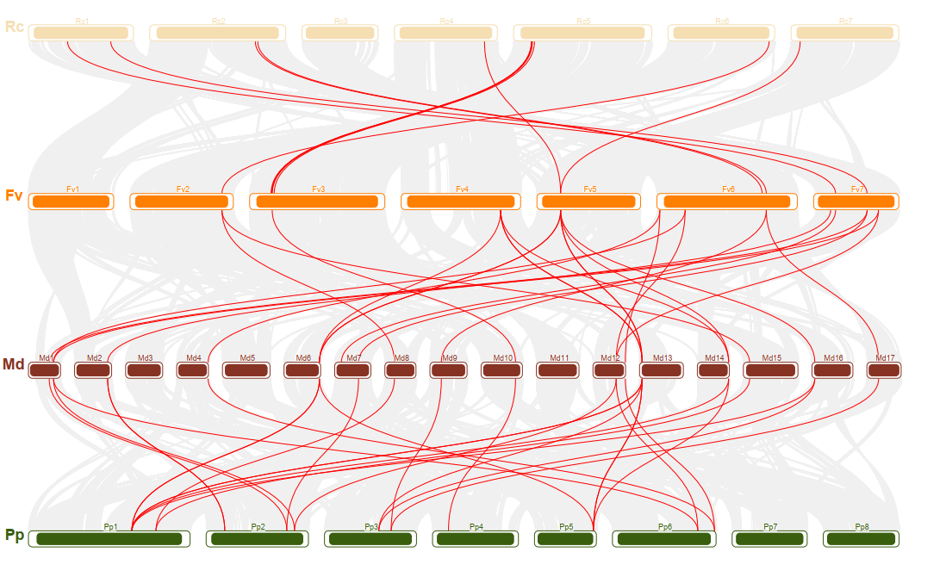
Supplementary Figure 4 Syntenic map of orthologous genes running through Rosaceae species. The different coloured bars indicate their chromosomes, the grey lines indicate pairs of genes that are covalently related, and the highlighted red lines mean both of the genes from the WAK/WAKL family.

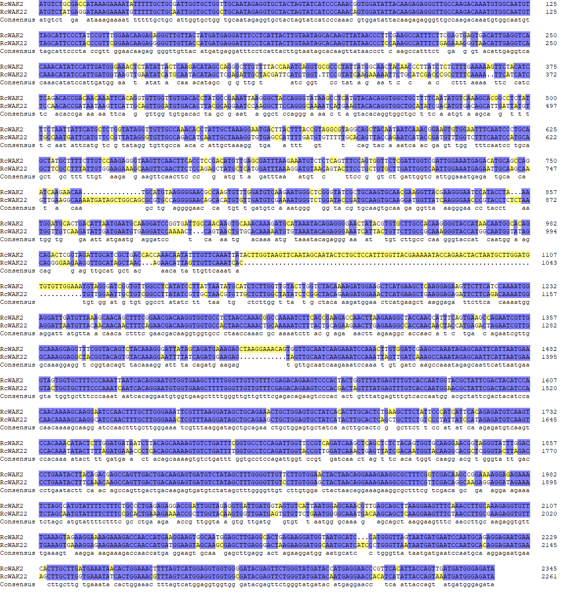

Supplementary Figure 5 Comparison of CDS (coding sequence) of RcWAK2 and RcWAK22. Sequence alignment was performed by DNAMAN with default parameters in pairwise alignment.

