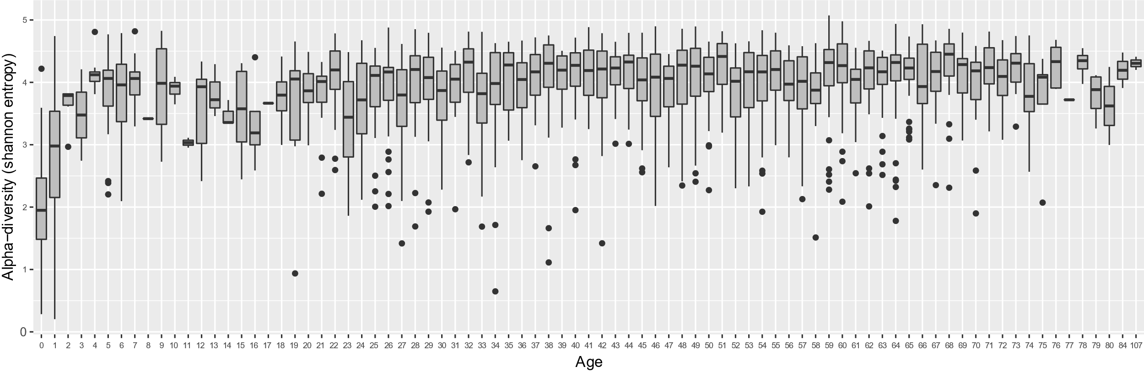
Figure S1: Shannon diversity of the metagenomes in this study. The figure shows Shannon entropy measures of the metagenomes per age category. The metagenomes in age category 0 and 1 stand out due to their low bacterial diversity compared to the other age categories. The largest difference in Shannon diversity was between age category 0 and 1 and the rest (Wilcoxon rank-sum test,
p < 10⁻¹⁵⁹).

