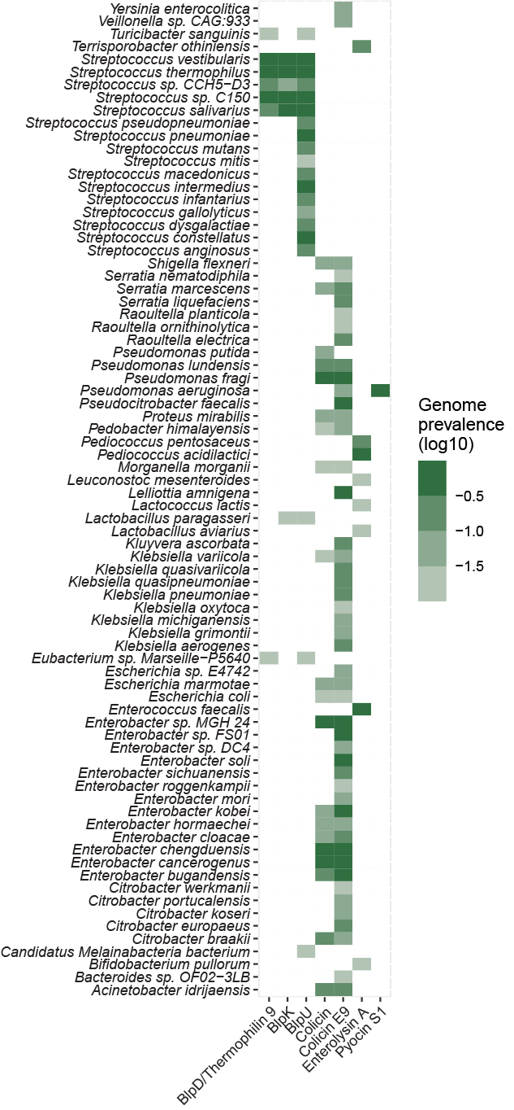
Figure S2: Bacteriocin gene distribution in gut bacterial genomes at species-level. The figure shows the prevalence of the highly prevalent bacteriocin genes detected in known human gut bacterial genomes at species-level.

