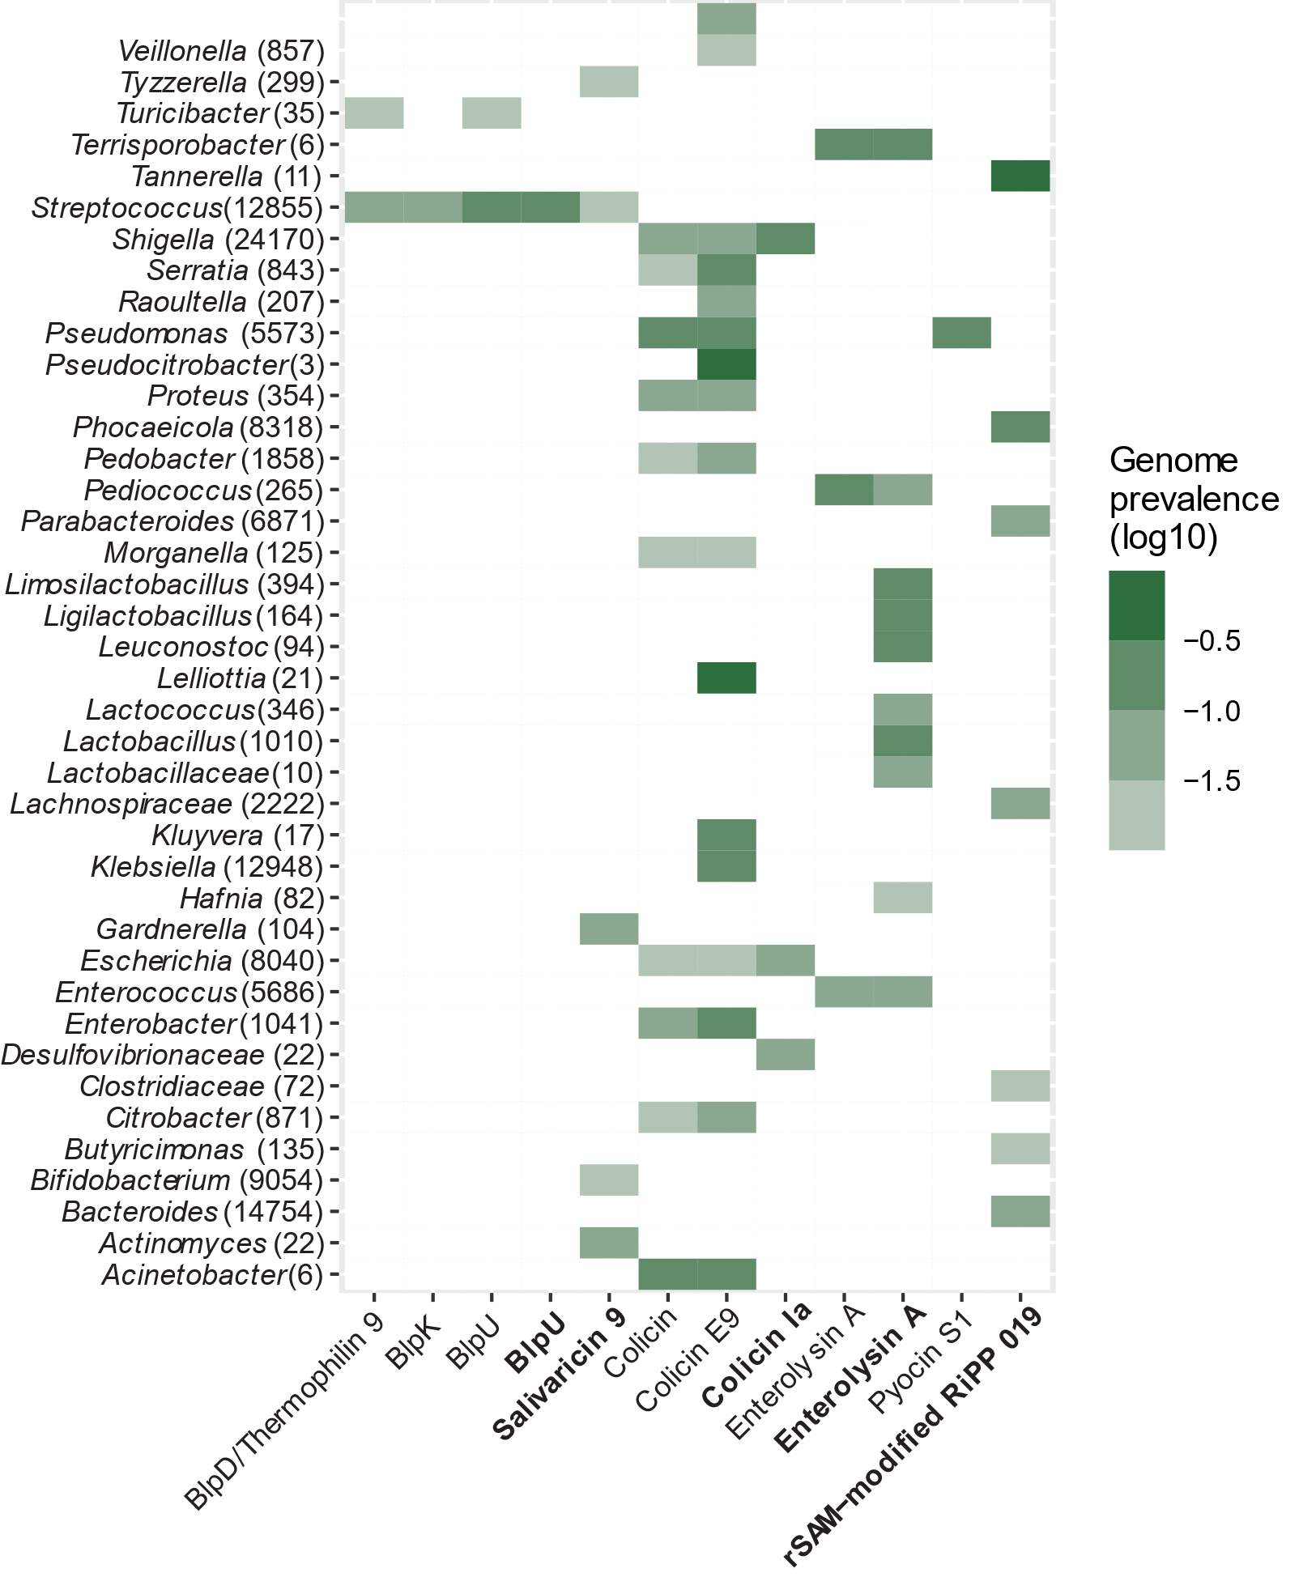
Figure S3: Distribution of highly prevalent and medium prevalent bacteriocin genes in gut bacterial genomes. The figure shows the average prevalence of the highly prevalent and medium prevalent enriched bacteriocin genes detected in known human gut bacterial genomes at genus-level. The bacteriocin names in bold are the medium prevalent bacteriocins. The number in parenthesis behind each genus is the number of genomes scanned for that genus.

