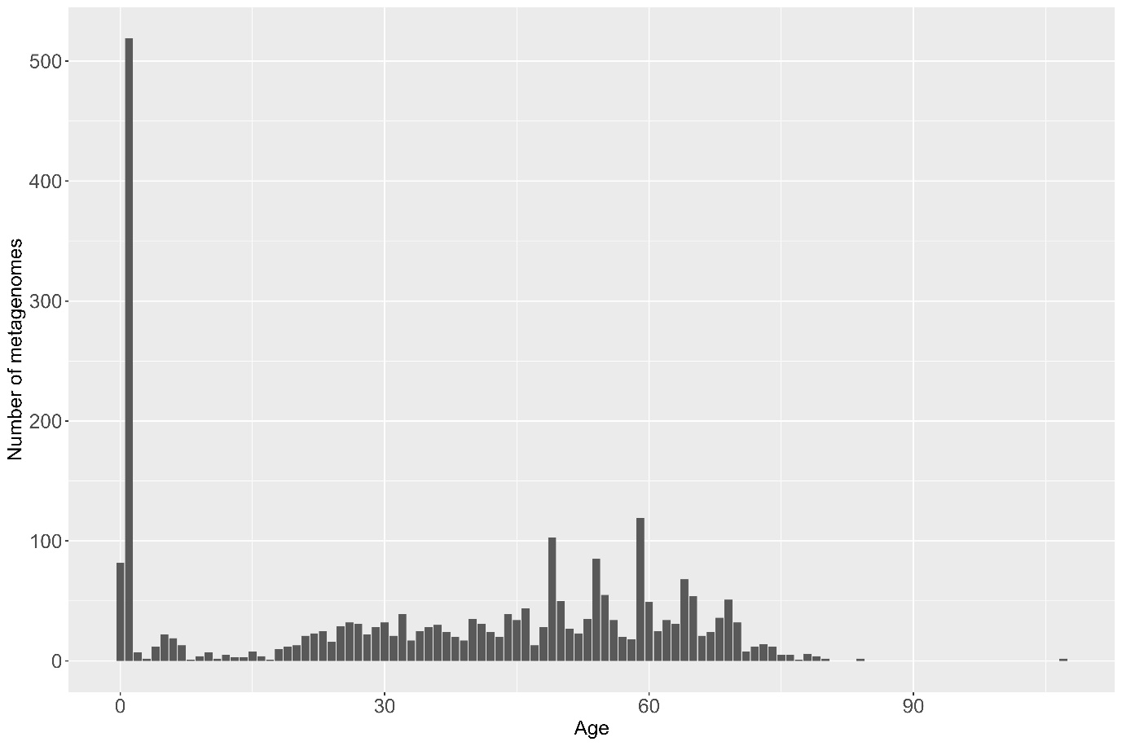
Figure S6: Distribution of metagenomes: The figure shows the number of metagenomes per age category.

