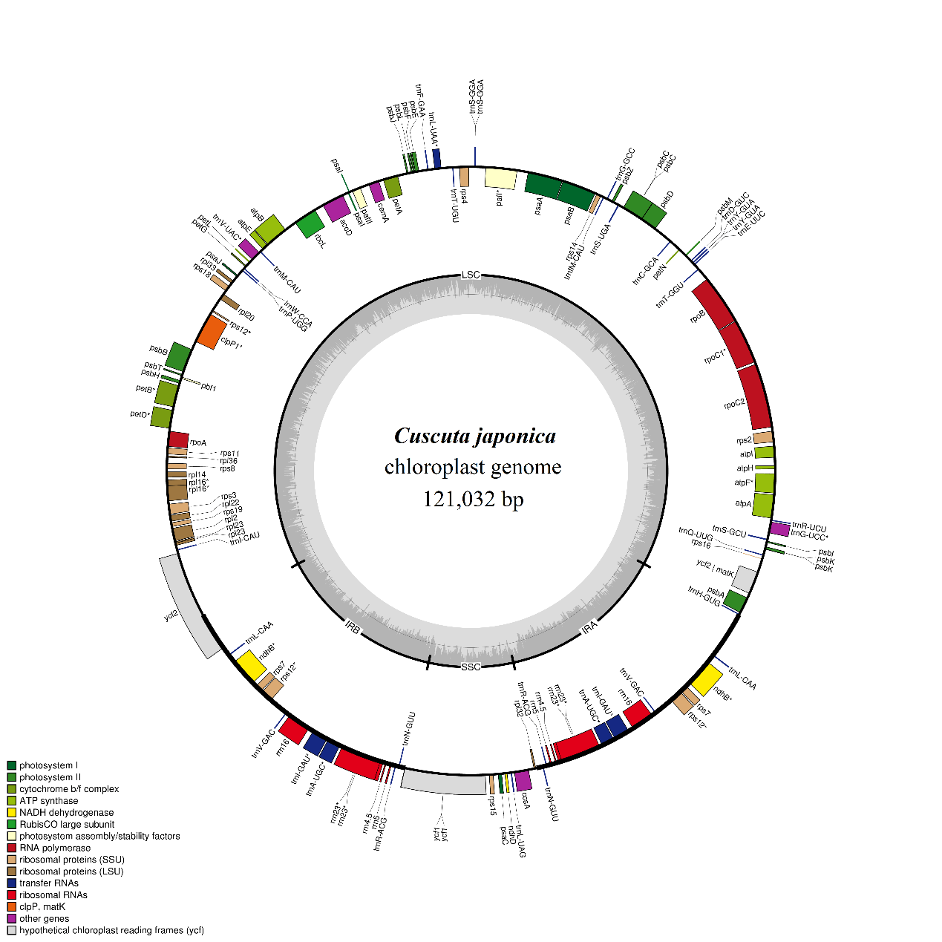
Figure S1: Genetic map of the chloroplast genomes of Cuscuta japonica.

