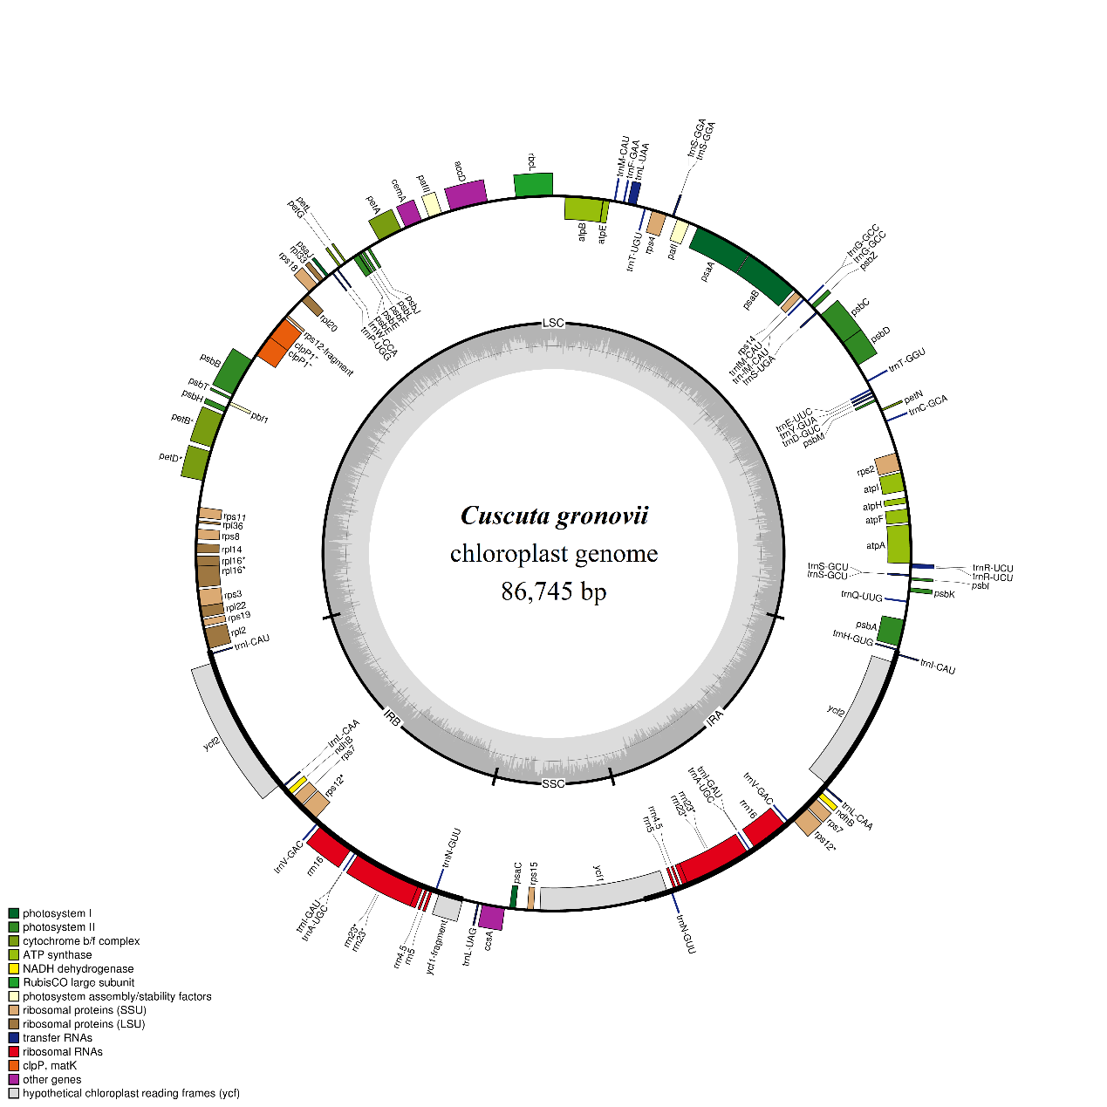
Figure S2. Genetic map of the chloroplast genomes of Cuscuta gronovii.

