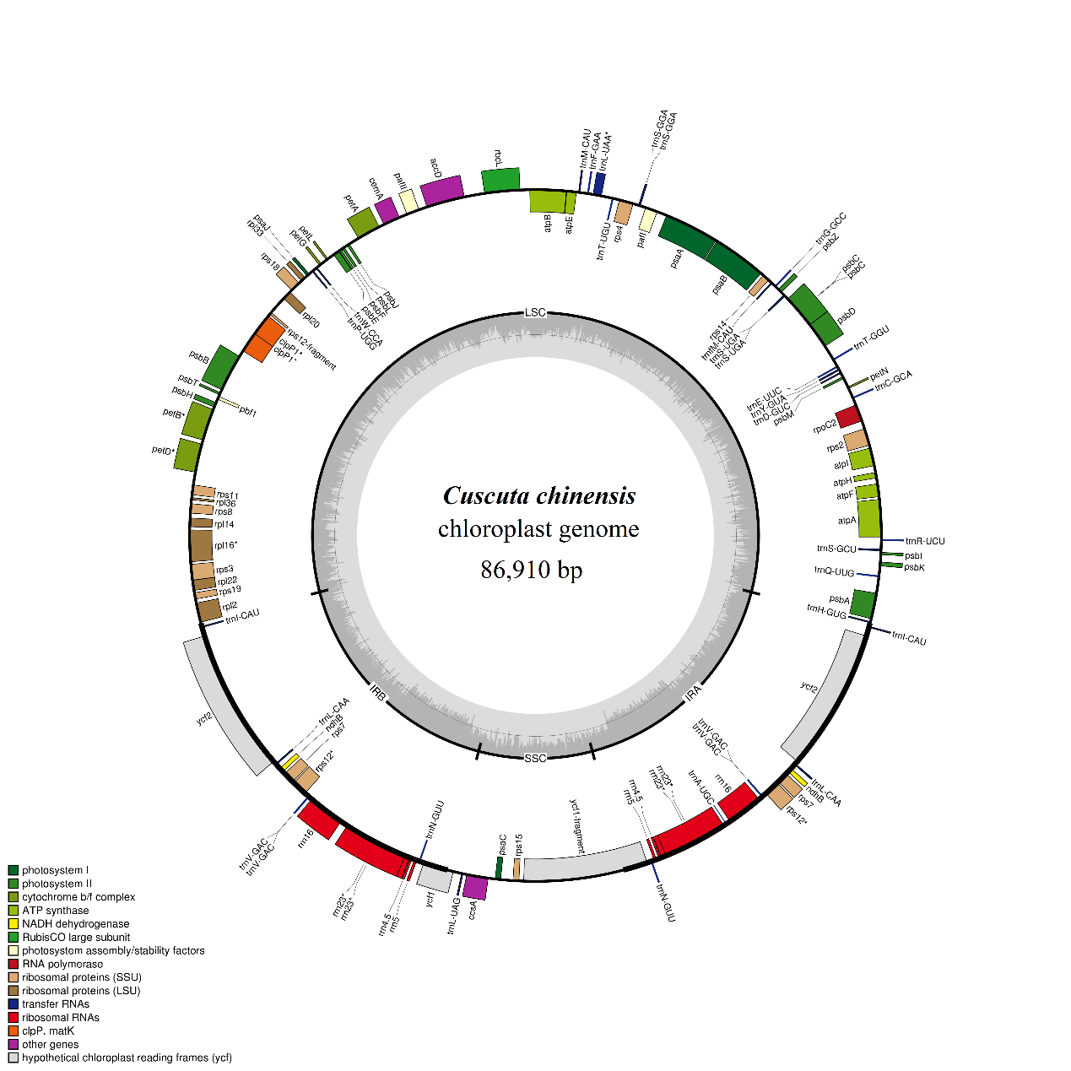
Figure S3. Genetic map of the chloroplast genomes of Cuscuta chinensis.

