Table S1. Detailed information of all identified Prunus sibirica WRKY proteins
Protein name | Sequence ID | Number of amino acids | Molecular weight  /Da | pI | Instability index | Aliphatic index | Grand average of hydropathicity | Chromosomal Location | Subcellular location prediction | Group
PsWRKY1 | PaF106G0100000825.01 | 284 | 30910.93 | 9.91 | 48.58 | 65.6 | -0.58 | Chr1 | Nuclear | II-d
PsWRKY2 | PaF106G0100001343.01 | 388 | 42657.78 | 5.95 | 63.4 | 47.58 | -0.886 | Chr1 | Nuclear | II-c
PsWRKY3 | PaF106G0100002721.01 | 185 | 20880.43 | 9.56 | 44.73 | 54.81 | -0.821 | Chr1 | Nuclear | II-c
PsWRKY4 | PaF106G0100003357.01 | 515 | 55892.53 | 8.13 | 62.24 | 50.82 | -0.924 | Chr1 | Nuclear | I
PsWRKY5 | PaF106G0100003388.01 | 424 | 46980.96 | 10.33 | 55.69 | 60.8 | -0.764 | Chr1 | Nuclear | II-c
PsWRKY6 | PaF106G0100004627.01 | 325 | 36428.04 | 7.63 | 55.27 | 63.94 | -0.733 | Chr1 | Nuclear | II-a
PsWRKY7 | PaF106G0100004628.01 | 285 | 31577.44 | 8.38 | 51.29 | 75.65 | -0.599 | Chr1 | Nuclear | II-a
PsWRKY8 | PaF106G0100004783.01 | 163 | 18833.51 | 5.12 | 46.95 | 48.34 | -1.164 | Chr1 | Nuclear | II-c
PsWRKY9 | PaF106G0100005037.01 | 364 | 39656.95 | 9.32 | 54.08 | 59.23 | -0.573 | Chr1 | Nuclear | II-d
PsWRKY10 | PaF106G0100005329.01 | 345 | 37660.39 | 9.42 | 56.09 | 58.26 | -0.649 | Chr1 | Nuclear | II-d
PsWRKY11 | PaF106G0100006525.01 | 562 | 62075 | 5.21 | 52.62 | 58.54 | -0.963 | Chr1 | Nuclear | II-b
PsWRKY12 | PaF106G0200008520.01 | 244 | 27730.33 | 7.29 | 44.4 | 44.67 | -1.026 | Chr2 | Nuclear | II-c
PsWRKY13 | PaF106G0200009086.01 | 363 | 40001.12 | 7.16 | 54.03 | 48.9 | -0.837 | Chr2 | Nuclear | II-e
PsWRKY14 | PaF106G0200009090.01 | 221 | 24717.93 | 9.22 | 45.21 | 68.42 | -0.725 | Chr2 | Peroxisome | II-c
PsWRKY15 | PaF106G0200009172.01 | 358 | 39659.14 | 5.03 | 43.98 | 61.62 | -0.582 | Chr2 | Nuclear | III
PsWRKY16 | PaF106G0200009748.01 | 209 | 23893.9 | 8.9 | 46.54 | 61.1 | -0.904 | Chr2 | Peroxisome | II-c
PsWRKY17 | PaF106G0200010134.01 | 323 | 36428.42 | 5.7 | 47.03 | 56.13 | -0.853 | Chr2 | Nuclear | III
PsWRKY18 | PaF106G0200010574.01 | 296 | 32774.38 | 9.68 | 54.08 | 67.26 | -0.603 | Chr2 | Nuclear | II-e
PsWRKY19 | PaF106G0200010641.01 | 290 | 31551.62 | 5.02 | 57.96 | 51.52 | -0.74 | Chr2 | Nuclear | III
PsWRKY20 | PaF106G0300011395.01 | 505 | 55472.74 | 6.62 | 51 | 64.93 | -0.687 | Chr3 | Nuclear | II-b
PsWRKY21 | PaF106G0300011494.01 | 533 | 58223.38 | 8.18 | 62.79 | 56.75 | -0.892 | Chr3 | Nuclear | I
PsWRKY22 | PaF106G0300012051.01 | 652 | 71121.59 | 6.31 | 49.94 | 59.92 | -0.798 | Chr3 | Nuclear | II-b
PsWRKY23 | PaF106G0300012177.01 | 486 | 52923.2 | 5.9 | 41.99 | 63.29 | -0.903 | Chr3 | Nuclear | I
PsWRKY24 | PaF106G0300012509.01 | 363 | 41058.09 | 6.89 | 53.75 | 49.45 | -1.066 | Chr3 | Nuclear | II-c
PsWRKY25 | PaF106G0300013322.01 | 258 | 28060.17 | 5.13 | 54.12 | 55.19 | -0.696 | Chr3 | Nuclear | II-e
PsWRKY26 | PaF106G0300013492.01 | 272 | 30035.4 | 8.12 | 48.26 | 65.96 | -0.795 | Chr3 | Nuclear | II-a
PsWRKY27 | PaF106G0300014526.01 | 165 | 18526.84 | 9.3 | 64.88 | 53.21 | -0.681 | Chr3 | Nuclear | II-c
PsWRKY28 | PaF106G0300014596.01 | 611 | 66391.05 | 6.23 | 54.24 | 64.14 | -0.588 | Chr3 | Nuclear | II-b
PsWRKY29 | PaF106G0400015495.01 | 587 | 64119.61 | 6 | 50.75 | 54.92 | -0.831 | Chr4 | Nuclear | I
PsWRKY30 | PaF106G0400015665.01 | 536 | 58725.97 | 6.02 | 48.68 | 66.44 | -0.544 | Chr4 | Nuclear | II-b
PsWRKY31 | PaF106G0400017105.01 | 527 | 57094.68 | 6.06 | 56.09 | 54.52 | -0.761 | Chr4 | Nuclear | II-e
PsWRKY32 | PaF106G0400017434.01 | 340 | 37588.33 | 6.55 | 55.43 | 48.53 | -0.941 | Chr4 | Nuclear | II-c
PsWRKY33 | PaF106G0400017534.01 | 342 | 38516.69 | 9.16 | 53.39 | 50.23 | -0.691 | Chr4 | Nuclear | II-e
PsWRKY34 | PaF106G0400018245.01 | 617 | 67027.07 | 7.34 | 46.93 | 60.16 | -0.761 | Chr4 | Nuclear | II-b
PsWRKY35 | PaF106G0500019357.01 | 330 | 36942.17 | 9.68 | 54.35 | 72.7 | -0.623 | Chr5 | Nuclear | II-d
PsWRKY36 | PaF106G0500019756.01 | 314 | 35487.83 | 5.18 | 60.23 | 70.83 | -0.593 | Chr5 | Nuclear | II-e
PsWRKY37 | PaF106G0500019874.01 | 248 | 28031.79 | 5.12 | 64.54 | 47.22 | -0.866 | Chr5 | Nuclear | III
PsWRKY38 | PaF106G0500020691.01 | 683 | 73580.87 | 6.95 | 49.02 | 55.94 | -0.811 | Chr5 | Nuclear | II-b
PsWRKY39 | PaF106G0500020010.01 | 205 | 23126.62 | 4.78 | 31.07 | 72.73 | -0.768 | Chr5 | Chloroplast | I
PsWRKY40 | PaF106G0600021797.01 | 697 | 75002.92 | 5.61 | 52.3 | 53.49 | -0.776 | Chr6 | Nuclear | I
PsWRKY41 | PaF106G0600021917.01 | 590 | 64692.37 | 6.58 | 52.5 | 45.15 | -0.945 | Chr6 | Nuclear | I
PsWRKY42 | PaF106G0600023566.01 | 196 | 21998.11 | 6.21 | 56.69 | 42.19 | -0.989 | Chr6 | Nuclear | II-c
PsWRKY43 | PaF106G0600024291.01 | 326 | 35586.26 | 9.6 | 41.21 | 67.33 | -0.54 | Chr6 | Nuclear | II-d
PsWRKY44 | PaF106G0600024432.01 | 479 | 52136.65 | 8.91 | 49.61 | 55.55 | -0.92 | Chr6 | Nuclear | I
PsWRKY45 | PaF106G0600024597.01 | 252 | 28590.67 | 9.27 | 47.6 | 62.34 | -0.775 | Chr6 | Peroxisome | II-c
PsWRKY46 | PaF106G0600024936.01 | 536 | 59540.37 | 7.17 | 62.54 | 48.21 | -0.94 | Chr6 | Nuclear | I
PsWRKY47 | PaF106G0600025042.01 | 354 | 39732.74 | 5.65 | 53.66 | 57.37 | -0.781 | Chr6 | Nuclear | III
PsWRKY48 | PaF106G0600025043.01 | 337 | 38056.18 | 5.5 | 45.51 | 61.6 | -0.698 | Chr6 | Nuclear | III
PsWRKY49 | PaF106G0600025044.01 | 336 | 37434.25 | 5.81 | 49.6 | 61.22 | -0.708 | Chr6 | Nuclear | III
PsWRKY50 | PaF106G0600025642.01 | 355 | 40054.93 | 9.68 | 50.11 | 69.18 | -0.763 | Chr6 | Nuclear | II-d
PsWRKY51 | PaF106G0600025823.01 | 512 | 56847.87 | 6.53 | 52.82 | 59.22 | -0.818 | Chr6 | Nuclear | I
PsWRKY52 | PaF106G0700026001.01 | 533 | 58804.27 | 5.54 | 57.32 | 66.02 | -0.834 | Chr7 | Nuclear | I
PsWRKY53 | PaF106G0800029338.01 | 262 | 29836.13 | 5.29 | 67.04 | 58.36 | -1.011 | Chr8 | Nuclear | II-d
PsWRKY54 | PaF106G0800029773.01 | 355 | 40061.3 | 9.61 | 58.09 | 62.59 | -0.85 | Chr8 | Nuclear | II-d
PsWRKY55 | PaF106G0800031110.01 | 291 | 32971.63 | 8.91 | 44.92 | 79.07 | -0.387 | Chr8 | Nuclear | II-c

Table S2. Primer pairs used for qRT-PCR analysis on the target sequences in P. sibirica
PsWRKY | Primer pairs
PsWRKY | Forward primer (5'-3') | Reverse primer (5'-3')
PsWRKY1 | TCGTCGGGTTCTCAAGGAT | TCGGTGATTTCTCGGCAGT
PsWRKY4 | GGCAGAAAGTCGTCAAAG | GTTGTTGGCTGCGTAGTG
PsWRKY6 | TATTCCTTTCCACCCTGCTAG | TGCTGCCTCTTGTTTCACC
PsWRKY9 | TCTTCCTCATCGAACCCTG | GGAGGCGGAGATGGAGT
PsWRKY10 | CCAGCAGCAAACTAACCAG | TGTGAATACGAGGGATGAGAAG
PsWRKY12 | CTTAGGGAGCCAAGATTC | TTCTTCACCCGACAGTTAC
PsWRKY13 | AAAGGGCAGTCCTATGGTC | ACAAAGAAATCGTCGCTCAC
PsWRKY14 | TAATGTTGGTGCCTCTGCT | CTGGCTTTCTCATCTTACCC
PsWRKY18 | AACAAGTGGAGCGGAGTAC | CGTTGGACGAGGGTGATT
PsWRKY21 | ATGGCGGTGAGAACAAGTC | AAAGAAGCCAGGCGAGTTAAG
PsWRKY27 | TGGCTACAGATGGAGAAAG | GAGTTGGGCGAGGTATGAG
PsWRKY36 | TAGCAGGAAGAATCAGAGC | TGCCCATATTTACGCCAC
PsWRKY38 | AATCATTGGCAGCAACAGT | GCGTTTGGAGGTATGGAGAAG
PsWRKY42 | ATGGGTCATAGGGTTGCTT | TTGGATTTGGGCTGTTCTT
PsWRKY44 | ATCAGTCGAGGCTGGTGTT | TATTGGCTGTGGACGGTAT
PsWRKY51 | TGCCTCAGCCTAATCGT | CCAGACCTTCAGCCCTC
PsWRKY52 | GACATGCCTGTTCCAAAG | TCACCAGTCAATTCTCCC
PsWRKY54 | GGAGACGATGGGAGTGT | TTGGCTTCTGTCCATACTT
PsWRKY55 | ACCAAGCCACGAGAACACT | CCAACAGCATACCGAATAG
PsWRKY15 | CTGGAACAGGGCTAGATGG | TTTGAACTTGCTTGGTGGC
PsWRKY17 | TTTTGGCGAGGTTTATC | CCTGCACCTTCCTACTCT
PsWRKY49 | TCAAATAGGGAAAGGGTG | CCTCTGCCGACTCAACAT
PsWRKY5 | GCTTGTTGCGGACTGCTTAC | GTATCTCGGGCGGTGGTTT
18SrRNA | AAACGGCTACCACATCCA | CACCAGACTTGCCCTCCA

Table S3. Quantitative real-time PCR candidate gene information
Gene ID | Sequence ID | Gene Information
PsWRKY1 | PaF106G0100000825.01 | Contains LTR cis-acting elements
PsWRKY4 | PaF106G0100003357.01 | Contains LTR cis-acting elements; response to stimuli (GO:0050896)
PsWRKY5 | PaF106G0100003388.01 | reproductive process (GO:0022414); reproduction (GO:0000003); Homologs of the cold resistance gene PmWRKY57 in Prunus mume [16]
PsWRKY6 | PaF106G0100004627.01 | regulation of response to stimulus (GO:0048583)
PsWRKY9 | PaF106G0100005037.01 | Contains cis-acting regulatory element involved in the MeJA-responsiveness
PsWRKY10 | PaF106G0100005329.01 | response to external stimulus (GO:0009605);
PsWRKY12 | PaF106G0200008520.01 | Homologs of the cold resistance gene PmWRKY57 in Prunus mume[16]
PsWRKY13 | PaF106G0200009086.01 | Contains LTR cis-acting elements; developmental process (GO:0032502)
PsWRKY14 | PaF106G0200009090.01 | Contains a variety of cis-acting elements associated with plant growth and development
PsWRKY15 | PaF106G0200009172.01 | Homologs of the frost resistance gene PARG18453 in Prunus armeniaca ; developmental process (GO:0032502)
PsWRKY17 | PaF106G0200010134.01 | regulation of response to stimulus (GO:0048583); response to external stimulus (GO:0009605); Homologs of the frost resistance gene PARG18453 in Prunus armeniaca
PsWRKY18 | PaF106G0200010574.01 | response to external stimulus (GO:0009605)
PsWRKY21 | PaF106G0300011494.01 | Contains LTR cis-acting elements
PsWRKY27 | PaF106G0300014526.01 | Contains LTR cis-acting elements; response to external stimulus (GO:0009605)
PsWRKY36 | PaF106G0500019756.01 | Contains LTR cis-acting elements
PsWRKY38 | PaF106G0500020691.01 | Contains LTR cis-acting elements
PsWRKY42 | PaF106G0600023566.01 | response to external stimulus (GO:0009605)
PsWRKY44 | PaF106G0600024432.01 | reproductive process (GO:0022414); reproduction (GO:0000003)
PsWRKY49 | PaF106G0600025044.01 | regulation of response to stimulus (GO:0048583); response to external stimulus (GO:0009605); Homologs of the frost resistance gene PARG18453 in Prunus armeniaca
PsWRKY51 | PaF106G0600025823.01 | reproductive process (GO:0022414); reproduction (GO:0000003); developmental process (GO:0032502)
PsWRKY52 | PaF106G0700026001.01 | Contains LTR cis-acting elements
PsWRKY54 | PaF106G0800029773.01 | Contains LTR cis-acting elements
PsWRKY55 | PaF106G0800031110.01 | Contains LTR cis-acting elements
Note: LTR cis-acting element involved in low-temperature responsiveness

Table S4. Mass concentrations in aseptic seedlings of P. sibirica total RNA
Type | RNA concentration（ng.μL⁻¹） | RNA integrity number
0 h | 786 | 9.1
15 min | 987 | 7.2
30 min | 1408 | 8.3
1 h | 1186 | 9.1
2 h | 1097 | 7.3
petal | 628 | 8.6
pistil | 969 | 8.6
root | 1178 | 8.7
stem | 1103 | 8.9
leaf | 927 | 7.1

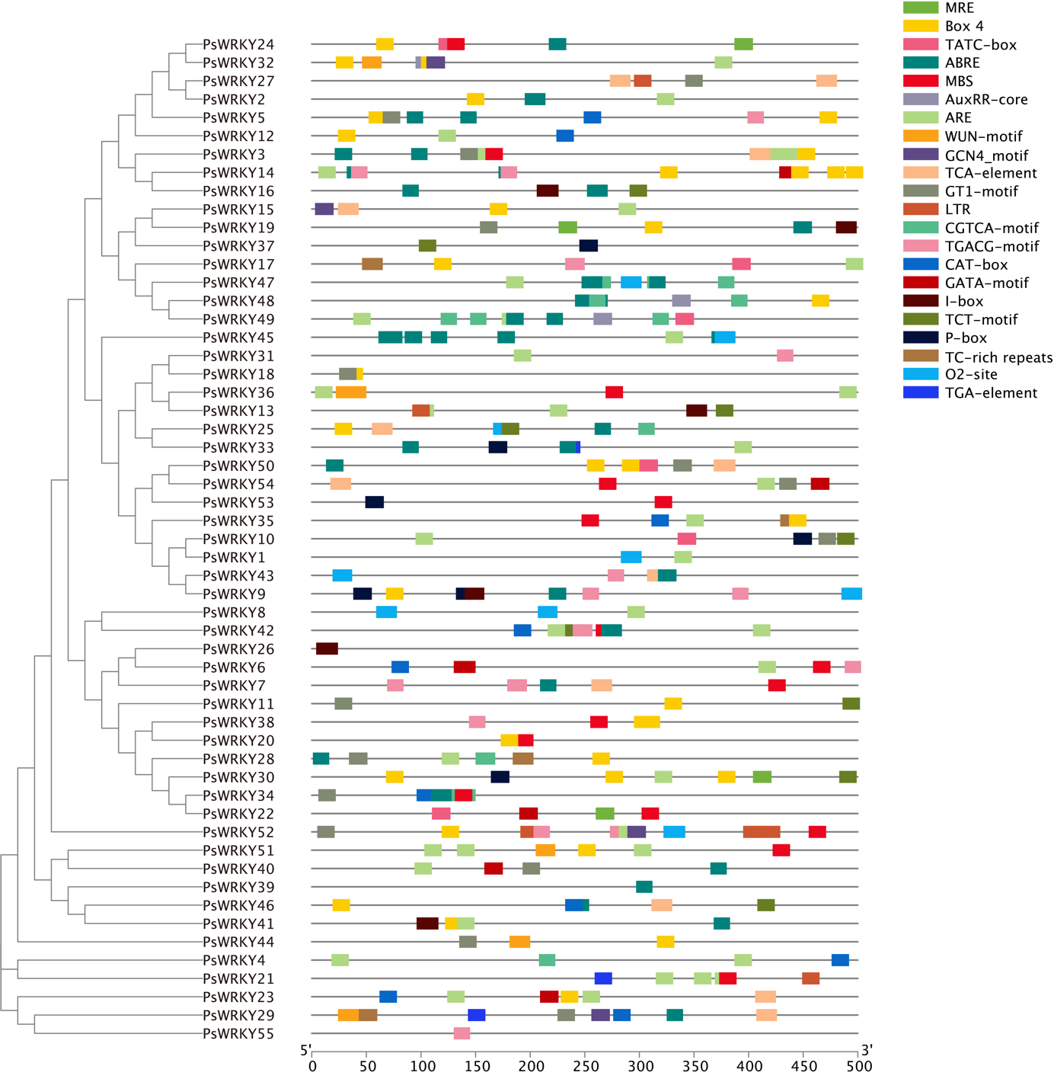
Figure S1. Cis-acting elements of the PsWRKYs
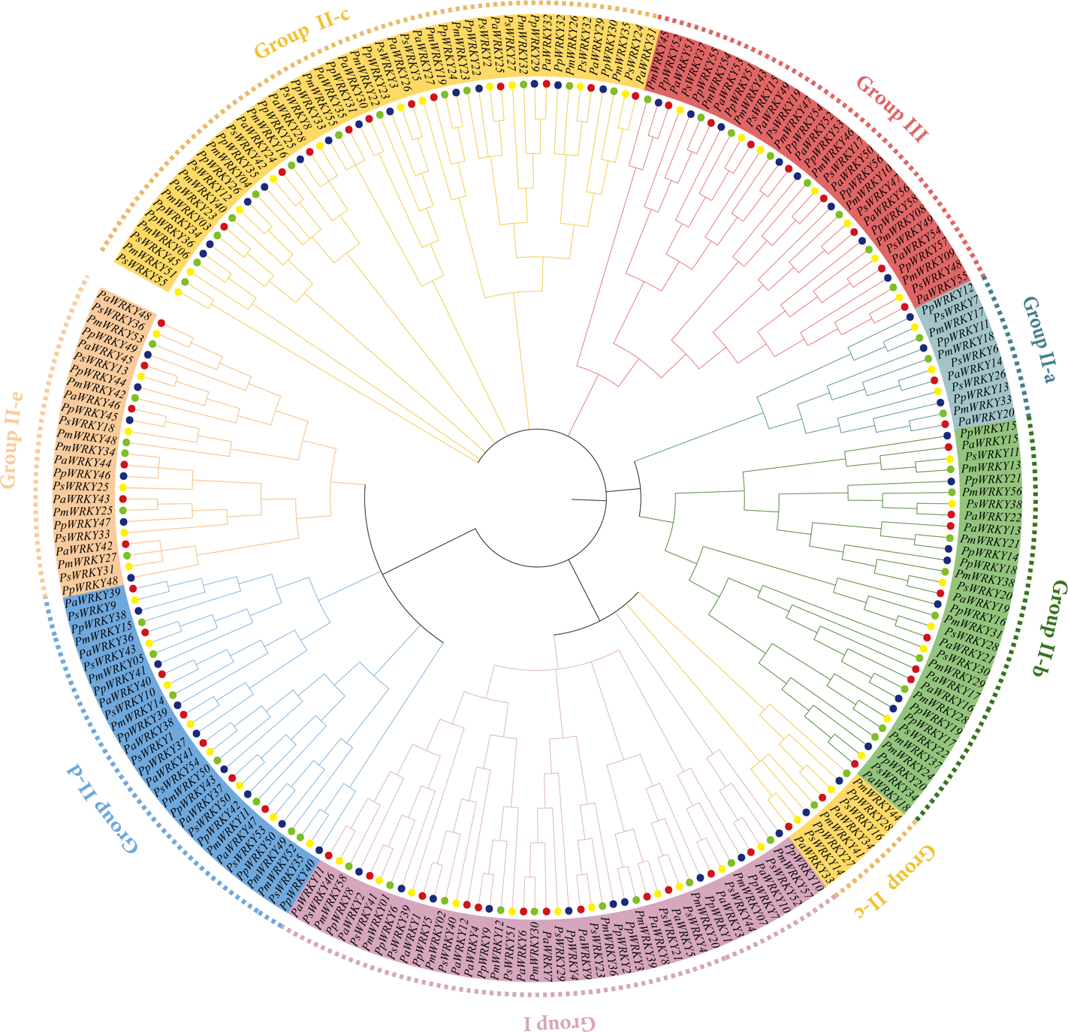
Figure S2. Phylogenetic tree of WRKY gene family from P. sibirica, P. mume, P. persica, and P. armeniaca.
Subgroups of WRKY gene family are highlighted with different colors. P. sibirica, P. mume, P. persica, and P. armeniaca are marked as yellow, green, blue, and red circles, respectively.

