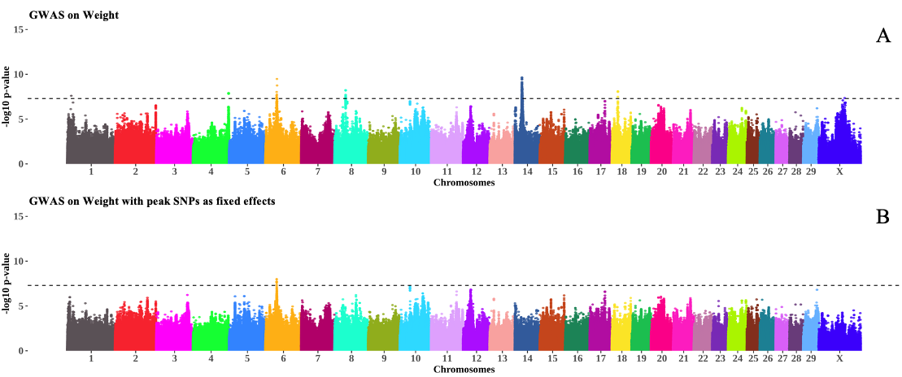
Figure S1. The Manhattan plot in A shows associations for Weight in GWAS LOCO, whereas the Manhattan plot in B shows associations for Weight after fitting the most significant SNP in each chromosome as a fixed effect. The inverse log p – values for each SNP are plotted along the y-axis for each chromosome on the x-axis. The dotted line represents the genome-wide significance threshold of 5 x 10⁻⁸.

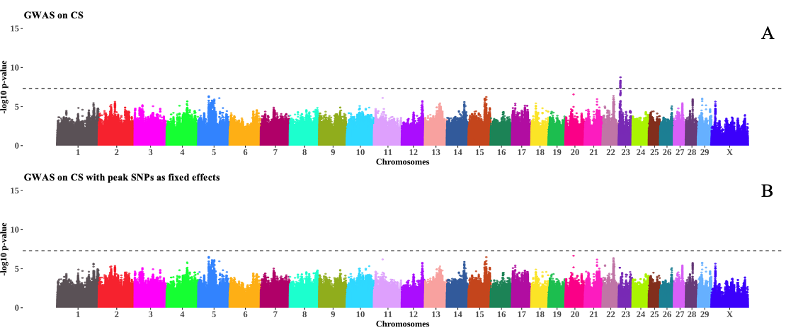
Figure S2. The Manhattan plot in A shows associations for CS in GWAS LOCO, whereas the Manhattan plot in B shows associations for CS after fitting the most significant SNP in each chromosome as a fixed effect. The inverse log p – values for each SNP are plotted along the y-axis for each chromosome on the x-axis. The dotted line represents the genome-wide significance threshold of 5 x 10⁻⁸.

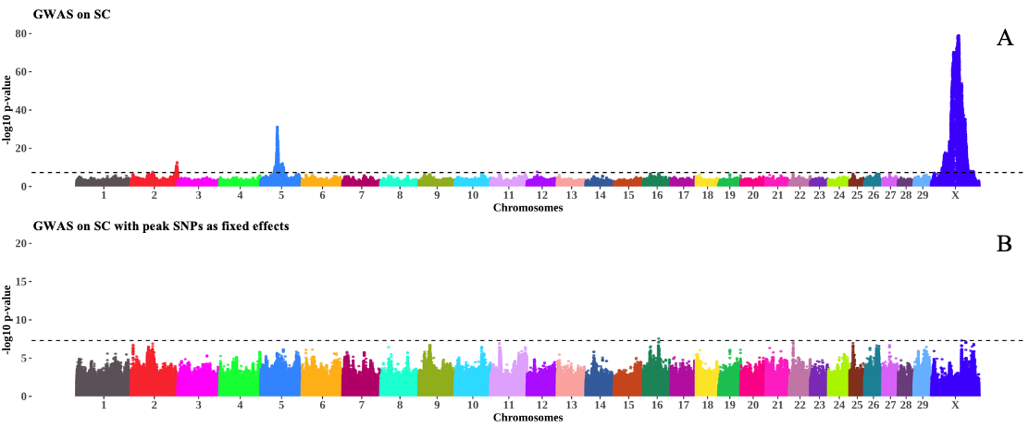
Figure S3. The Manhattan plot in A shows associations for SC in GWAS LOCO, whereas the Manhattan plot in B shows associations for SC after fitting the most significant SNP in each chromosome as a fixed effect. The inverse log p – values for each SNP are plotted along the y-axis for each chromosome on the x-axis. The dotted line represents the genome-wide significance threshold of 5 x 10⁻⁸.

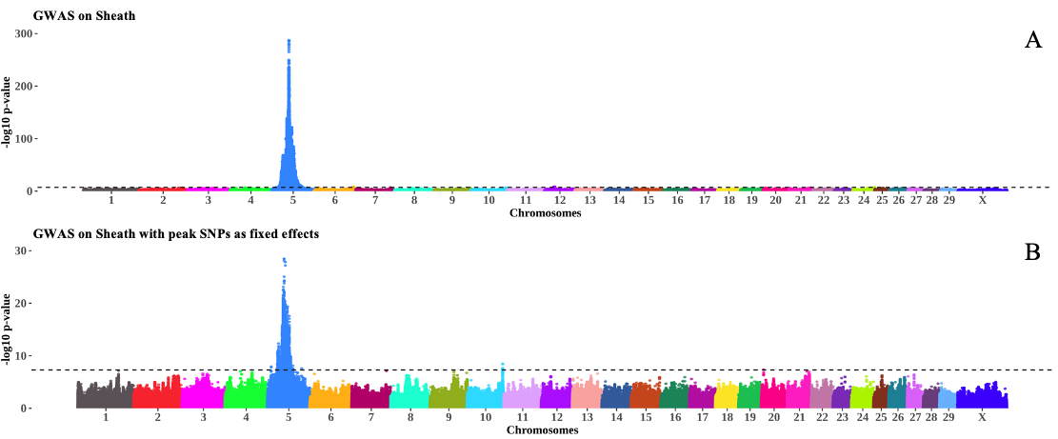
Figure S4. The Manhattan plot in A shows associations for Sheath in GWAS LOCO, whereas the Manhattan plot in B shows associations for Sheath after fitting the most significant SNP in each chromosome as a fixed effect. The inverse log p – values for each SNP are plotted along the y-axis for each chromosome on the x-axis. The dotted line represents the genome-wide significance threshold of 5 x 10⁻⁸.

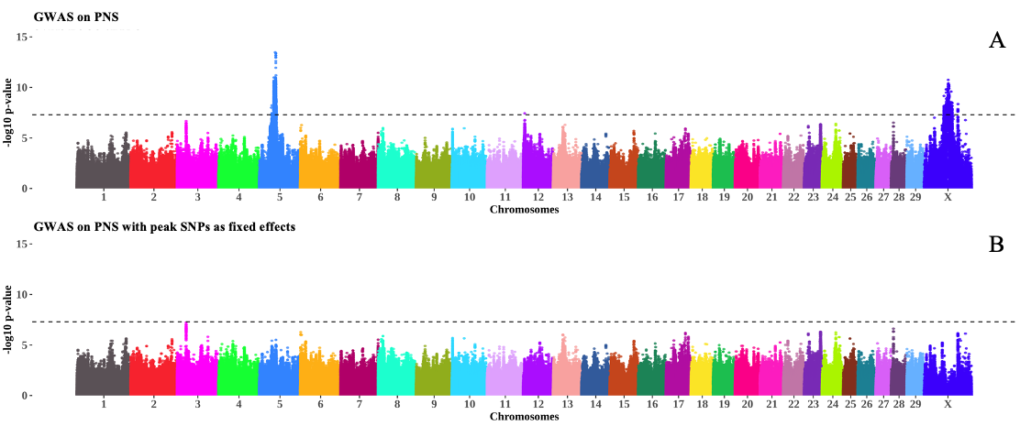
Figure S5. The Manhattan plot in A shows associations for PNS in GWAS LOCO, whereas the Manhattan plot in B shows associations for PNS after fitting the most significant SNP in each chromosome as a fixed effect. The inverse log p – values for each SNP are plotted along the y-axis for each chromosome on the x-axis. The dotted line represents the genome-wide significance threshold of 5 x 10⁻⁸.
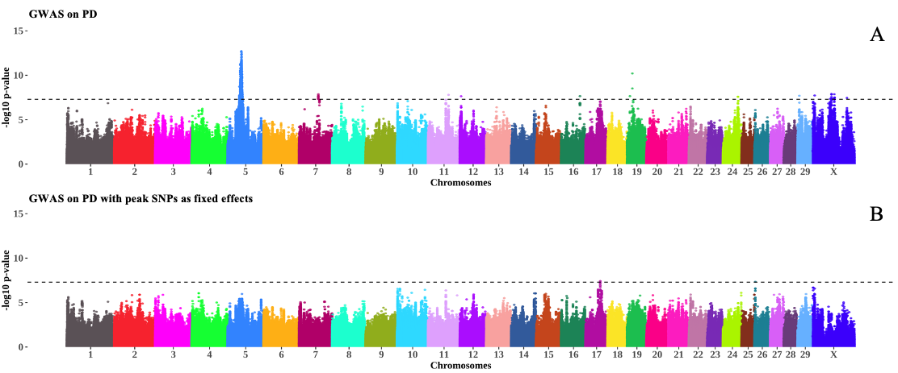
Figure S6. The Manhattan plot in A shows associations for PD in GWAS LOCO, whereas the Manhattan plot in B shows associations for PD after fitting the most significant SNP in each chromosome as a fixed effect. The inverse log p – values for each SNP are plotted along the y-axis for each chromosome on the x-axis. The dotted line represents the genome-wide significance threshold of 5 x 10⁻⁸.

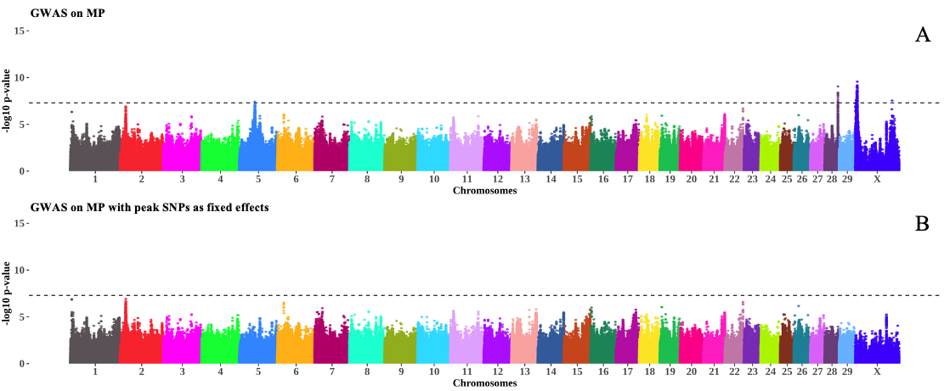
Figure S7. The Manhattan plot in A shows associations for MP in GWAS LOCO, whereas the Manhattan plot in B shows associations for MP after fitting the most significant SNP in each chromosome as a fixed effect. The inverse log p – values for each SNP are plotted along the y-axis for each chromosome on the x-axis. The dotted line represents the genome-wide significance threshold of 5 x 10⁻⁸.

