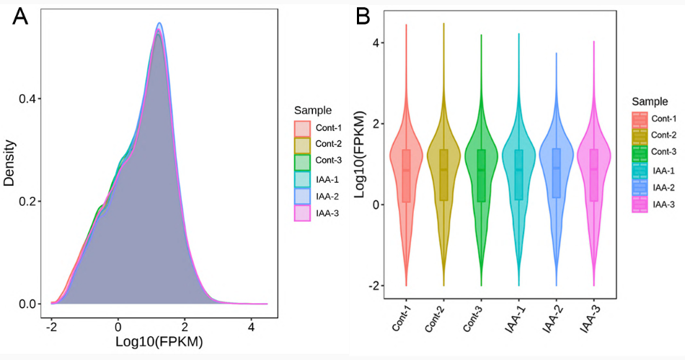
Fig. s2 The FPKM density distribution curve and box diagram of each sample. (a) Different colored curves in the figure represent different samples. The abscissa of each point on the curve represents the logarithm of the corresponding sample FPKM, and the ordinate of each point represents the probability density. (b) The different colors in the figures represent different samples. The abscissa is the name of the sample, and the ordinate is log10 (FPKM). The width of each violin figure reflects the number of genes at this expression level.

