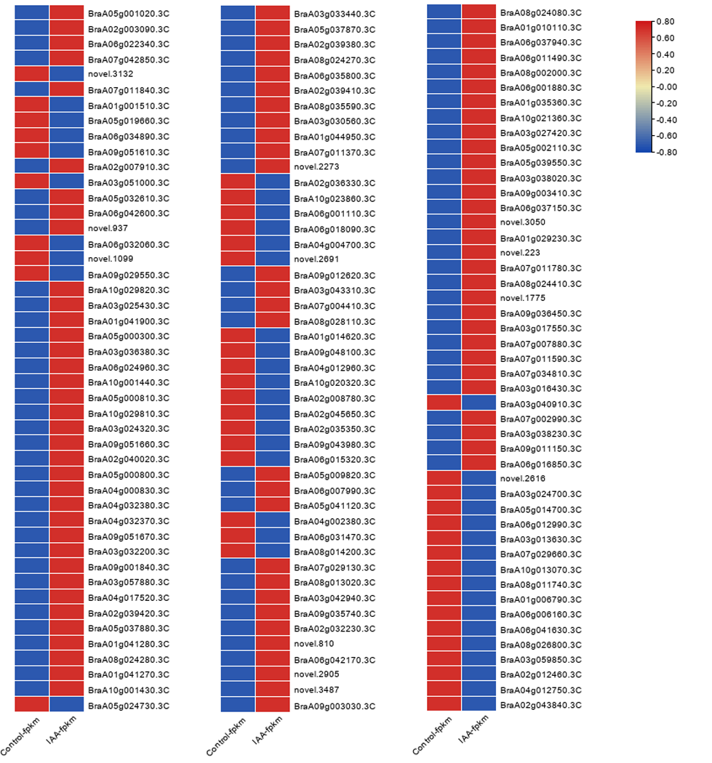
Fig s4. Heat map of DEGs.
Note: Each row represents a gene, red represents upregulation, and blue represents downregulation.

