Supplementary Information

The retinoic acid response is a minor component of the cardiac phenotype in H9c2 myoblast differentiation
Carlos Campero-Basaldua, Jessica Herrera-Gamboa, Judith Bernal-Ramírez, Silvia Lopez-Moran, Luis-Alberto Luévano-Martínez, Hugo Alves-Figueiredo, Guillermo Guerrero, Gerardo García-Rivas, Víctor Treviño

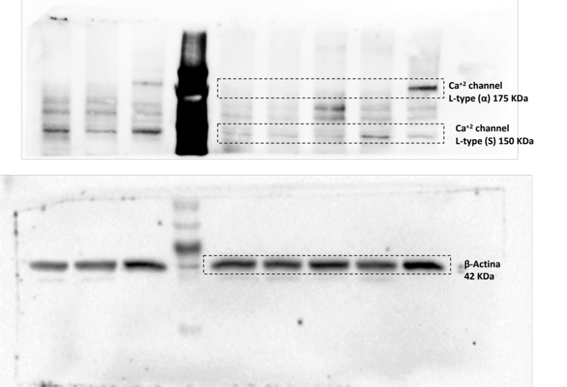
Supplementary Figure 1. Original western blots gel images. Top gel shows the two digital cuts shown in main manuscript for the labeled calcium channels. Bottom gel shows the corresponding digital cut for the beta-actin protein.

