Genetic diversity and genome-wide association study of 13 agronomic traits in 977 Beta vulgaris L. germplasms
Dali Liu^{1,2}, Wenbo Tan^{1,2}, Hao Wang^{1,2}, Wangsheng Li^{1,2}, Jingjing Fu^{1,2}, Jiajia Li^{1,2}, Yuanhang Zhou³, Ming Lin³, Wang Xing^{1,2,*}
1 National Beet Medium-term Gene Bank, Heilongjiang University, Harbin, 150080, P. R. China
2 Key Laboratory of Sugar Beet Genetics and Breeding, College of Advanced Agriculture and Ecological Environment, Heilongjiang University, Harbin 150080, P. R. China
3 Xinjiang Academy of Agricultural Sciences, Urumqi 830091, P. R. China
* Correspondence: xyjiayou_086@163.com; Tel.: +86 451 86609494

Supplementary Figures

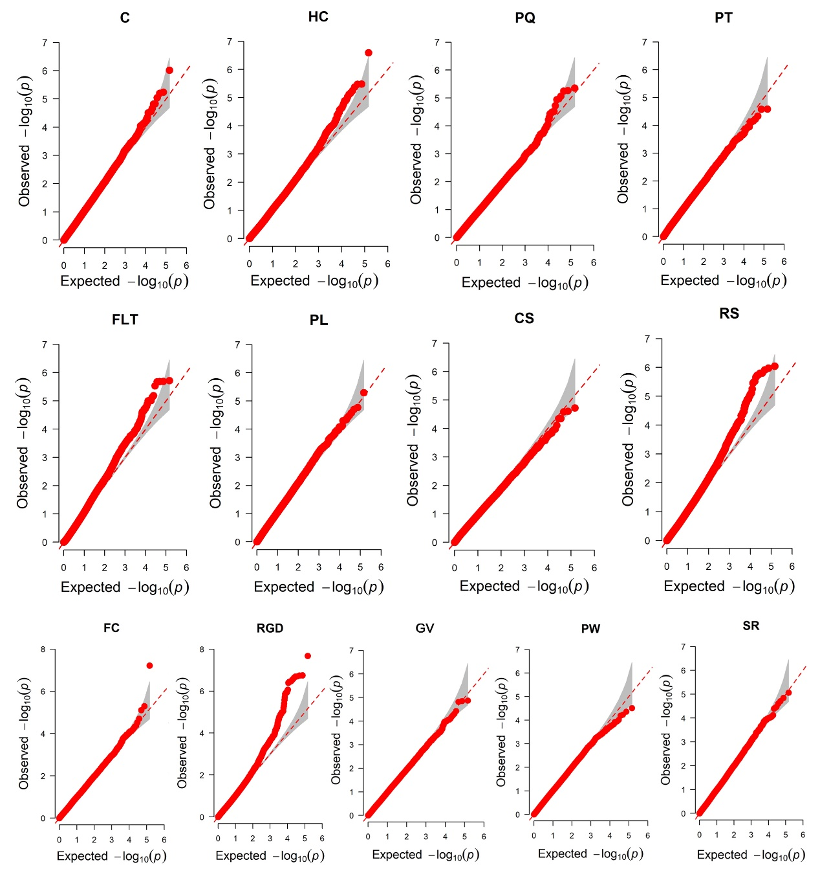
Fig. S1 Quantile–quantile (QQ) plots of 13 descriptive traits constructed using a mixed linear model (MLM). PQ, pollen quantity; PT, plant type; HC, hypocotyl colour; C, cotyledon size; PW, petiole width; PL, petiole length; FLT, fascicled leaf type; RS, root shape; CS, crown size; RGD, root groove depth; SR, skin roughness; F, flesh colour; GV, growth vigour.

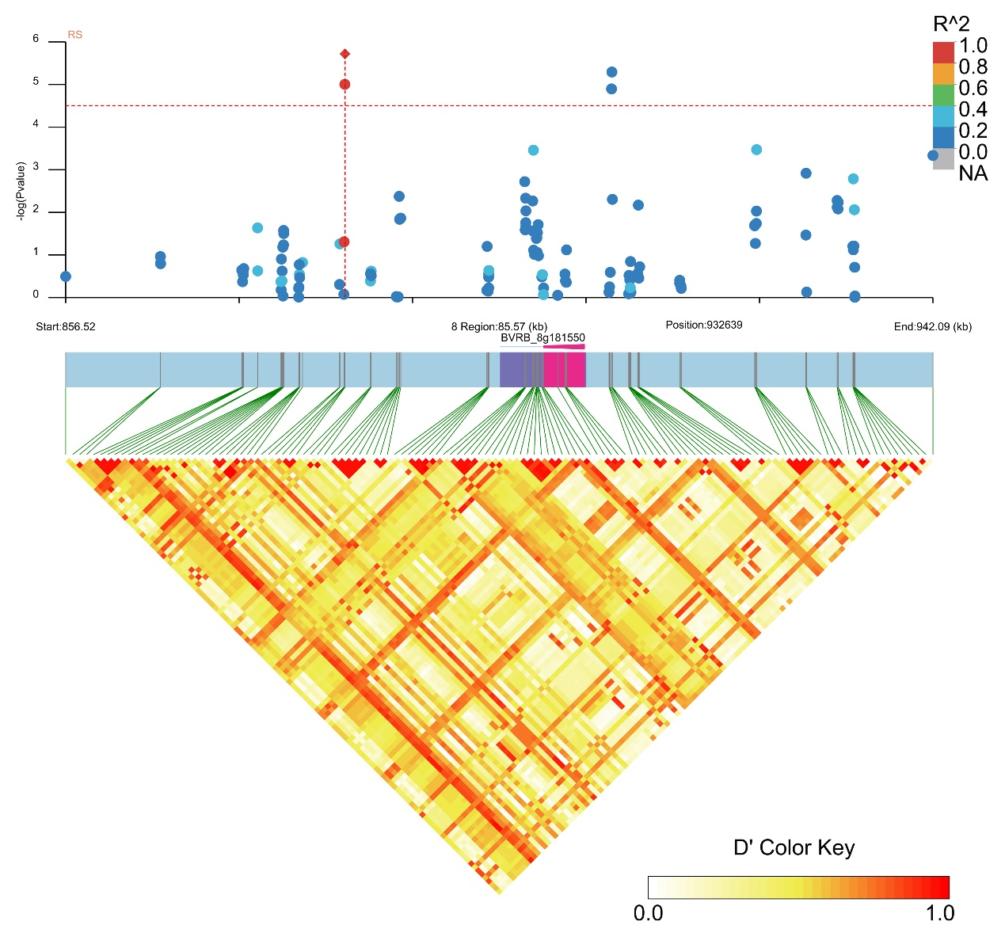
Fig. S2 Manhattan plot and LD heatmap of the candidate genes for RS. The orange vertical line indicates the position of the associated SNPs, and the orange horizontal line indicates -log₁₀p.
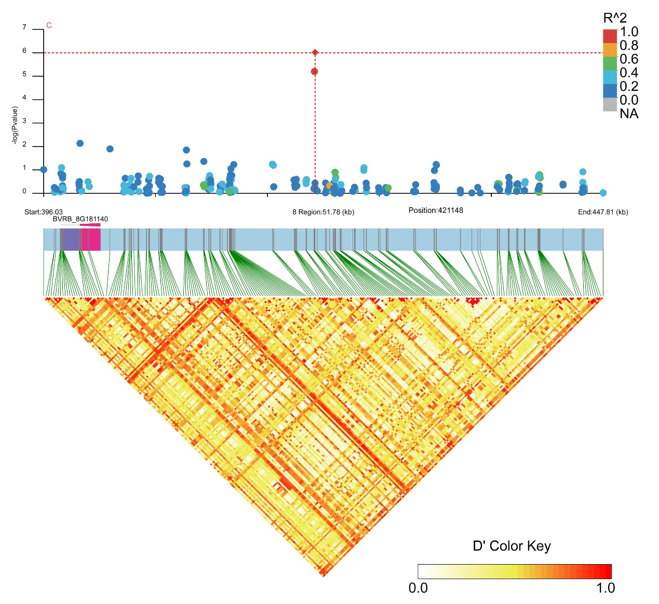
Fig. S3 Manhattan plot and LD heatmap of the candidate genes for C. The orange vertical line indicates the position of the associated SNPs, and the orange horizontal line indicates -log₁₀p.

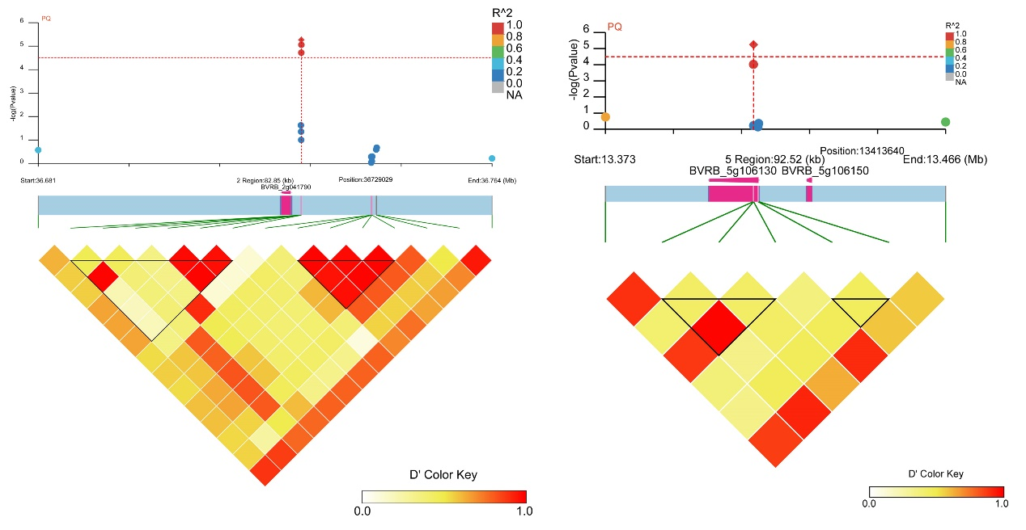
Fig. S4 Manhattan plot and LD heatmap of the candidate genes for PQ. The orange vertical line indicates the position of the associated SNPs, and the orange horizontal line indicates -log₁₀p.
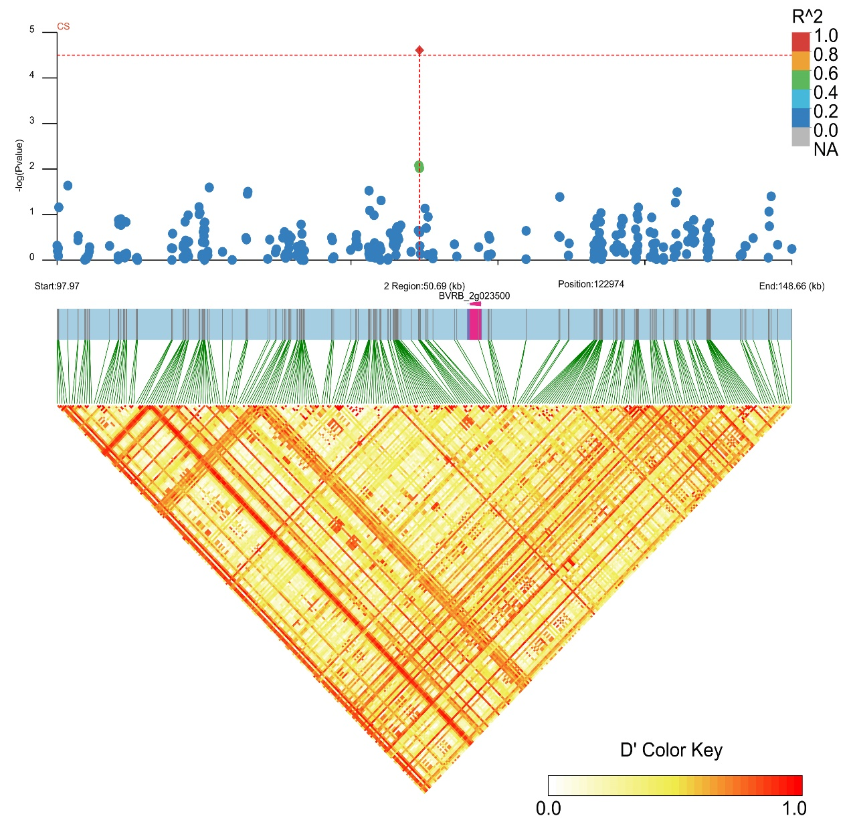
Fig. S5 Manhattan plot and LD heatmap of the candidate genes for CS. The orange vertical line indicates the position of the associated SNPs, and the orange horizontal line indicates -log₁₀p.
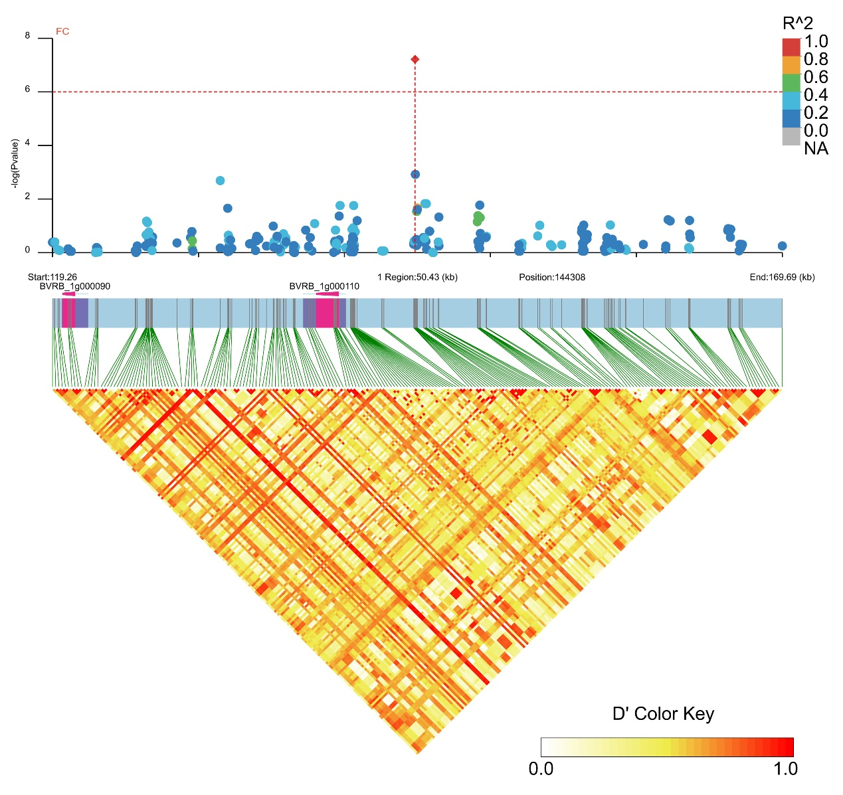
Fig. S6 Manhattan plot and LD heatmap of the candidate genes for FC. The orange vertical line indicates the position of the associated SNPs, and the orange horizontal line indicates -log₁₀p.
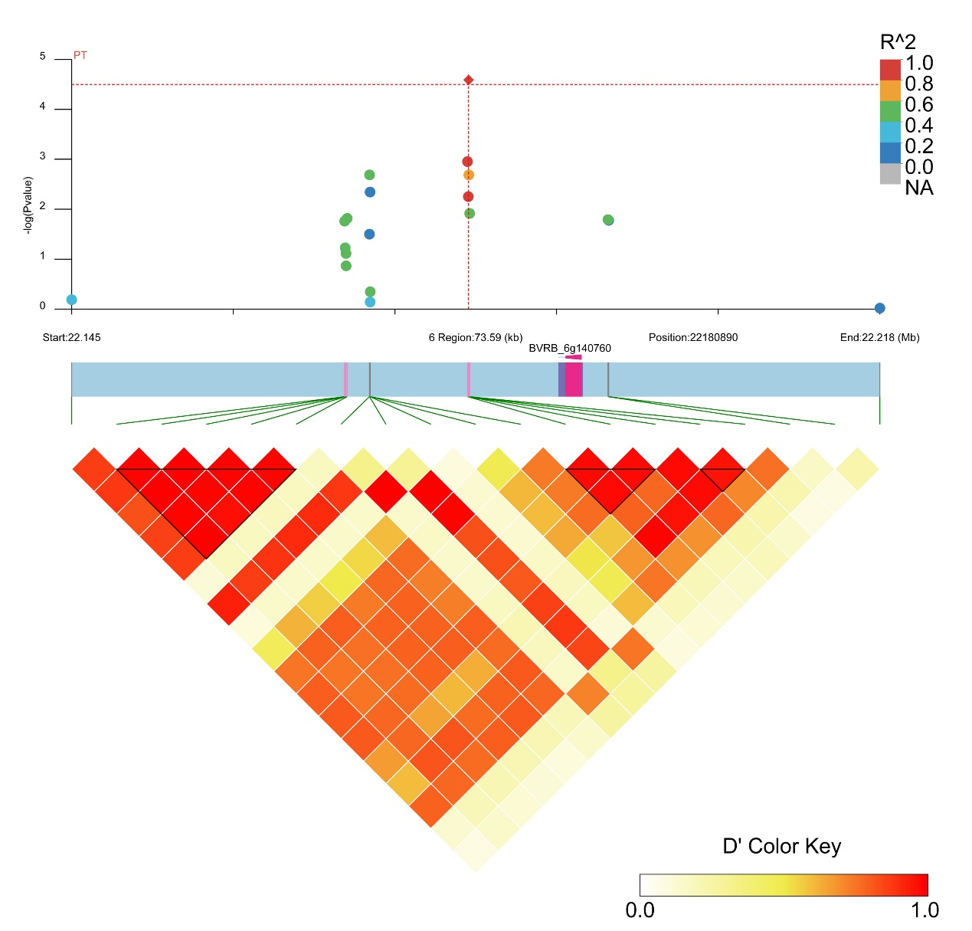
Fig. S7 Manhattan plot and LD heatmap of the candidate genes for PT. The orange vertical line indicates the position of the associated SNPs, and the orange horizontal line indicates -log₁₀p.
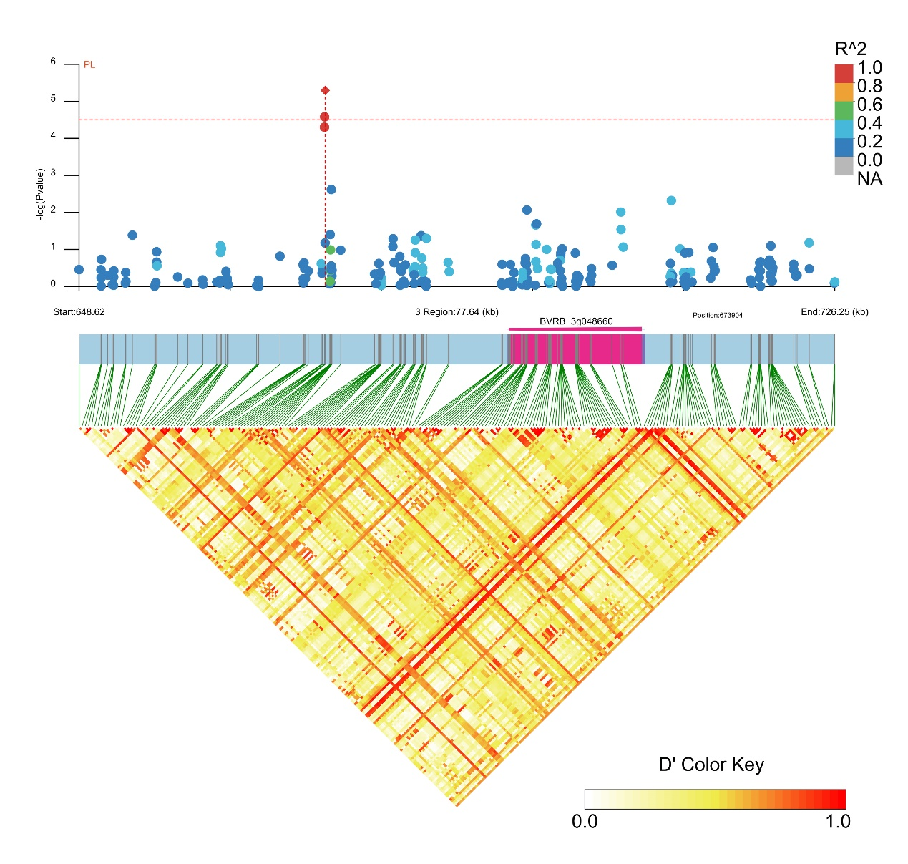
Fig. S8 Manhattan plot and LD heatmap of the candidate genes for PL. The orange vertical line indicates the position of the associated SNPs, and the orange horizontal line indicates -log₁₀p.

