Genomic analyses reveal a low-temperature adapted clade in Halorubrum, a widespread haloarchaeon across global hypersaline environments

Liangzhong Chen^{1,2,3}, Tao Hong¹, Zirui Wu¹, Weizhi Song⁴, Shaoxing Chen^{1*}, Yongqin Liu⁵, Liang Shen^{1,2,6*}
¹College of Life Sciences, Anhui Normal University, Wuhu 241000, China
²Anhui Provincial Key Laboratory of Conservation and Exploitation of Biological Resources, Wuhu 241000, China
³Engineering Research Centre for Molecular Detection and Diagnostics Anhui, Anhui Normal University, Wuhu 241000, China
⁴Centre for Marine Bio-Innovation, University of New South Wales, Sydney, NSW 2052, Australia
⁵Center for the Pan-third Pole Environment, Lanzhou University, Lanzhou 730000, China
⁶State Key Laboratory of Tibetan Plateau Earth System Science, Environment and Resources (TPESER), Institute of Tibetan Plateau Research, Chinese Academy of Sciences, Beijing 100085, China

*Corresponding author.
E-mail addresses: shenliang@ahnu.edu.cn (L. Shen), chensx@ahnu.edu.cn (S.X. Chen).

Fig. S1 Comparison of growth profiles of the representative isolates from the polar and deep-earth group (LN27) and the reference group (T3) at 4 ℃.

Fig. S2 Summary scheme of carbon cycling processes of Halorubrum. Each arrow represents a single transformation to step within a cycle, arrows in red indicate at least one isolate was positive for the reactions. Carbon cycle scheme showing that Halorubrum are typical heterotrophic bacteria characterized as able to utilize organic carbon, ferment ethanol and oxidize acetate.

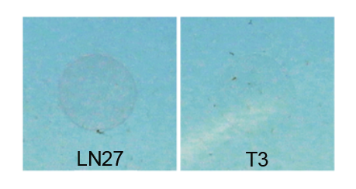
Fig. S1 Comparison of growth profiles of the representative isolates from the polar and deep-earth group (LN27) and the reference group (T3) at 4 ℃.

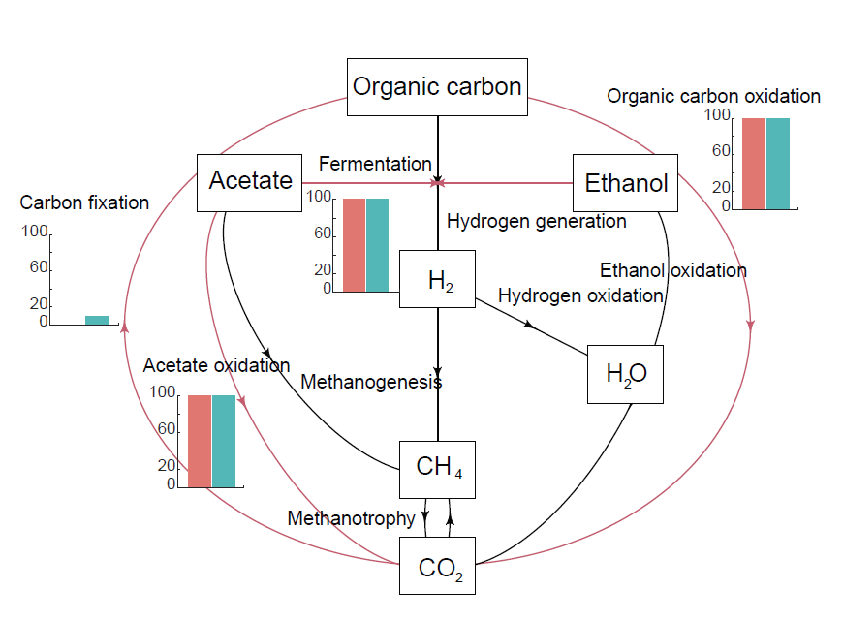
Fig. S2 Summary scheme of carbon cycling processes of Halorubrum. Each arrow represents a single transformation to step within a cycle, arrows in red indicate at least one isolate was positive for the reactions. Carbon cycle scheme showing that Halorubrum are typical heterotrophic bacteria characterized as able to utilize organic carbon, ferment ethanol and oxidize acetate.

