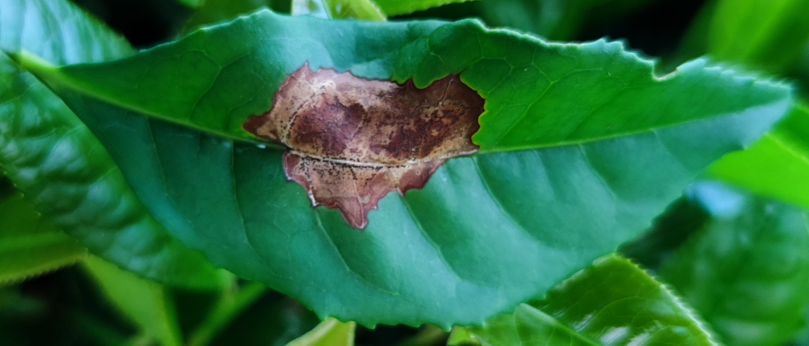
Figure S1 Typical brown blight symptoms on a tea leaf induced by Colletotrichum camelliae.

