Multi-omics analysis reveals the accumulation of secondary metabolites in fructus of Gardenia (Gardenia jasminoides Ellis)

Supplementary Figures
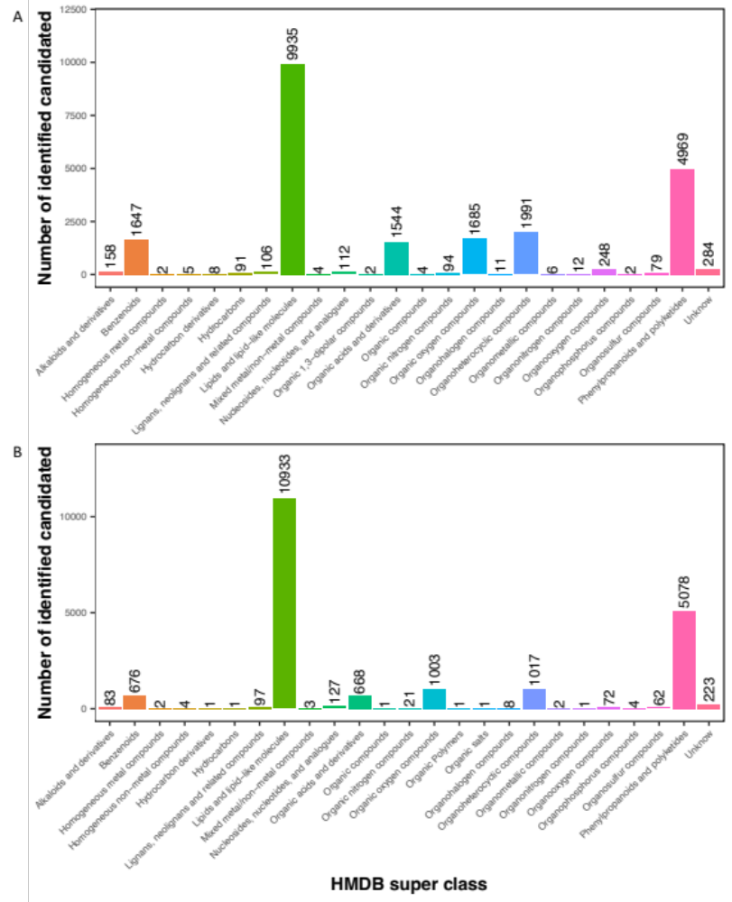
Fig. S1 Identified metabolites from level-one identification were classified into 24 and 25 HMDB super classes. (A) POS mode; (B) NEG mode. The x-axis represents HMDB super classes, and the y-axis represents the number of identified metabolites.

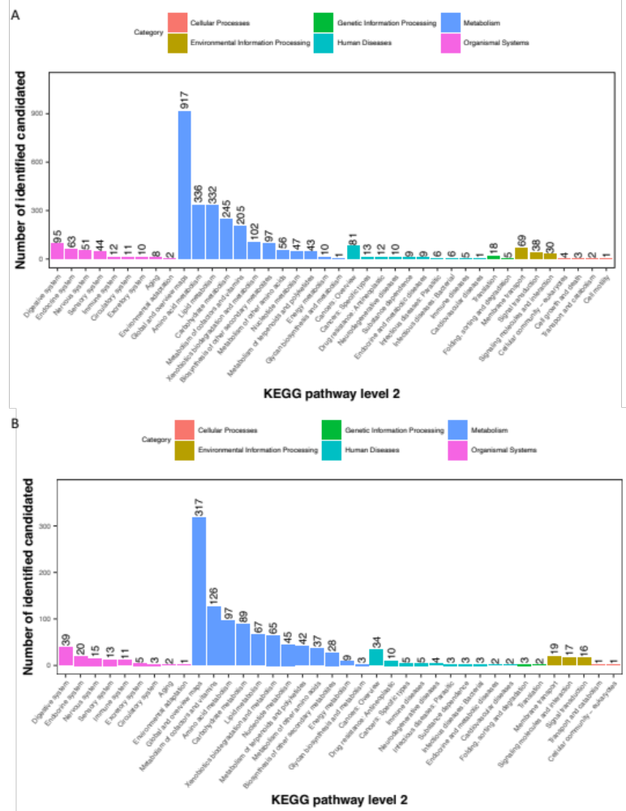
Fig. S2 KEGG pathway classification: metabolites detected and annotated. (A) POS mode; (B) NEG mode. The x-axis represents level-2 terms of the KEGG pathway, and the y-axis represents the number of metabolites identified.
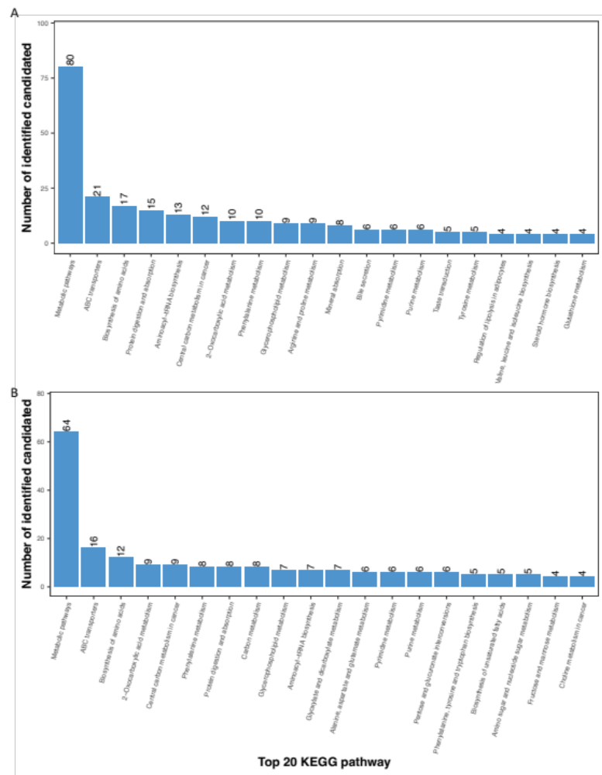
Fig. S3 Identified metabolites classified into the top 20 KEGG pathways. (A) POS mode; (B) NEG mode. The x-axis represents the top 20 KEGG pathways and the y-axis represents number of identified metabolites involved in this pathway.

Fig. S4. Profile of two tissues and metabolites of gardenia fruit at different growth stages. (A) PCA analysis of metabolites of POS mode; (B) PCA analysis of metabolites of NEG mode. (C) Heatmap analysis of metabolites of different samples in NEG mode.
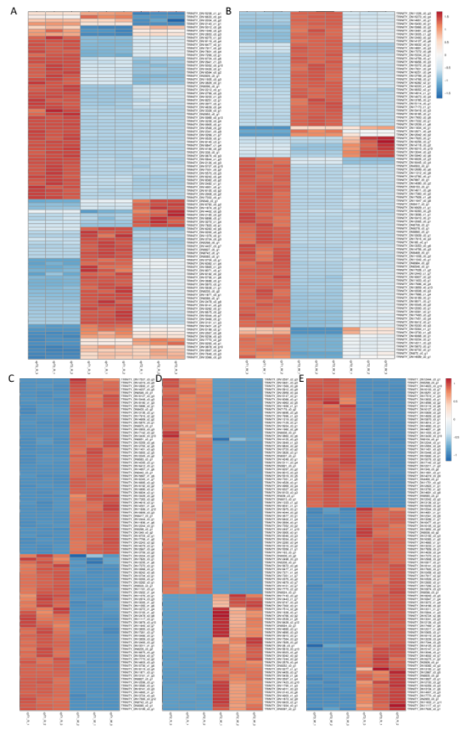
Fig. S5. Heatmap of differentially expressed genes among different tissues of Gardenia fruits at different growth stages. (A-E), T1_K vs T2_K vs T3_K, T1_P vs T2_P vs T3_P, T1_K vs T1_P, T2_K vs T2_P, T3_K vs T3_P. Red represents higher gene expression and blue represents lower gene expression.
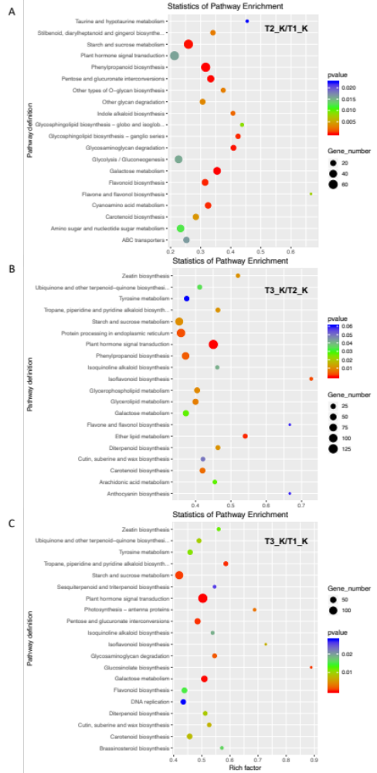
Fig. S6. KEGG enrichment analysis of differentially expressed genes among different tissues of Gardenia fruits at different growth stages. (A-C), T2_K vs T1_K, T3_K vs T2_K, T3_K vs T1_K. Horizontal coordinates represent the enrichment factor, vertical coordinates represent the pathway definition, dot size represents the number of genes, and color represents the p-value.
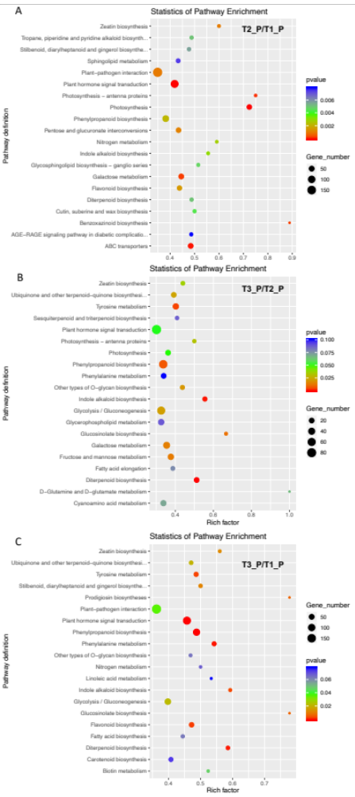
Fig. S7. KEGG enrichment analysis of differentially expressed genes among different tissues of Gardenia fruits at different growth stages. (A-C), T2_P vs T1_P, T3_P vs T2_P, T3_P vs T1_P. Horizontal coordinates represent the enrichment factor, vertical coordinates represent the pathway definition, dot size represents the number of genes, and color represents the p-value.

