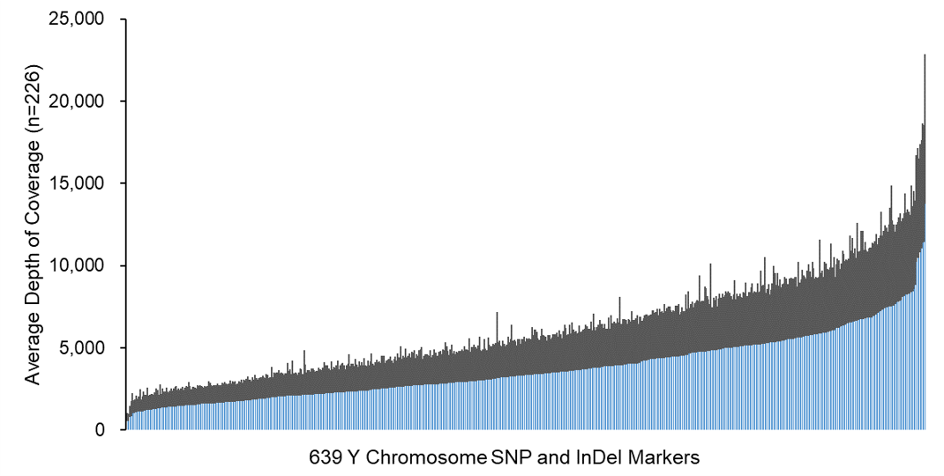
Fig. S2. Average sequencing depth of each locus in the 639-plex panel on MGISEQ-2000RS (n=226). The light blue and dark blue columns represented the mean depth of coverage and the standard deviation of each locus.

