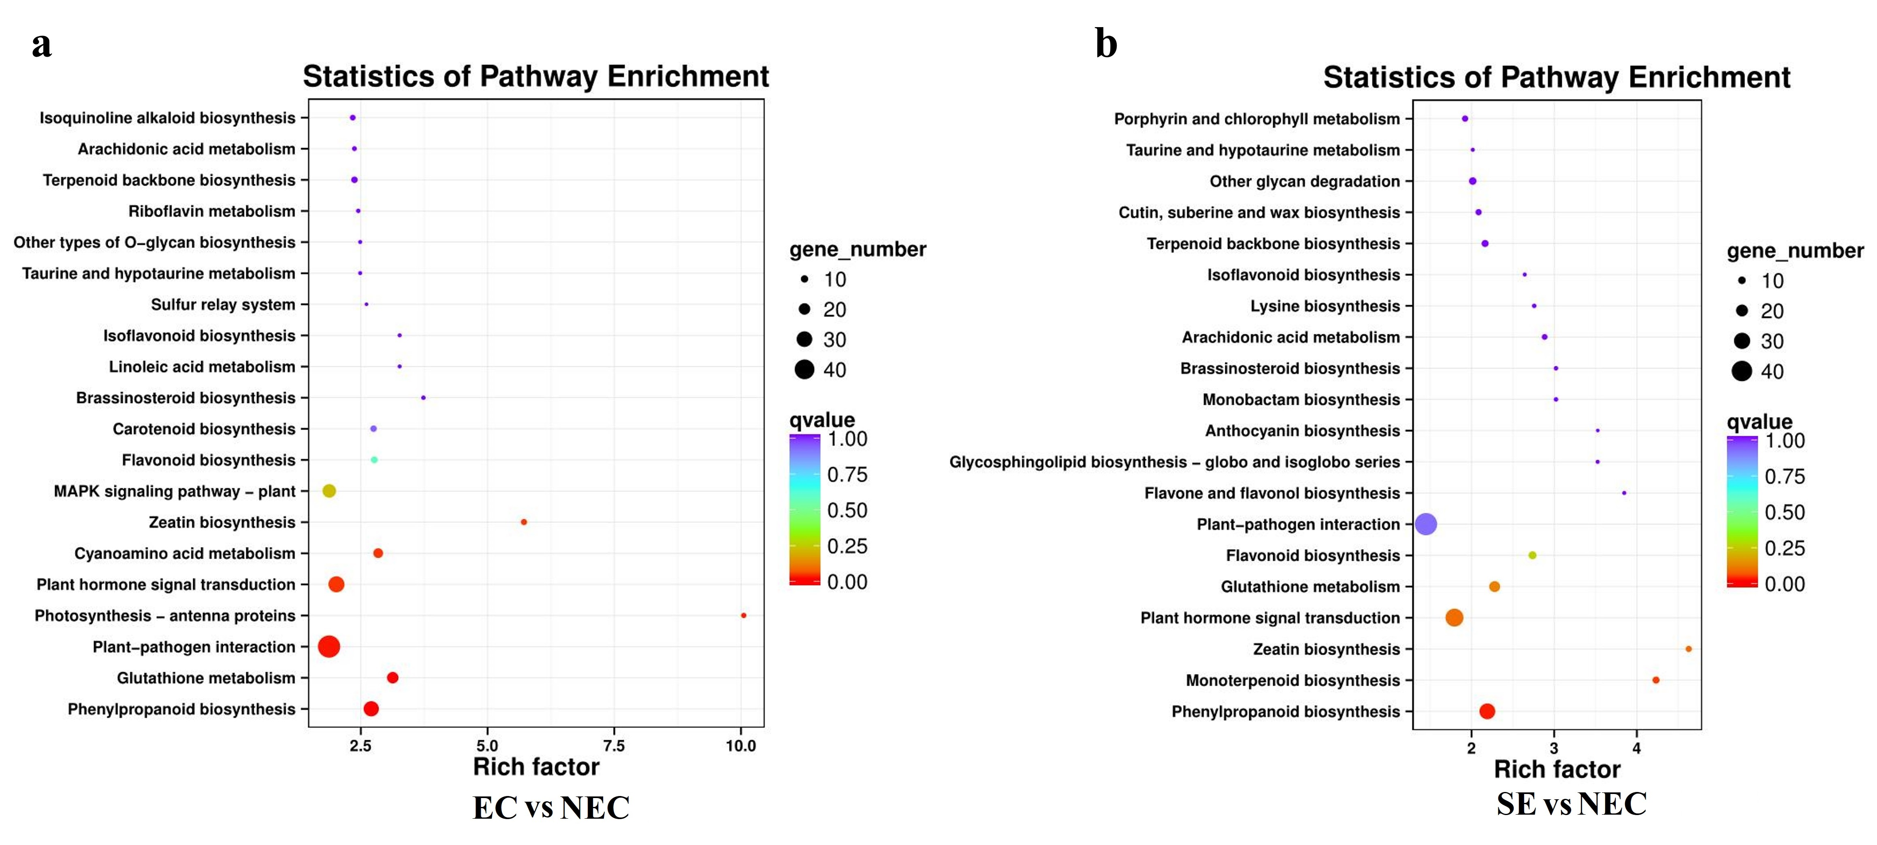
Fig. S2 KEGG enrichment analysis of differentially expressed genes. (a) KEGG Enrichment Analysis of Differentially Expressed Genes in EC vs NEC. (b) KEGG enrichment analysis of differentially expressed genes in SE vs NEC. EC vs NEC: embryonic callus and non-embryogenic callus. SE vs NEC: somatic embryos and non-embryogenic callus.

