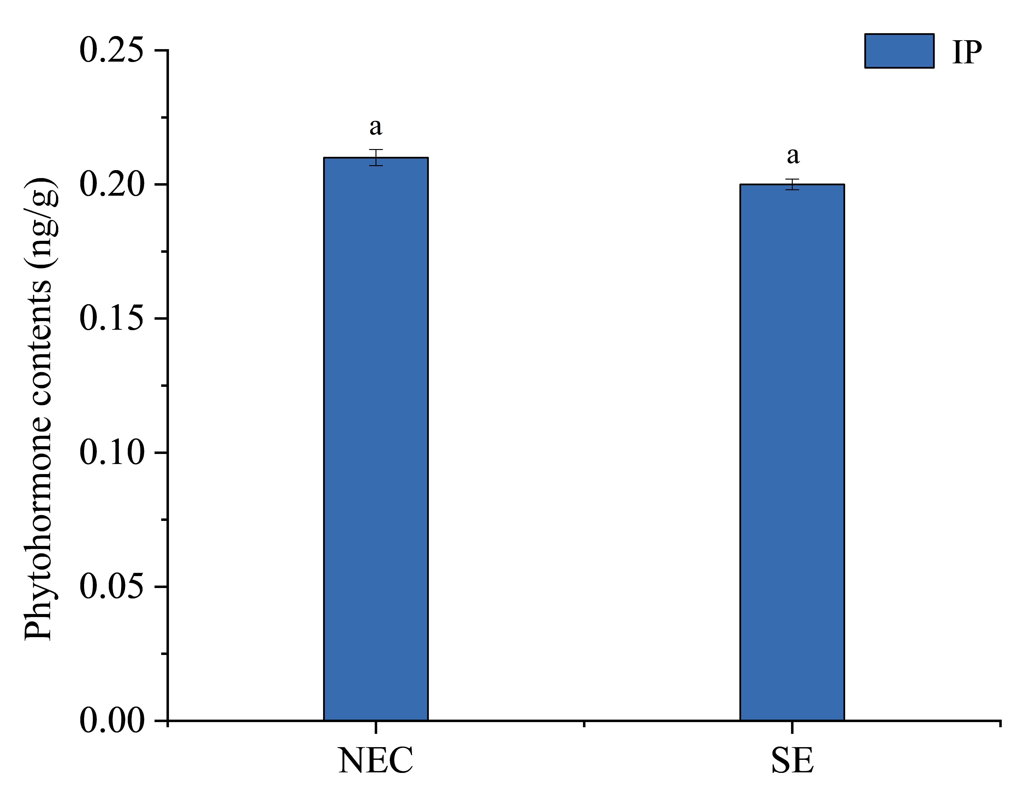
Fig. S3 Content of endogenous hormone in somatic embryos. NEC: non-embryogenic callus. SE: somatic embryos. The medium in NEC and SE is MS+ 0.5mg·L⁻¹ 2,4-D + 0.25mg·L⁻¹ TDZ. Data are the means ± standard error of three replicates. The use of the same lowercase letters indicates that the values were not significantly different according to Tukey’s test (P < 0.05).

